Module 3, Lesson 2
Seasonal differences

In this activity, you will analyze the variable patterns of precipitation in South Asia that result from the region’s seasonal monsoon winds. As you investigate those patterns, you will explore relationships between rainfall and physical features and analyze the climate’s impact on agriculture and population.

Task 1: Open the map

- Launch an internet browser.
- Go to this link:
- http://www.arcgis.com/home/webmap/viewer.html?webmap=147738c4df704d70bb285e33e721b30f

- Click on Contents in the Table of Contents (to the left of the map).

OR

When the map document opens, you see a map with five layers turned on: Mumbai, Rivers South Asia, Cities South Asia, South Asia Borders, South Asia. The checkmark next to the layer name tells you the layer is turned on and visible on the map. The world Topographic layer is called the basemap and cannot be turned on and off with a checkbox.

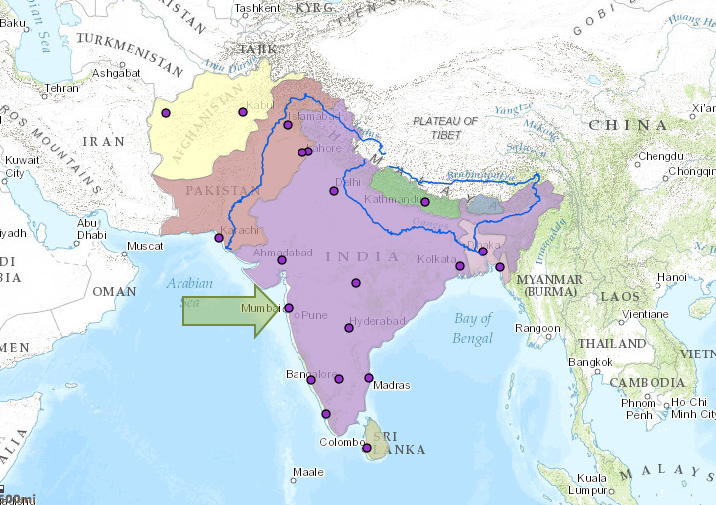

- If you would like to complete this lesson and save your work, click on the Save As button, provide your login and password and provide a new name for your Map. If you do not want to save your work, proceed to Step 4 without clicking on the Save As button.

Note: if you have issues saving your document, go to this link and follow further instructions.
http://education.maps.arcgis.com/home/item.html?id=431f6bc3b0474f5e8933f8ba81bdc925

- Click on the Modify Map link on the top right corner above your map.
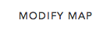

- Click on the city of Mumbai with your left mouse button. Mumbai is on the west coast of India and has an arrow pointing to it.

- Scroll down the popup to view the Monthly Rainfall mm graph for Mumbai.

- Click on the black arrow to the right of the Monthly Rainfall mm graph to view the Annual Rainfall mm graph.

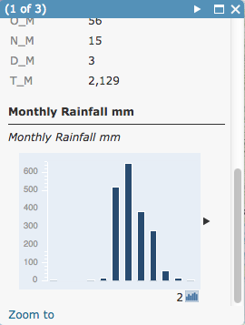
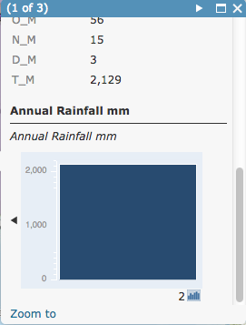

Task 2: Observe annual world temperature patterns

The map allows you to explore and compare variations in the patterns of rainfall throughout the South Asian region. Look at the map and notice that the city of Mumbai is selected — it is highlighted blue. The graphs display rainfall information for the selected city — Mumbai. Hover your mouse over the graph to see the attribute information. The data in this lesson gives rainfall amounts in millimeters. The following table shows what some measurements in millimeters would be equivalent to in inches (25.4 mm = 1 in.).

mm | 100 | 200 | 600 | 1,600 | 2,800 | 5,600 | 12,000
inches | 3.9 | 7.9 | 23.6 | 63 | 110.2 | 220.5 | 472.4

Answers to questions in this activity should be recorded on the answer sheet.

- Q1: Which month gets the most rainfall in Mumbai?

- Q2: Which months appear to get little or no rainfall in Mumbai?

- Q3: Approximately how much rainfall does Mumbai get each year (in millimeters)?

- Q4: Write a sentence summarizing the overall pattern of rainfall in Mumbai in an average year?

- Close the Identify popup window and click on the coastal city directly to the south of Mumbai named Mangalore. (Hint, you might not see the city labeled but you will know if you have the correct city when you click on the dot.)

- Q5: Analyze the graphs and fill in the Mangalore section of the table on your answer sheet. Estimate the rainfall amounts.

- Close the Identify popup window and click on the city directly north of Mumbai named Ahmadabad.

- Q6: Complete the table on the answer sheet. Use estimates.

- Q7: As you move northward along the subcontinent’s west coast, how does the pattern of rainfall change?

- Q8: Although the monthly rainfall amounts differ, what similarities do you see among the overall rainfall patterns of these three cities?

Task 3: Compare coastal and inland cities

- Click on the city directly west of Mangalore named Bangalore.

- Q9: Use the Monthly Rainfall and Annual Rainfall graphs to complete the table on your answer sheet.

- Click back on the city of Mangalore.

- Q10: How does the rainfall pattern of Bangalore compare with that of Mangalore?

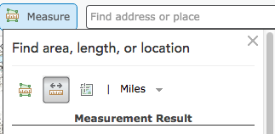
- Close the Identify window. Click the Measure tool and then click the Distance button.

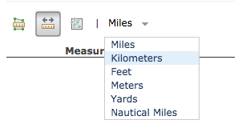
- Click the down arrow for units and click Kilometers.

- Click the dot that represents Bangalore once, and then move the cursor west to the dot that represents Mangalore and double click.

- Q11: What is the distance between the two cities?

If you accidentally clicked the wrong spot, you can double-click to end the line and start over. Check to be sure your distance units stay as Kilometers. If not, choose Kilometers and measure your line again.

- Close the Measure window.

Although Bangalore is located only a short distance inland from Mangalore, it receives far less rainfall than the coastal city.

- In the Legend, turn on the Physical Features layer by putting a check in the box.
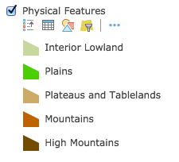
- Click on the layer name Physical Features and click on the Show Legend icon. The legend should display.
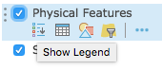

- Q12: How can the data in the Physical Features layer help you explain the differences between patterns of rainfall in inland Bangalore and coastal Mangalore?

- Turn off Physical Features and click on the Show Legend icon to collapse the legend.

Task 4: Compare eastern and western South Asian cities

- Take turns clicking the only two cities in Afghanistan, Kabul and Herat.

- Q13: Analyze the graphs and complete the table on your answer sheet.

Your first impression may be that the Afghan cities get a fair amount of rainfall. But notice that the millimeters scale along the left side of each graph (y-axis) changed to reflect the rainfall range of the selected cities.

- Q14: Describe the pattern of rainfall in these two cities.

- Q15: How do you think Afghanistan’s rainfall pattern affects the way of life in that country?

- In India, select the eastern cities of Kolkata and Dhaka.

If you are unsure if you have chosen the correct cities, you can click once on each dot to look at the city name in the popup.

- Q16: Analyze the graphs and complete the table on your answer sheet.

- Q17: Describe the pattern of rainfall in these two cities.

- Taking turns, click on each of the four cities: Herat, Delhi, Kolkata, and Dhaka. Look at each city’s annual rainfall graph.

- Q18: What is happening to the patterns of rainfall as you move from west to east across South Asia?

Task 5: Observe yearly precipitation

You’ve already looked at the monthly precipitation patterns for individual cities across South Asia. In this step, you will add data and look at the total yearly rainfall for regions of South Asia.

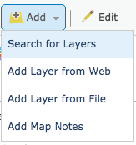
- Click the Add button and then Search for Layers pull down.

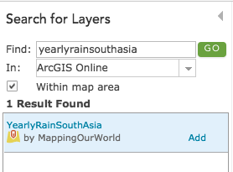
- Making sure that ArcGIS is selected in the In: box, type YearlyRainSouthAsia in the Find: box and click on Go.

- Click on the Add link next to the layer that appears in the results box to the right.

- Click the Done Adding Layers button at the bottom of the Table of Contents box.

The Yearly Rainfall layer will automatically be added to your map.

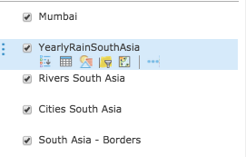
- Click on the YearlyRainSouthAsia layer name and click on the three verticle dots to the left of the layer name. Drag the layer down using the left mouse button until it is under the layer named South Asia - Borders.

- Q19: Which regions of South Asia get the least rainfall?

- Q20: Which regions of South Asia get the most rainfall?

- Q21: In Q18 you were comparing Herat, Delhi, Kolkata, and Dhaka. Does the map of yearly rainfall that is on your screen now reflect the observation you made at that time? Explain.

- Turn off YearlyRainSouthAsia and turn on Physical Features. If necessary, move Physical Features layer below the South Asia - Borders layer and click on the word Physical Features and then the Show Legend icon to expand the legend.

- Q22: What relationships do you see between South Asia’s patterns of yearly rainfall and its physical features?

Task 6: Explore the monsoon’s impact on agriculture and population density

The rain patterns and physical features of an area have a significant impact on the way of life of the people who live there. Now you will look at those characteristics and determine the kinds of impact they have on individual countries.

- Turn the Physical Features, Rivers South Asia, and YearlyRainSouthAsia layers on and off to make your observations and to answer the questions below.

- Q23: Which regions or countries of South Asia are suitable for crop farming and which are not? Explain.

- Q24: In which regions of South Asia do you expect to see the lowest population density? Explain.

- Q25: In which regions of South Asia do you expect to see the highest population density? Explain.

- Turn off Physical Features, Rivers South Asia, and YearlyRainSouthAsia layers.

Now you will add agricultural data for the region and will see if your predictions are correct.

- Use what you learned in Steps 22 – 26 to add and move the AgricultureSouthAsia layer so you can see the borders on top of the agriculture.

- Q26: Does the Agriculture layer reflect the predictions you made in Q23? Explain.

- Q27: Why are grazing, herding, and oasis agriculture the major activities in Afghanistan?

- Q28: What do you know about rice cultivation that would help explain its distribution on the agriculture map?

- Q29: Is there any aspect of the agriculture map that surprised you? Explain.

- Turn off the AgricultureSouthAsia and the South Asia layers.

You will now examine population density in relation to precipitation and land use.

- Use what you learned in Steps 22 – 26 to add the Esri_Population_World layer. This layer is an image so was positioned automatically below the South Asia - Borders layer, so you can see the borders on top of the population density layer without having to move it down in the Contents.

- Q30: Does the Population Density layer reflect the population predictions you made in Q24 and Q25? Explain.

- Q31: Why is Afghanistan’s population density so low?

- Q32: Since most of Pakistan gets little to no rainfall, how do you explain the areas of high population density in that country?

- Q33: What is the relationship between population density and patterns of precipitation in South Asia?

- Q34: What is the relationship between population density and physical features in South Asia?

In this lesson, you explored the patterns of monsoon rainfall in South Asia. You used the ArcGIS.com Map Viewer to compare monthly and annual patterns of precipitation in cities throughout the region and explore the relationship between those patterns and the region’s physical features. After analyzing this data, you added layers reflecting patterns of agriculture and population density and analyzed the relationship between those human characteristics and the region’s climate and landforms.

