Module 3, Lesson 1
Running Hot and Cold

Lesson overview
Students will explore characteristics of the earth’s tropical, temperate, and polar zones by analyzing monthly and annual temperature patterns in cities around the world. In the course of their investigation, students will observe temperature patterns associated with changes in latitude as well as differences caused by factors such as elevation and proximity to the ocean.

Estimated time
Two to three 45-minute class periods

Materials
- Internet access to arcgis.com
- Student instructions
- Student answer sheet
- Student supplements
- Student assessments

Objectives
After completing the lesson, a student is able to do the following:
- Locate tropical, temperate, and polar zones
- Describe the characteristic yearly and monthly temperature patterns in those zones

GIS tools and functions
- Identify a feature to learn more about it
- Zoom in on the map
- Measure distances between points on the map
- Add layers to the map
- Search for addresses
- Utilize Bookmarks
- Pan the map to view different areas
- Turn layers on and off

National Geography Standards
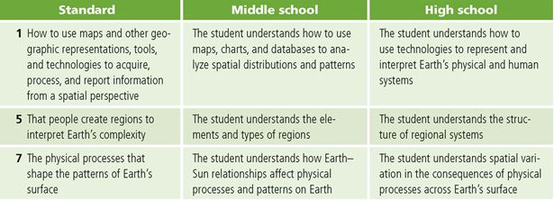

Teaching the lesson

Introducing the lesson
Begin the lesson by asking students to name places that they believe to be the coldest and hottest on the planet. Briefly compare their choices and the reasoning behind them. Using the “Hot and cold cities” Supplement, have the students work in pairs or small groups to identify the three hottest cities in July and three coldest cities in January. At the end of five minutes, each group should share their lists with the rest of the class. Use the blackboard or an overhead projector to tally the cities mentioned as each group reports. Based on the tally, circle the cities that were listed most often. Explain that they are going to do an activity that will explore temperature patterns in cities around the world. As they complete the activity, they will have an opportunity to check their own answers on this handout and reconsider them in view of what they learn.

Before beginning the computer activity, engage students in a discussion about the cities that are circled on the list.
- Why do you think this city is one of the coldest or hottest?
- What countries are these cities located in?
- Has anyone ever visited one of these cities?

Student activity
We recommend that you complete the activity yourself before presenting the lesson in class. Doing so will allow you to modify the activity to accommodate the specific needs of your students. If they will not be working on individual computers, be sure to explain any necessary modifications.
Explain to students that in this activity they will use GIS to analyze yearly and monthly temperature patterns in cities around the world. They will identify global and regional temperature variations and speculate on possible reasons for the patterns observed.
The following are things to look for while the students are working on this activity:
- Are students using a variety of GIS tools?
- Are students answering the questions?
- Are students experiencing any difficulty navigating between windows in the map document?

Concluding the lesson
When the class has finished the activity, lead a discussion that summarizes the conclusions the students reached. Be sure to address latitude in the Northern Hemisphere, latitude in the Southern Hemisphere, proximity to ocean, and elevation as factors that influence temperature. After students have had an opportunity to share their conclusions, discuss the similarities and differences among the ideas presented. Allow students to question each other and clarify confusing or contradictory statements. Develop a consensus about how each factor influences temperature.
Assessment
Students will draw conclusions about the factors that influence temperature patterns. They will write an essay offering data and examples from the activity that support these statements.

Extending the lesson
Challenge students to try the following:
- Collect additional temperature data for cities in one region. Use that data to create a map document of that region and a regional temperature profile.
- Investigate the phenomenon of global warming. Use the Internet to collect recent monthly temperature data for one or more of the cities included in the map document. Compare actual recorded temperatures to average monthly temperatures to see if current temperatures are warmer than average. Compare changes in one region with global changes to see if there are differences.
- Collect rainfall data for the cities included in the map document. Use this data in combination with the temperature data to create an ArcGIS Online map that illustrates typical climate patterns.
See the “Resources by Module” section of this book’s Web site—www.esri.com/ourworldgiseducation— for print, media, and Internet resources on the topics of climate and global temperatures.

Answer key

Task 2: Look at population density and earthquake magnitudes
Q1. Write three observations about the pattern of temperatures displayed on the map. Your observations should describe regions of the world, not specific countries or cities.
Student answers will vary. Possible observations include the following: The warmest temperatures are clustered halfway between the North and South poles. Temperatures get steadily colder as you go from the equator toward the North Pole. There are many cities with cold temperatures in the Northern Hemisphere, but none in the Southern Hemisphere.

Task 3: Label latitude zones
Q2. Complete the table.
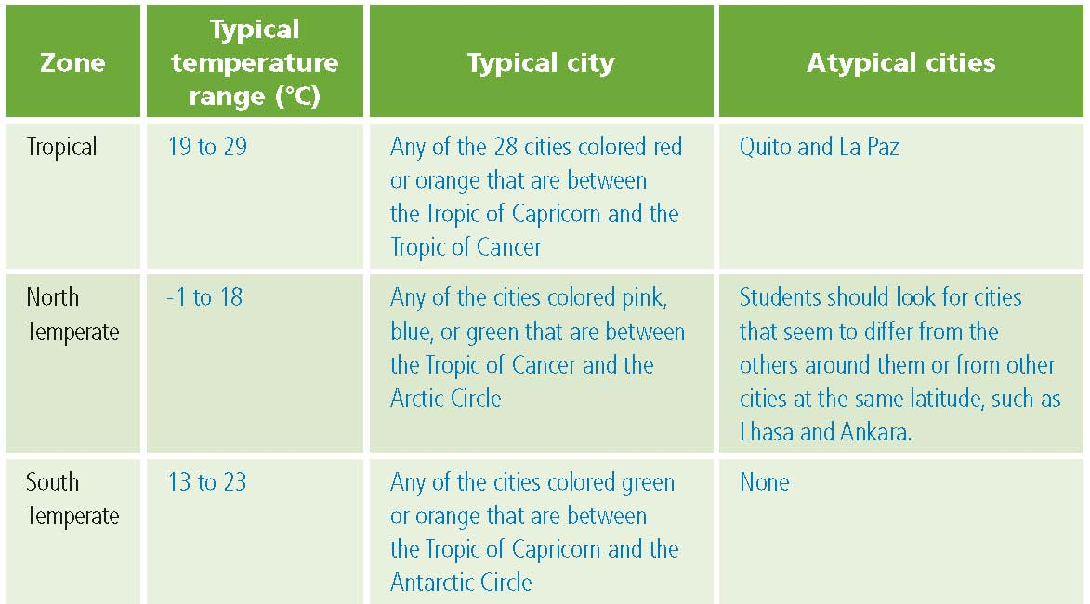

Q3. Why do you think there aren’t any major cities in the North or South Polar Zones? The temperatures are probably too cold to support major cities.

Q4. How is the North Temperate Zone different from the South Temperate Zone?
Answers will vary and may include the following: There is more land area in the North Temperate Zone. There are cities with average temperatures below 13°C in the North Temperate Zone, but none in the South Temperate Zone.

Task 4: Observe climate distribution
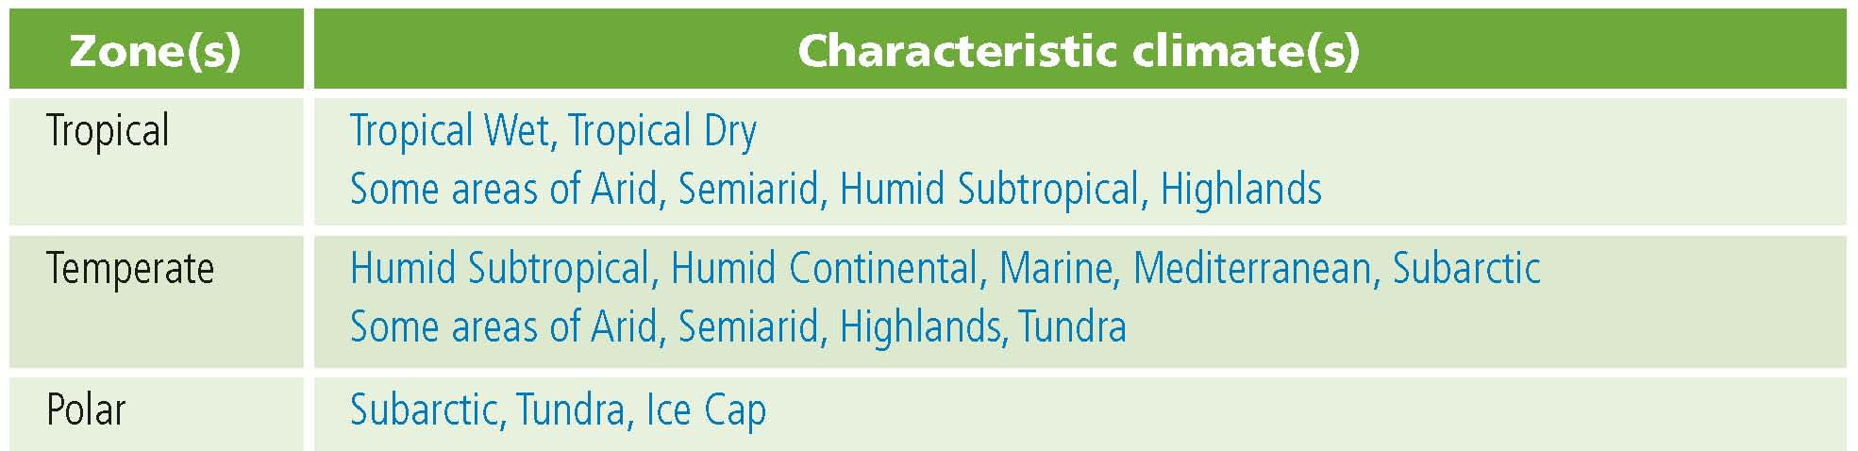
Q5. Complete the following table.

Q6. Which zone has the greatest number of climates? Temperate Zones (or North Temperate Zone)
Q7. Give an example of a city in each of the following climate zones:
Answers will vary and may include the following:
Arid Khartoum
Tropical Wet Kisangani
Tropical Dry Bamako
Humid Subtropical Atlanta
Mediterranean Roma (Rome)
Marine Paris
Humid Continental Warsaw
Subarctic Irkutsk
Highland Lhasa

Task 5: Observe monthly temperature patterns in the Northern Hemisphere
Q8. 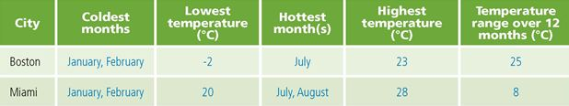
Q9. What is the name of the city? Quebec

Q10. How does its monthly temperature pattern differ from Boston’s? The overall pattern is the same, but winter temperatures are colder and summer temperatures are slightly cooler. The annual temperature range is greater: 31°C. Summer is slightly shorter and winter slightly longer in the more northern city.

Q11. What is the name of the city? Kingston

Q12. How does its monthly temperature pattern differ from Miami’s? Kingston has a smaller temperature range (2°C) than Miami. Both cities are warm year-round, but Miami shows more seasonal variation. They have identical high temperatures, but Kingston’s lows are not as cool as those in Miami.
Q13. Complete the following table. Student answers for temperature may vary slightly depending on how they interpret the graph. Answers below are the actual attribute values.
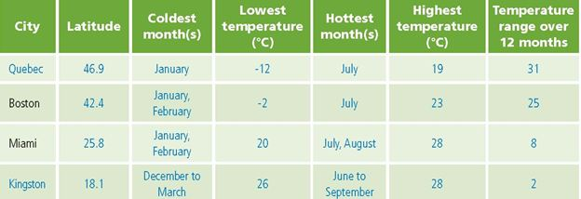

Q14. Based on the information displayed in the graph, the map and the table in Q13, formulate a hypothesis about how the monthly temperature patterns change as latitude increases. Answers will vary but should include the following points: As latitude increases, the range of temperatures over the year increases. The lower latitudes have less seasonal variation and tend to be warm year-round. Temperatures get steadily colder as latitude increases. January and February are among the coldest months, and July and August are among the hottest months.

Task 6: Test your hypothesis
Q15. Complete the table.

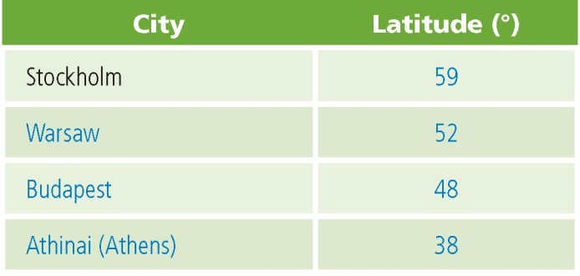

Q16. Does the data for the cities you selected confirm or dispute your hypothesis in Q14?
Explain. Answers will vary depending on the hypotheses. Like the pattern observed in North America, these cities get warmer as you move south. Coldest temperatures occur in December and January, while warmest temperatures occur in June through August. Unlike in North America, the annual range of temperatures varies little among these cities.
Task 7: Analyze temperature patterns in the Southern Hemisphere
Q17. Complete the following table.
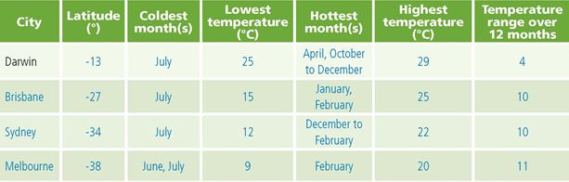

Q18. Compare the monthly temperature patterns in the Southern Hemisphere to those in the Northern Hemisphere. Patterns in the Southern Hemisphere mirror those in the Northern Hemisphere. The coldest winter temperatures are not as low as for the Northern Hemisphere because none of the cities has a latitude higher than -38°. The major difference is that the warmest and coldest months are reversed.

Q19. Formulate a hypothesis about the relationship between monthly temperature patterns and increases in latitude in the Southern Hemisphere. Answers will vary.

Task 8: Test your hypothesis for the Southern Hemisphere
Q20. Complete the following table. Possible answers are listed in the table. Libreville and Nairobi are also correct cities.
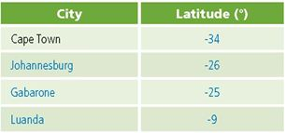

Q21. Does the data for the cities you selected confirm or dispute your hypothesis about how latitude affects monthly temperature patterns in the Southern Hemisphere?
Explain. Answers will vary. The seasonal pattern is similar to that observed in Australia.

Task 9: Investigate the ocean’s influence on temperature
Q22. In which Canadian city would you experience the coldest winter temperatures?
Winnipeg

Q23. In which Canadian city would you experience the warmest winter temperatures?
Vancouver

Q24. Looking at the map, why do you think the warmest city has winter temperatures that are so much warmer than the others?
Of the selected Canadian cities, Vancouver is the only one located on the coast. The proximity to the ocean has a steadying effect on the air temperature in Vancouver throughout the year. Therefore, the fluctuation between summer and winter temperatures is not as large as with inland cities at the same latitude.

Q25. Complete the following table.
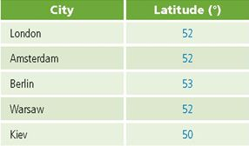

Q26. What do these cities have in common in terms of their locations on the earth?
All the cities are in the Northern Hemisphere, on the continent of Europe, and at approximately 50° north latitude.

Q27. Which two cities have the mildest temperatures? London and Amsterdam

Q28. What happens to the winter temperatures as you move from London to Kiev? Winter temperatures get steadily colder as you move east and inland.

Q29. Why do you think some cities have milder temperatures than the others?
Answers vary.

Q30. Based on your observations for Canada and Western Europe, formulate a hypothesis about the influence of proximity to the ocean (or distance from it. on patterns of temperature).
Answers will vary but should note that cities closest to the ocean have milder temperatures than cities at similar latitudes located inland.

Task 10: Investigate the impact of elevation on temperature patterns
Q31. Complete the following table.
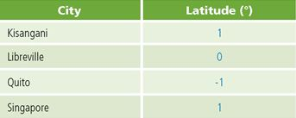
Q32. What do these cities have in common in terms of their locations on the earth?
All are located very close to the equator.
Q33. What temperature pattern do these four cities have in common?
All four cities show very little range in monthly temperatures throughout the year (3° or less).

Q34. How is Quito different from the other three?
Its temperatures are significantly cooler than the temperatures of the other three cities.

Q35. Since all these cities are located on or very near the Equator, what other factor could explain the difference in their temperature patterns? Answers will vary. Students should not predict that Quito’s close proximity to the ocean causes its cooler temperatures, because they just learned that proximity to the ocean causes milder temperatures.

Q36. Analyze the selected records and complete the following table.

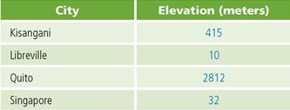

Q37. Based on your observation of temperatures along the equator and the information in the table in Q36, formulate a hypothesis about the influence of elevation on patterns of temperature. Answers will vary but should note that cities at significantly higher elevations have cooler temperatures than other cities at similar latitude.

Task 11: Revisit your initial ideas
Q38. Rank the 13 cities from coldest to hottest according to their average January temperatures.
- Khartoum 8. Helsinki
- Miami 9. Vancouver
- Singapore 10. Lhasa
- Tunis 11. Quito
- Minneapolis 12. Buenos Aires
- London 13. Wellington
- Irkutsk

Q39. Rank the 13 cities from hottest to coldest according to their average July temperatures.
- Irkutsk 8. Quito
- Minneapolis 9. Wellington
- Helsinki 10. Miami
- Lhasa 11. Khartoum
- Vancouver 12. Buenos Aires
- London 13. Singapore
- Tunis

Q40. Put a check mark next to the answers in Q38 and Q39 that you predicted correctly.
Answers will vary.

Assessment rubrics
Middle School
This is a four-point rubric based on the National Standards for Geographic Education. The mastery level meets the target objective for grades 5–8.

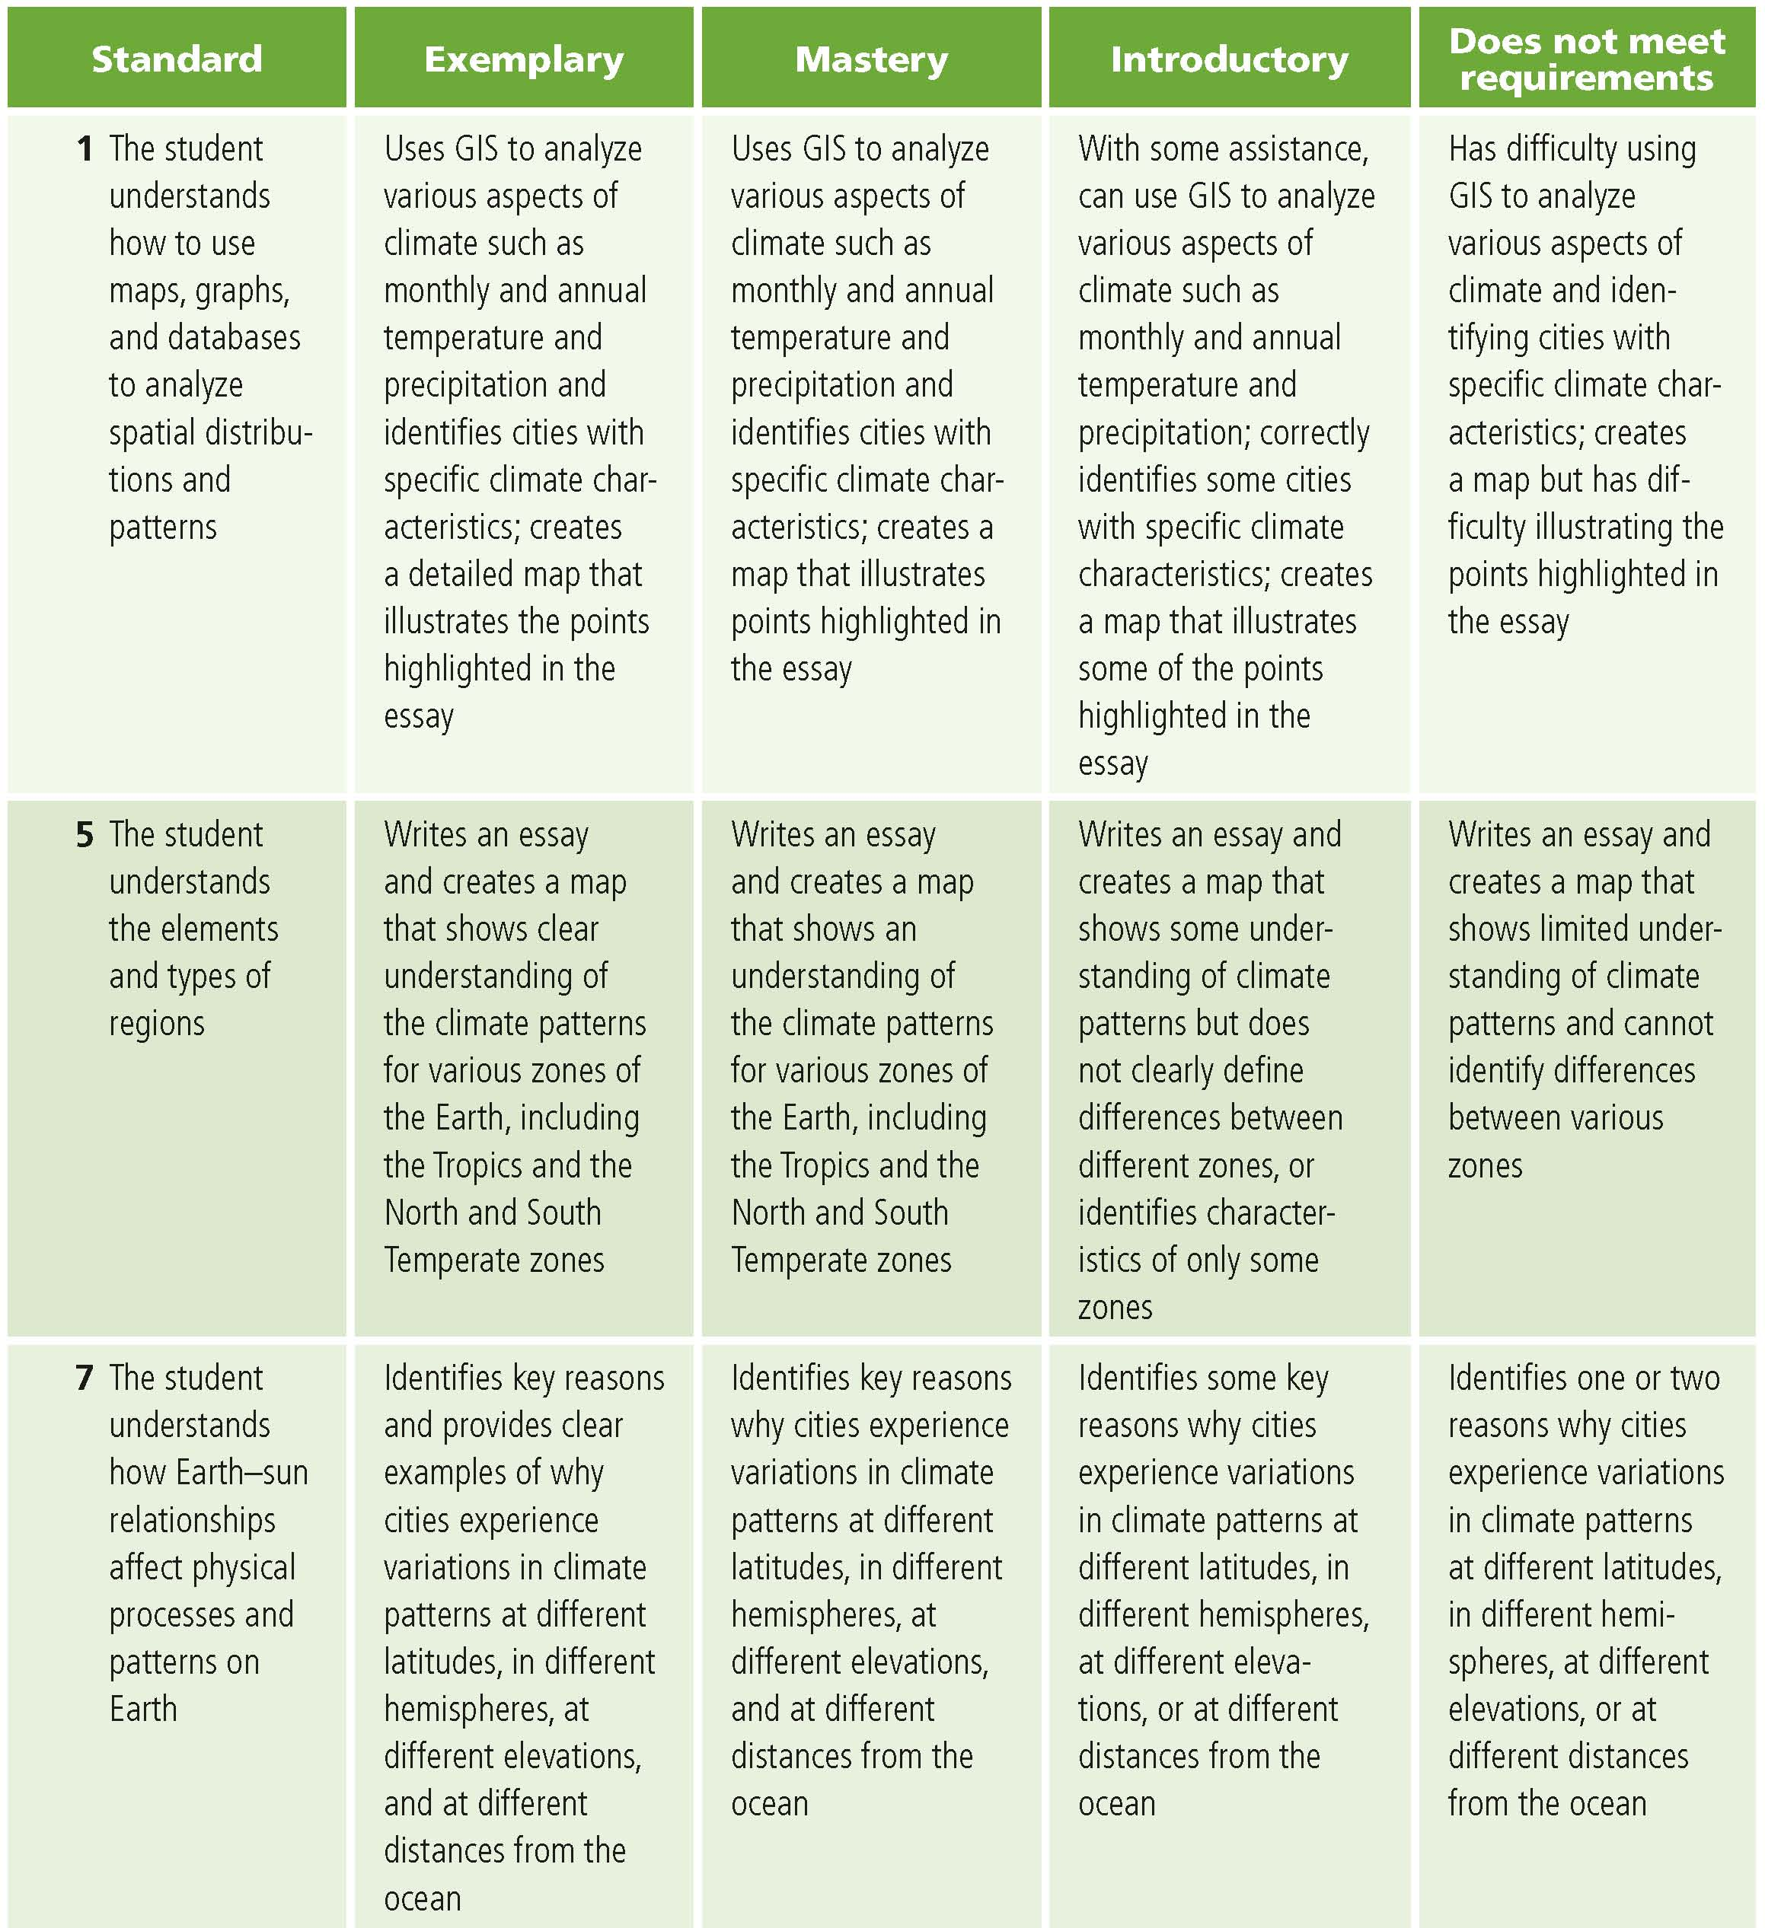

High school
This is a four-point rubric based on the National Standards for Geographic Education. The mastery level meets the target objective for grades 9–12.
