Module 3, Lesson 1
Running hot and cold

In this activity, you will analyze monthly and annual temperature patterns in cities around the world. You will explore how latitude, elevation, and proximity to the ocean influence temperature patterns in the world’s tropical, temperate, and polar zones.

Task 1: Open the map

- Launch an internet browser.
- Go to this link:
- http://education.maps.arcgis.com/home/webmap/viewer.html?webmap=fc815e1d342045aaaf567a5dded9a94e

When the map document opens, you see a map with four layers turned on: Lakes, Rivers, Countries, and Oceans.

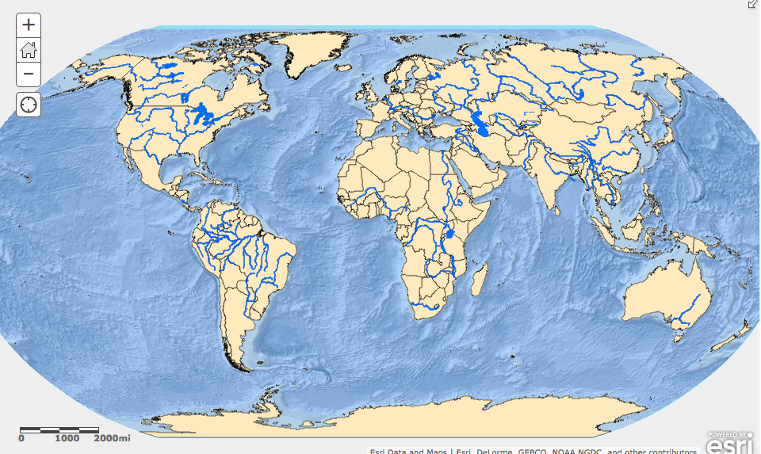

- Click on the Modify Map link on the top right corner above your map.
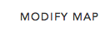

- If you would like to complete this lesson and save your work, click on the Save As button, provide your login and password and provide a new name for your Map. If you do not want to save your work, proceed to Step 4 without clicking on the Save As button.

Note: if you have issues saving your document, go to this link and follow further instructions.
https://www.dropbox.com/s/25g07fiof7ceq9q/Opening%20the%20right%20map.pdf

Task 2: Observe annual world temperature patterns

- Click on the Show Contents of Map button.
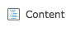
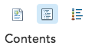
OR

- Turn on the Average Yearly Temperature layer.

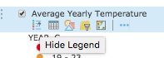
- Hover over the Average Yearly Temperature layer name and click on Show Table icon to see the legend.

The symbols on the map represent cities around the world. The color of each symbol reflects an average of temperatures recorded throughout the year in that city (in degrees Celsius).

- Look at the global temperature patterns displayed on the map.

Answers to questions in this activity should be recorded on the answer sheet.

- Q1: Write three observations about the pattern of temperatures displayed on the map. Your observations should describe regions of the world, not specific countries or cities.

Task 3: Label latitude zones

- Turn on the Latitude and Longitude and Zones layers.

The major latitude and longitude lines plus the Prime Meridian are drawn on the map along with the zones of latitude.

For the purposes of this exercise, the areas between the major latitude lines represent five zones of latitude. The table below names each latitude zone and the area it covers.

Zone | Latitude range
North Polar | Arctic Circle—North Pole
North Temperate | Tropic of Cancer—Arctic Circle
Tropical | Tropic of Cancer—Tropic of Capricorn
South Temperate | Tropic of Capricorn—Antarctic Circle
South Polar | Antarctic Circle—South Pole

- Q2: Use the mouse cursor to click on the cities dots on your map and get the necessary information to complete the table on your answer sheet (remember that each dot represents a city).

- Q3: Why do you think there aren’t any major cities in the North or South Polar Zones?

- Q4: How is the North Temperate Zone different from the South Temperate Zone?

- Turn off Average Yearly Temperature layer and the Zones layer.

Task 4: Observe climate distribution

- Turn on the Climate Zones layer.

The Climate Zones layer displays the regions of the world characterized by different types of climate.

- Q5: Complete the table on your answer sheet.

- Q6: Which zone has the greatest number of climates?

- Turn on the Average Yearly Temperature layer.

- Q7: Give an example of a city in each of the climate zones listed in the answer sheet (use the Identify tool to get the names of the cities).

Task 5: Observe monthly temperature patterns in the Northern Hemisphere

- Turn off the Climate Zones layer and click on Bookmarks on the right of the top menu bar. Choose North America.

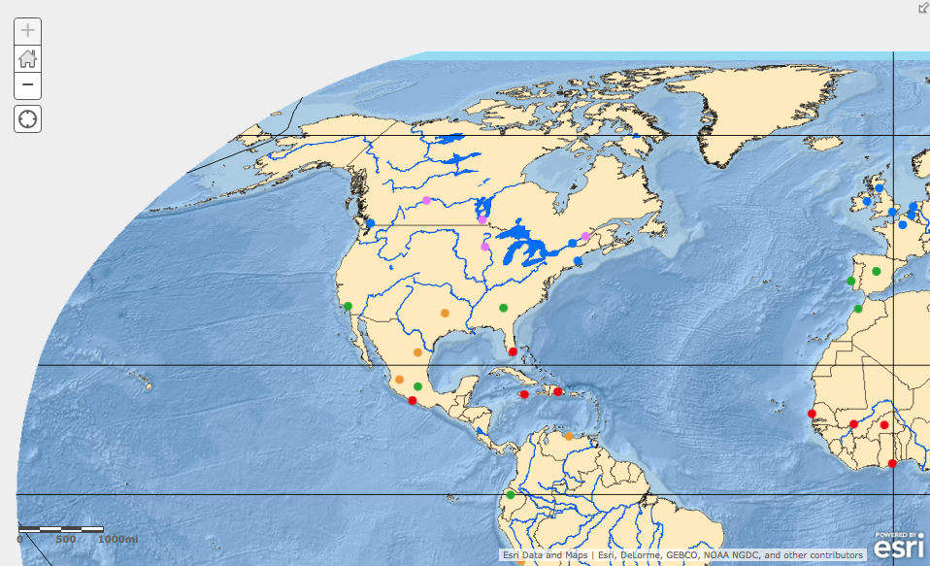
You see a map centered on North America showing cities, rivers, and lakes. If your map looks different than the one pictured above, zoom and pan your map until North America is displayed.

Remember, you can zoom in and out by scrolling your mouse scroll button or by clicking on the “+” or “-“ buttons on the left of your map. You can pan your map by holding down the left mouse button.

utton and moving your mouse.

- Type in Boston in the Find address or place box on the menu bar. Click on the “Boston, MA, USA” selection.
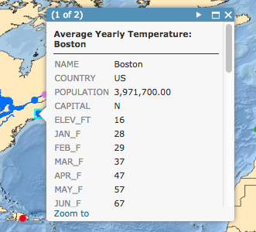
- Click on the dot that represents Boston with the left button on the mouse.

- Scroll down to the bottom of the popup to view the graph entitled Monthly Temp in Celsius.

- Hover over or click on each dot on the line graph to view the month and temperature in Celsius.

The graph displays the monthly temperatures in Celsius for Boston. You’re going to view additional cities on the map by clicking on several cities and recreating those graphs on your student handout or by creating a digital “screen capture” of the graphs.

- Record the points for each monthly temperature for Boston on the student handout entitled Cities Monthly Temperature Graphs. Connect the dots to duplicate the line graph on the popup. Write the name Boston in the City Name space.

Be sure to be conscious of the values on the X-axis and the min and max for each graph.

- Click on Miami at the southern tip of Florida (if you are not sure which city is Miami, type in Miami in the Find address or place box on the menu bar).

- Repeat steps 12 – 15 to complete the temperature graph for Miami in the blank graph to the right of the Boston graph you created.

- Q8: Use the Monthly Temperature graphs you created to compare Miami and Boston and complete the table on your answer sheet.

- Click on the city northeast of Boston.

- Q9: What is the name of the city?

- Repeat steps 12 – 15 to complete the temperature graph for this city in the next blank graph and write the name of that city in the City Name space provided.

- Q10: How does its monthly temperature pattern differ from Boston’s?

- Click on the closest city south of Miami.

- Q11: What is the name of the city?

- Repeat steps 12 – 15 to complete the temperature graph for this city in the next blank graph and write the name of that city in the City Name space provided.

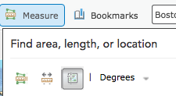
- Q12: How does its monthly temperature pattern differ from Miami’s?

- Click on Measure tool in the menu bar at the top and click on the Location icon.

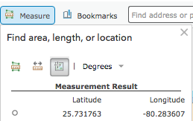

- Click on a city symbol on the map to find that city’s coordinate. The coordinates (latitude followed by longitude) are displayed in the measurement result.

The coordinates are displayed in decimal degrees rather than in degrees, minutes, and seconds. Latitudes north of the equator and longitudes east of the Prime Meridian are positive numbers, whereas latitudes south of the equator and longitudes west of the Prime Meridian are negative numbers.

- Q13: List the name of each of the cities for which you created Monthly Temperature graphs and complete the information in the table on the answer sheet.

- Q14: Based on the information displayed in the graph, the map, and the table, in Q18 formulate a hypothesis about how the monthly temperature patterns change as latitude increases.

Task 6: Test your hypothesis

- Click Bookmarks and select the Western Europe bookmark.

- Type in Stockholm in the Find address on the menu bar.

- Click on Stockholm, SWE and create a graph for that city using a blank graph on your graph worksheet as well as filling in the longitude and latitude for Stockholm.

- Repeat step 26 with three more European cities that are increasingly south of Stockholm.

- Q15: Complete the table on the answer sheet.

- Q16: Does the data for the cities you selected confirm or dispute your hypothesis in Q14? Explain.

Task 7: Analyze temperature patterns in the Southern Hemisphere

You’ve already formulated a hypothesis about how latitude affects monthly temperature patterns in the Northern Hemisphere. Now you will explore the effect of latitude on the monthly temperature patterns within the Southern Hemisphere.

- Click and hold the left click button on your mouse and pan the map so it is centered on Australia. You can also choose the Bookmark entitled Australia.

- Type in Darwin in the Find address on the menu bar as you did for Stockholm above.

- Click on Darwin, Northern Territory, AUS and create a graph for that city using a blank graph on your graph worksheet as well as filling in the longitude and latitude for Darwin.

- Repeat step 30 with the three cities on Australia’s eastern and southern coasts.

- Q17: Complete the table on the answer sheet.

- Q18: Based on the information displayed on the graph, the map and the table you just completed, compare the monthly temperature patterns in the Southern Hemisphere to those in the Northern Hemisphere.

- Q19: Formulate a hypothesis about the relationship between monthly temperature patterns and increases in latitude in the Southern Hemisphere.

Task 8: Test your hypothesis for the Southern Hemisphere

- Click Bookmarks and select the Africa bookmark.

- Type in Cape Town in the Find address or place box on the menu bar.

- Click on Cape Town, Western Cape, ZAF and create a graph for that city using a blank graph on your graph worksheet as well as filling in the longitude and latitude for Cape Town.

- Repeat step 34 with three more African cities that are located between Cape Town and the Equator.

- Q20: Complete the table on the answer sheet.

- Q21: Does the data for the cities you selected confirm or dispute your hypothesis about how latitude affects monthly temperature patterns in the Southern Hemisphere? Explain.

- Reposition your map so that it’s centered on North America.

Task 9: Investigate the ocean’s influence on temperature

In addition to latitude and hemisphere, a city’s proximity to the ocean also influences its temperature. Now you will investigate how the ocean influences the air temperature of coastal cities.

- Using the techniques you learned above, create graphs for the five cities in Canada.

- Q22: In which Canadian city would you experience the coldest winter temperatures?

- Q23: In which Canadian city would you experience the warmest winter temperatures?

- Q24: Looking at the map, why do you think the warmest city has winter temperatures that are so much warmer than the others? (Think of how this city is different from all the others in terms of its location.)

- Reposition your map so that it is centered on Western Europe.

- View the table provided below.

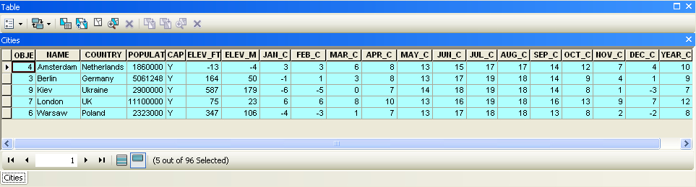
- Create a graph for each city using the method you learned in the previous tasks above.

- Q25: Complete the table on your answer sheet.

- Q26: What do these cities have in common in terms of their locations on Earth?

- Q27: Which two cities have the mildest temperatures?

- Q28: What happens to the winter temperatures as you move from London to Kiev?

- Q29: Why do you think some cities have milder temperatures than the others?

- Q30: Based on your observations for Canada and Western Europe, formulate a hypothesis about the influence of proximity to the ocean (or distance from it) on patterns of temperature.

Task 10: Investigate the impact of elevation on temperature patterns

A city’s elevation significantly affects temperature in that city. You will now investigate the relationship between elevation and temperature.

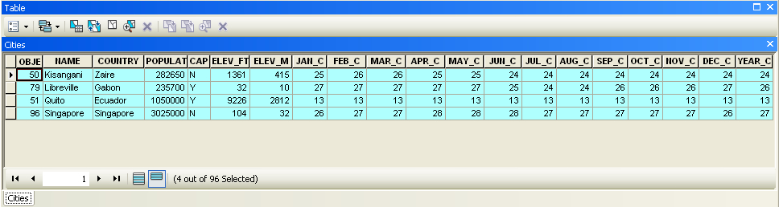
- View the table provided below.

- Create a graph for each city using the method you learned in the previous tasks above. Use the Find feature and take note of where each city is on the map as you recreate their graphs.

- Q31: Complete the table on your answer sheet.

- Q32: What do these cities have in common in terms of their locations on Earth?

- Q33: What temperature pattern do these four cities have in common?

- Q34: How is Quito different from the other three?

- Q35: Since all these cities are located on or very near the Equator, what other factor could explain the difference in their temperature patterns?

- Q36: Using the ELEV_M (elevation in meters) field in the table above, complete the table on your answer sheet.

- Q37: Based on your observation of temperatures along the Equator and the information in the table in Q36, formulate a hypothesis about the influence of elevation on patterns of temperature.

Task 11: Revisit your initial ideas

- Take out the Supplement map you used at the beginning of the lesson to identify the three coldest cities in January and the three hottest cities in July.

- Visit the 13 cities that appear on your Supplement map by clicking on each city on your computer map.

- Scroll down to the NAME field in each city popup until you see the field JAN_C (January temperatures in Celsius).

- Record the JAN_C temperatures on your answer sheet.

- Continue scrolling down until your see the field JUL_C (July temperatures in Celsius).

- Record the JUL_C temperatures on your answer sheet.

- Q38: On your answer sheet, rank the 13 cities from coldest to hottest according to their average January temperatures.

- Q39: Rank the 13 cities from hottest to coldest according to their average July temperatures.

- Q40: Put a check mark next to the answers in Q38 and Q39 that you predicted correctly.

In this lesson you explored temperature data for 96 world cities. You explored the different latitude zones and have identified the variety of climates in each zone. You formulated and tested different hypotheses to explain temperature patterns. Now you know how latitude, hemisphere, proximity to the ocean, and elevation affect temperature patterns around the world.

