Module 4, Lesson 2
Growing Pains

In this activity, you will analyze natural population growth for different countries. You will focus on Africa, one of the fastest growing regions in the world, and Europe, the slowest growing region in the world. You will analyze the standard-of-living indicators for each region and form a hypothesis about the relationship between these indicators and population growth.

Task 1: Open the map

- Launch an internet browser.
- Go to this link:
- http://www.arcgis.com/home/webmap/viewer.html?webmap=d7c167a8eba2429bb7fea9ab1699d0ac

You see a world map with Countries, Oceans and Lakes visible. The next task we will look at the data on birth and death rates.

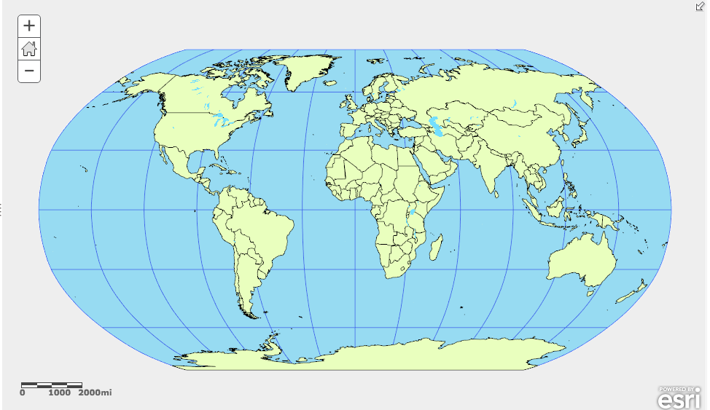
- Click on the Modify Map button on the top right corner above your map.
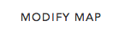

- If you would like to complete this lesson and save your work, click on the Save As button, provide your login and password and provide a new name for your Map. If you do not want to save your work, proceed to Step 4 without clicking on the Save As button.

Note: if you have issues saving your document, go to this link and follow further instructions.
http://education.maps.arcgis.com/home/item.html?id=431f6bc3b0474f5e8933f8ba81bdc925

- Click on the Show Contents of Map at the top of the Contents area on the left of the map.

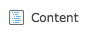
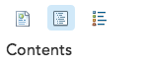
OR

Task 2: Compare birth rate and death rate data

The world’s population is growing because there are more births than deaths each year. This fact can be expressed as a simple formula:

Birth rate – Death rate = Natural increase
(BR – DR = NI)
You will now compare birth rates and death rates around the world to see if you can identify the regions that are growing fastest and slowest.

This table from the U.S. Census Bureau shows the number of births, number of deaths, and rate of natural increase for the world population per year, month, day, hour, and second for 2007. We’re going to investigate data from various years in 2014.

You will now interact with the data collected for each country by the CIA Factbook. The first two layers have a “PG” preceding the layer name. These layers are Population Growth layers. The layers with “SOL” preceding the layer name are Standard of Living layers.

NOTE: There are 254 countries on the map and the data layers are quite large. When you initially turn layers on, you may have to click the plus and minus buttons to zoom in and then out and wait several seconds for the thematically mapped layers to appear.

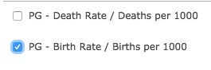
- Click the box next to PG – Birth Rate / Births per 1000 to turn on the layer. This layer shows the number of births for every one thousand people in a country.

Answers to questions in this activity should be recorded on the answer sheet.

- Q1: Which world region or regions have the highest birth rates in 2014?

- Q2: Which world region or regions have the lowest birth rates in 2014?

- Turn off the PG – Birth Rate / Births per 1000 layer by clicking in the box to the left of its name.

- Turn on the PG – Death Rate / Deaths per 1000 layer by clicking the box to the left of its name and click on the words PG – Death Rate / Deaths per 1000 layer name to display the legend for this layer.

- Q3: Which world region or regions have the highest death rates in 2014?

- Q4: Which world region or regions have the lowest death rates in 2014?

- Turn the PG – Death Rate / Deaths per 1000 layer off and on to compare the two sets of data.

- Q5: If the overall rate of growth is based on the formula BR – DR = NI, which world regions do you think are growing the fastest?

- Q6: Which world regions do you think are growing the slowest?

- Turn off the PG – Death Rate / Deaths per 1000 layer.

- Turn on the PG – Birth Rate / Births per 1000 layer.

- Now we need to get specific information by country. Click on the United States. A popup window identifies information from the layer that is turned on. So, with only the PG – Birth Rate / Births per 1000 layer on, you’ll get data on birth rate for 2014 for the United States. To see the death rate information, turn the PG – Birth Rate / Births per 1000 layer off and the PG – Death Rate / Deaths per 1000 layer on and then click on a country to see the death rate data for 2014.

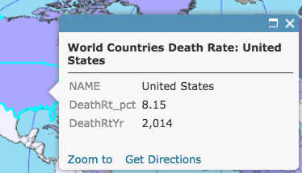
These layers contain information about each country. When you look at the popup window, you will see an attribute field names in the left column, and attribute values in the right column. The birth rate field is abbreviated as BrthRate_pct (birth rate percentage), and the death rate field is abbreviated as DeathRt_pct (death rate percentage). In the example above, the United States has a birth rate of 13.42 births per 1,000 living people and a death rate of 8.15 deaths per 1,000 living people. The year the data was collected is shown in the attribute field after the birth and death rate fields.

- Close the Identify popup window.

- Hold the shift key down and click and drag a box around Africa and Europe.

- Q7: Choose two European countries and two African countries and record their birth and death rates in the tables on the answer sheet. Click on your chosen countries to find information on them.

- Q8: List three questions that the Birth Rate and Death Rate maps raise in your mind.

Task 3: The Natural Increase layer

You can test your predictions of the fastest and slowest growing regions (Q5 and Q6) by investigating the Natural Increase data on your map. This information is in the PG – Natural Increase layer that shows the yearly increase in population percentage that results from the difference between births and deaths in each country.

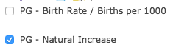
- Click the Home button to return to the view of the entire world.

- Turn off PG – Birth Rate / Births per 1000 and PG – Death Rate / Deaths per 1000 layers.

- Turn on the PG – Natural Increase layer.

Similarly to the birth and death rates, the natural increase rate is expressed as a specific number of people per 1,000. This means that all the countries colored dark blue on the map add between 24 and 36 people to their populations each year for every 1,000 people already there.
The actual growth rate of an individual country is based on its natural increase plus the net migration of people into or out of that country each year.

- Click on the words PC – Natural Increase to expand the layer’s legend and to see what the colors represent

- Q9: What is happening to the populations of countries that are beige?

- Q10: Which world regions are growing the fastest?

- Q11: Which world regions are losing people or not growing?

- Q12: Think about what it would mean for a country to have a population that is growing rapidly or one that is growing slowly or shrinking. Which of these two situations do you think would cause more problems within the country? List some of the problems you would expect to see.

Task 4: Look at standard-of-living indicators for Europe and Africa

- Geographers look at certain key statistics when they want to compare the standards of living in different countries. They refer to these statistics as “indicators” because they typically reveal or provide some information about the quality of life in that country. The indicators that you will look at in this activity are the following:
- SOL – Population 65 years or older / percent (ratio of population older than 64 to the working-age population – those ages 15-64)
- SOL – GDP / Billions USD – (annual gross domestic product)
- SOL - Infant Mortality Rate / Deaths per 1000 live births – [annual number of deaths of infants under one year of age per 1,000 live births]
- SOL - Life Expectancy / Years – Female or Male (number of years a newborn infant would live if prevailing conditions of mortality at the time of birth continue)
- SOL - Literacy Rate (percentage of the population over 15 years of age that can read and write; this definition varies slightly between countries)
- SOL – Workforce in Services / Percent (percentage of the workforce that is employed in the service sector)

Europe is one of the slowest growing regions and sub-Saharan Africa is one of the fastest growing regions in the world. You may want to refer to the World Imagery layer to understand where sub-Saharan Africa is and what it looks like.

- Make sure the SOL – Population 65 years or older layer is turned on and then click on the SOL – Population 65 years or older layer name link to expand the layer.

- Q13: Explore each of the six standard-of-living indicators by turning on and off and expanding each of the layers to complete the table on the answer sheet. Keep in mind the following points:

- A layer will cover the one beneath it when it is turned on. You will need to turn layers on and off to see all the indicators.
- You can change the order of the layers by dragging them to a new position in the table of contents.
- By clicking on the layer name, you can expand or collapse the layers in the table of contents to show or hide the legends as you examine different layers.

Task 5: Explore the Net Migration layer

The net rate of migration is a statistic that indicates the number of people per 1,000 gained or lost each year as a result of migration. A negative number indicates that more people are leaving the country than coming in. A positive number means more people are coming to the country than leaving it.

- Q14: In Q13 you compared standard-of-living indicators for Europe and sub-Saharan Africa. Based on your observations of those indicators, which region would you expect to have a negative net migration? A positive net migration? Explain your answers.

- Turn on the SOL - Net Migration statistics layers. (Make sure all other layers are turned off.)

- Q15: Summarize the overall patterns of net migration in Europe and sub-Saharan Africa in the table on the answer sheet.

- Q16: What political or social conditions or events could explain any of the migration patterns you see on the map?

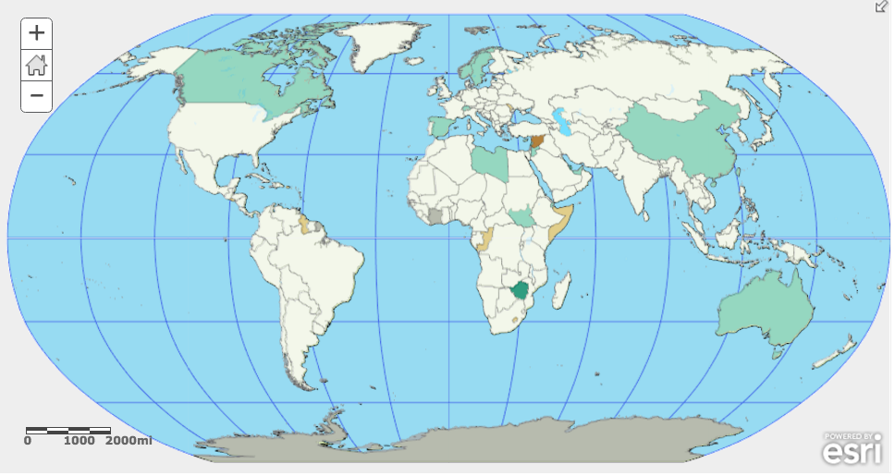
Task 6: Draw conclusions

- Now, let’s compare the SOL - Net Migration data to the PG - Natural Increase data.

- Turn on and off the PG - Natural Increase layer and compare to the Net Migration layer that should also be turned on.

- Look at the two maps and compare the rates of natural increase of some countries to their rates of net migration. Think about what correlation, if any, may exist between a country’s standard of living, its rate of natural increase, and its rate of net migration.

- Q17: Based on your map investigations, write a hypothesis about how a country’s rate of natural increase affects its standard of living and its net rate of migration.

- Q18: In the table on the answer sheet, illustrate your hypothesis with data from one European country and one sub-Saharan African country. Use the Identify tool to see the data for an individual country.
Indicator/Layer Attribute field
In this lesson, you explored world population growth and analyzed standard-of living indicators in one of the fastest growing regions of the world (sub-Saharan Africa) and the slowest growing region (Europe).

