Module 4 Lesson 2
Growing pains
A regional investigation of Europe and Africa

Lesson overview
In this lesson, students will compare the processes and implications of population growth in one of the world’s fastest growing regions, sub-Saharan Africa, and the slowest growing region, Europe. Through the analysis of standard-of-living indicators in these two regions, students will explore some of the social and economic implications of rapid population growth.

Estimated time
Two to three 45-minute class periods

Materials
The student worksheet files can be found on the Data and Resources CD. Install the teacher resources folder on your computer to access them.
- Internet access to arcgis.com
- Student Activity
- Student answer sheet
- One sheet of drawing paper and one marker per student

Objectives
After completing this lesson, a student is able to do the following:
- Describe the fundamentals of population growth by explaining the relationship between birth rate, death rate, and natural increase
- Identify the fastest and slowest growing regions in the world today
- Explain the socioeconomic implications of rapid population growth
- Explain the slow population growth in Europe and how standard-of-living indicators are affected
- Explain the rapid population growth in areas of Africa and how standard-of-living indicators are affected

GIS tools and functions
- View attributes for a feature on a map
- Zoom in or out on the map
- Turn layers on and off

National Geography Standards

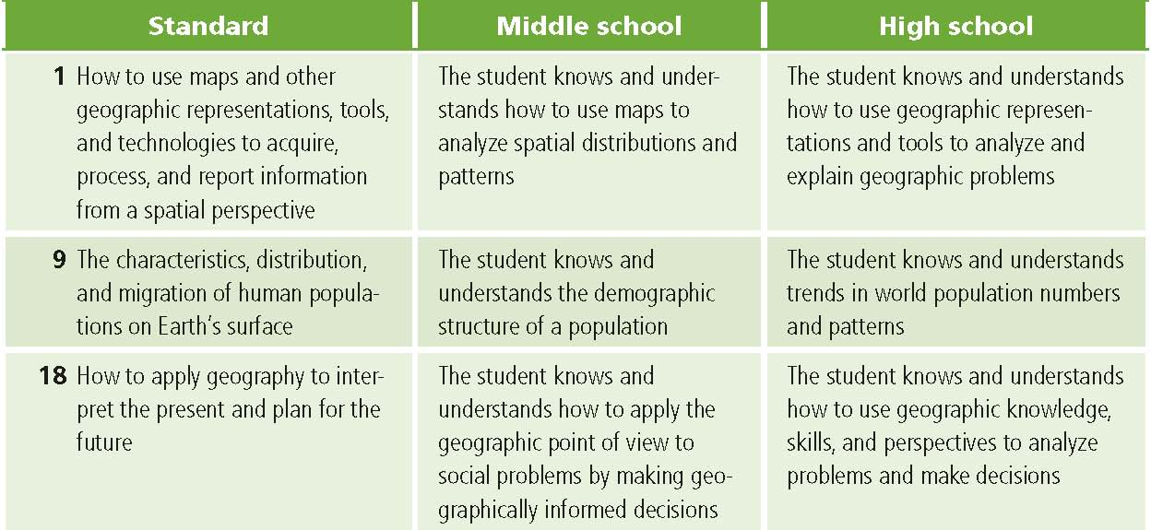

Teaching the Lesson

Introducing the lesson
Begin the lesson with a discussion of world population growth. Remind students that the world’s population reached six billion in 1999. World population is now over 7 billion and counting.
Consider the following questions:
- Why is the earth’s population growing?
- Are all regions growing at the same rate of speed?
- What does “overpopulation” mean, and at what point would you characterized the world as overpopulated?

If your community or state is growing, that would be a good starting point for this discussion. How has population growth affected your community or state? Do students see this as a good thing or a bad thing?

More information at National Geographic’s 7 Billion site: http://ngm.nationalgeographic.com/7-billion
National Geographic Video on YouTube: http://www.youtube.com/watch?v=sc4HxPxNrZ0

Student Activity
We recommend that you complete the activity yourself before presenting the lesson in class. Doing this will allow you to modify the activity to accommodate the specific needs of your students. If they will not be working on individual computers, be sure to explain necessary modifications.
Distribute the activity to students. Explain that in this activity they will use GIS to compare a region in the world where population is growing fast and region where it is growing slowly. They will also investigate the relationship between a region’s rate of population growth and its standard of living.

The following are things to look for while the students are working on this activity:
- Are the students using a variety of tools?
- Are the students answering questions?
- Do students need help with the lesson’s vocabulary?

Concluding the lesson
When the class has finished the activity, give each student a piece of drawing paper on which to write his or her hypothesis from Q17. Students should tape their hypothesis on the wall or blackboard and discuss them. Look for similarities and differences among the hypotheses. Allow students to question each other to clarify confusing or contradictory statements. If possible, try to reach consensus about the relationship between a country’s rate of natural increase and its standard of living based on evidence from the activity.

Middle School Assessment. Students will play the role of liaison to the United Nations, in charge of establishing a partnership between a slow growing nation and a fast growing nation. They will need to identify issues critical to each country and devise a way the countries can form a partnership to improve their standards of living.

High school assessment. Students will play the role of a special liaison to the United Nations, in charge of establishing a partnership between a group of slow growing nations and a group of fast growing nations. They will need to identify issues critical to each group and devise a way the countries can form a partnership to improve their standards of living.

Extending the lesson
Challenge students to try the following:
- Explore and map additional attributes from the module 4 data folder. Look for additional social and economic implications of rapid population growth.
- Test your hypothesis about the relationship between standard of living, net migration, and the rate of natural increase by investigating countries in other parts of the world.
- Explore an African country’s population, birth rate, death rate, and standard-of-living indicators and write a report about the country, including a map layout.
- Use ArcGIS Online map viewer attribute queries (filters) to identify countries that do not match your hypothesis. Try to figure out an explanation for these anomalies.
- Explore gender differences in standard of living in Europe and/or sub-Saharan Africa. Using the module data, map and analyze male and female life expectancies, male and female literacy rates, and male and female infant and child mortalities.
- Conduct research on the impact of HIV/AIDS on death rates and population growth in sub-Saharan Africa.
See the “Resources by Module” section of this book’s Web site www.esri.com/ourworldgiseducation for print, media, and Internet resources on the topics of Africa, Europe, demographics, and standard-of-living indicators.

Answer key
Task 2: Compare birth rate and death rate data
Q1. Which world region or regions have the highest birth rates? Africa, South Asia
Q2. Which world region or regions have the lowest birth rates? North America, Europe, Russia,
Australia
Q3. Which world region or regions have the highest death rates? Africa Q4. Which world region or regions have the lowest death rates? Mexico, Central America, western South America, Northern Africa, Southwest Asia
Q5. If the overall rate of growth is based on the formula BR – DR = NI, which world regions do you think are growing the fastest? Areas of sub-Saharan Africa, Arabia, and Central America
Q6. Which world regions do you think are growing the slowest? Many European countries, Russia
Q7. Choose two European countries and two African countries and record their birth and death rates in the table below. Answers will vary and may include the following: 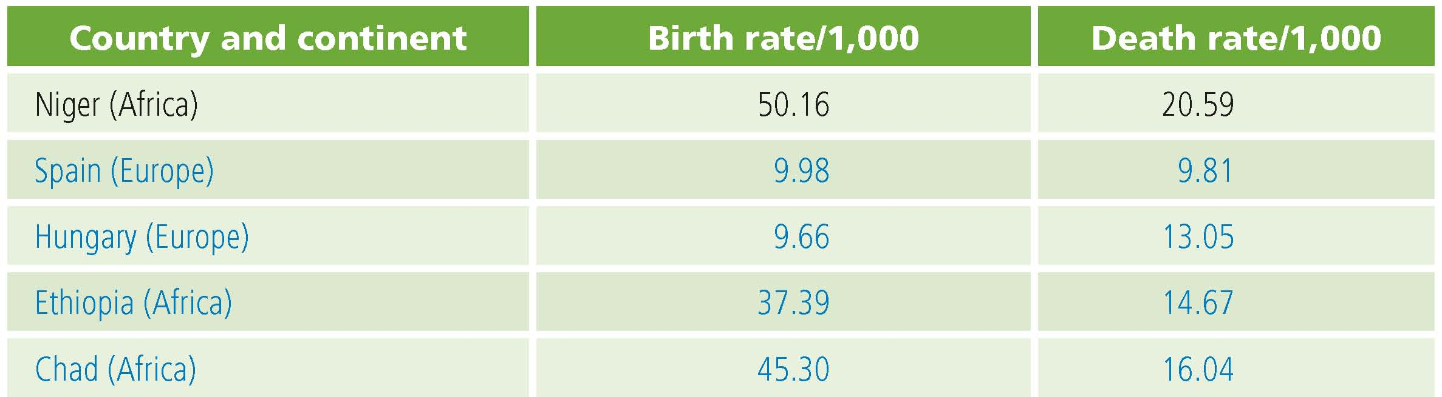
Q8. List three questions that the Birth Rate and Death Rate maps raise in your mind. Answers will vary.
Task 3: Add the Natural Increase layer
Q9. What is happening to the populations of countries that are pink? Their death rates exceed their birth rates. Over time these populations will decline unless migration into the countries makes up for the negative natural increase.
Q10. Which world regions are growing the fastest? Sub-Saharan Africa and Southwest Asia
Q11. Which world regions are losing people or not growing? Eastern Europe, Russia, and southern Africa
Q12. Think about what it would mean for a country to have a population that is growing rapidly or one that is growing slowly or shrinking. Which of these two situations do you think would cause more problems within the country? Students may answer that either situation or both situations can lead to problems.
List some of the problems you would expect to see. Answers will vary, but students who answered that rapid growth would cause more problems should recognize that a country with rapid growth will have a difficult time keeping up with the constantly increasing need for education, health care, social infrastructure, resources, and jobs. Students who answered that a shrinking population would cause more problems should list effects such as inability to defend itself, loss of industry, inability to fill industrial or technology jobs, the pressure to increase immigration, and so on.

Task 4: Look at standard-of-living indicators for Europe and Africa
Q13. Complete the table below.
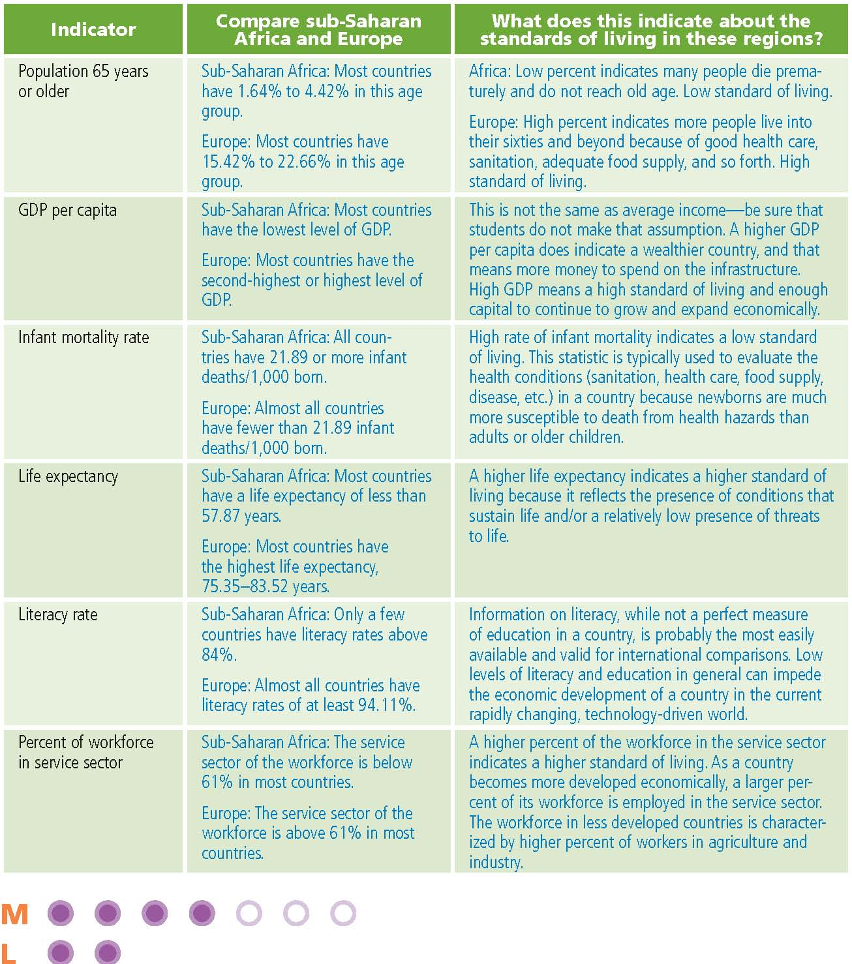

Task 5: Add the Net Migration layer
Q14. In Q13 you compared standard-of-living indicators in Europe and sub-Saharan Africa. Based on your observations of those indicators, which region would you expect to have a negative net migration? A positive net migration?
Negative: Sub-Saharan Africa (countries with low standards of living)
Positive: Europe (countries with high standards of living)
Explain your answers: Answers will vary, but students should recognize that there will be more out-migration from countries with low standards of living and more in-migration to countries with a higher standard of living.
Q15. Summarize the overall patterns of net migration in Europe and sub-Saharan Africa in the table below.
Net migration in sub-Saharan Africa
There is no clear pattern. Some countries have net migration, and others have net out-migration.
Net migration in Europe
Western Europe has net in-migration, and most in- Eastern European countries have net out-migration
.
Q16. What political or social conditions or events could explain any of the migration patterns you see on the map? Possible answers include Balkan wars, fall of communism, higher standard of living in Western Europe, and the end of civil war in Liberia.
Task 6: Draw conclusions
Q17. Based on your map investigations, write a hypothesis about how a country’s rate of natural increase affects its standard of living and its net rate of migration. Answers will vary, but students should note that natural increase has a direct effect on standard of living and that standard of living creates push–pull factors that influence migration.
Q18. In the table below, illustrate your hypothesis with data from one European country and one sub-Saharan African country. Answers will vary depending on the hypothesis that was formulated in Q17. However, students should include natural increase, net migration, and other data that support their hypotheses.

Assessment rubrics

Middle school
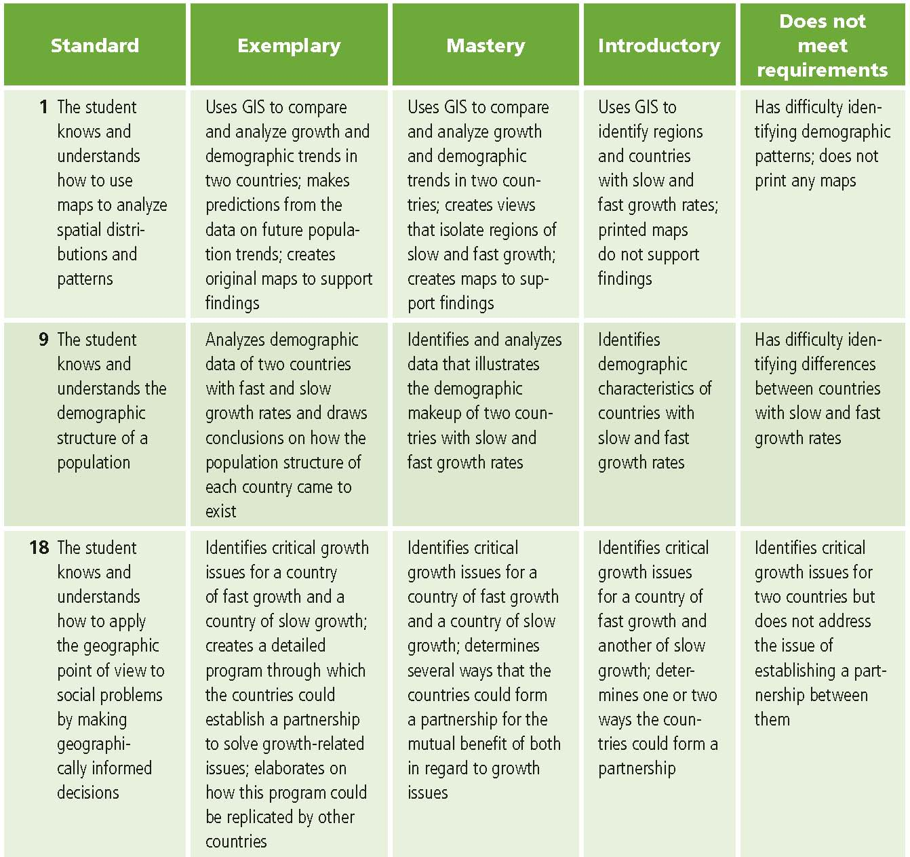
This is a four-point rubric based on the National Standards for Geographic Education. The mastery level meets the target objective for grades 5–8.

High School
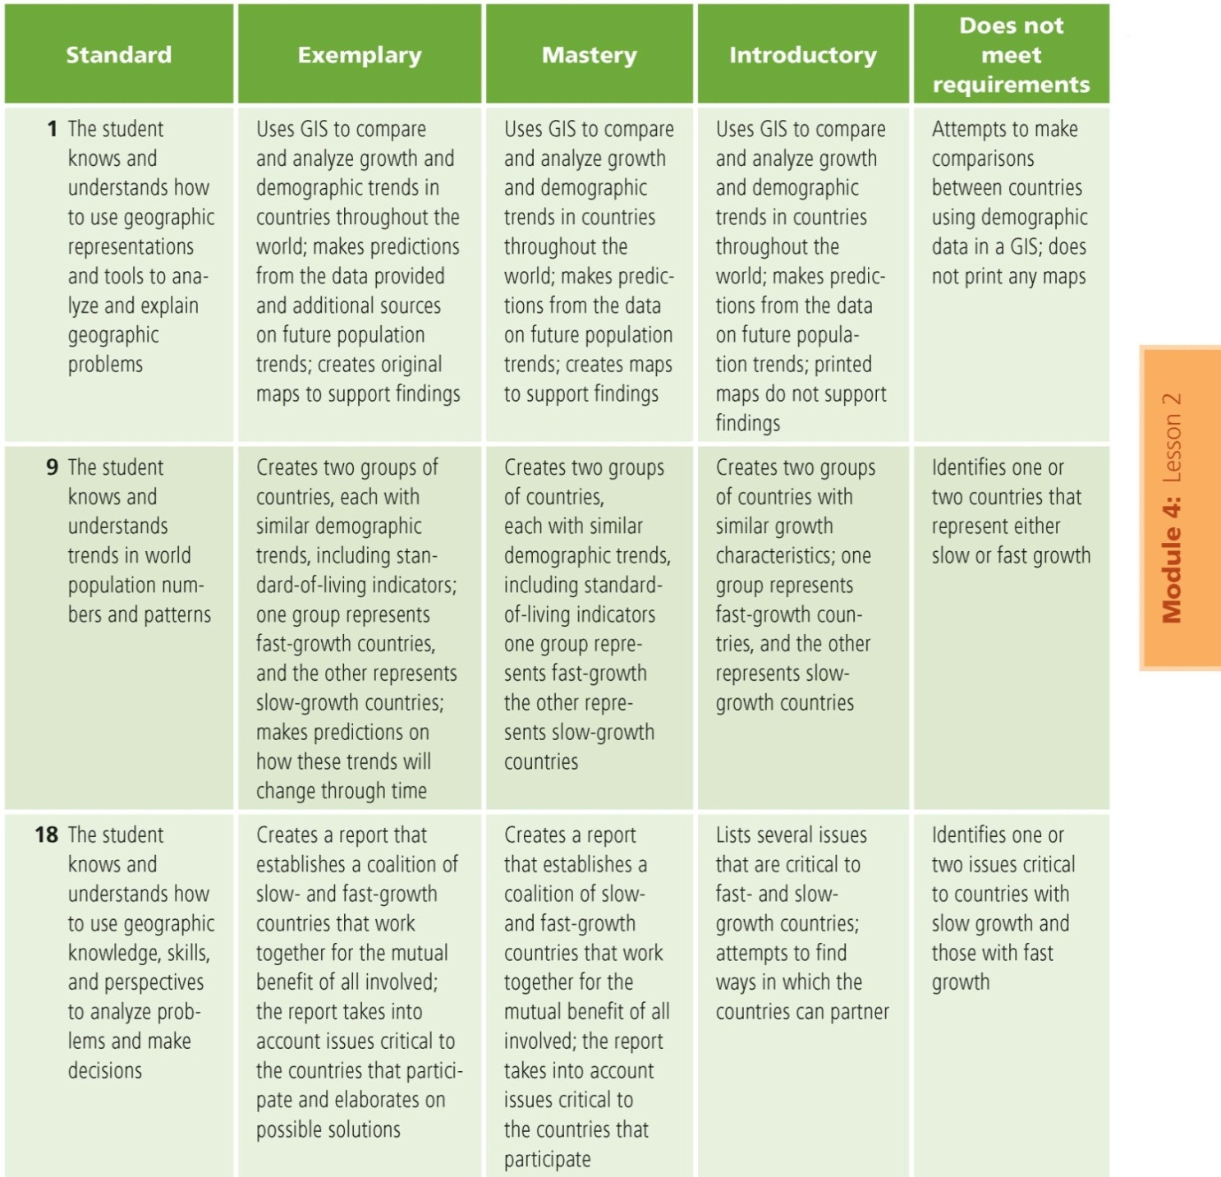
This is a four-point rubric based on the National Standards for Geographic Education. The mastery level meets the target objective for grades 9–12.

