Module 7, Lesson 1
Water world

Imagine that the year is 2100. Scientists have determined that the rapidly warming climate of the earth will cause the ice sheets of Antarctica to break apart and melt at a much faster rate than was predicted a hundred years earlier. You and your GIS investigation team are presented with the challenge of studying the impact this change will have on the planet.

You will explore and compare different maps of Antarctica and investigate specific Antarctic sites to learn more about the continent. You will also use world maps to investigate changes in ocean levels associated with the melting of the Antarctic ice sheets.

Task 1: Open the map

- Launch an internet browser.
- Go to this link:
- http://www.arcgis.com/home/webmap/viewer.html?webmap=d8cd8dd72caf42d999fc164defafd861

When the map document opens, you see a map with two layers Latitude & Longitude and Topographic basemap displayed on the map.

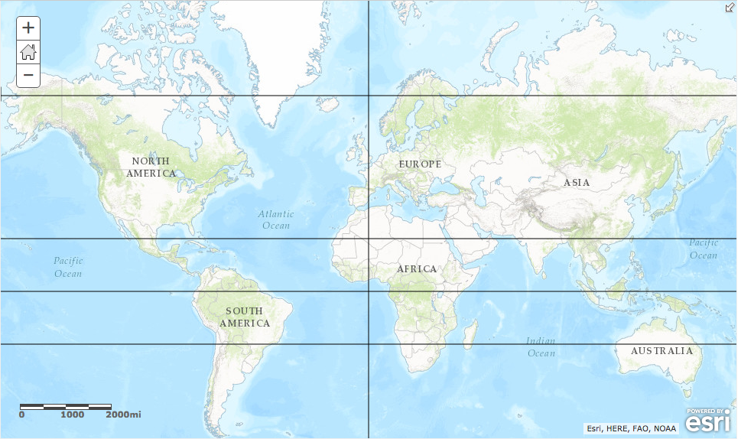

- Click on the Modify Map button on the top right corner above your map.
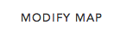

- If you would like to complete this lesson and save your work, click on the Save As button, provide your login and password and provide a new name for your Map. If you do not want to save your work, proceed to Step 4 without clicking on the Save As button.

Note: if you have issues saving your document, go to this link and follow further instructions.
http://education.maps.arcgis.com/home/item.html?id=431f6bc3b0474f5e8933f8ba81bdc925

- Click on Show Contents of Map in the Table of Contents to the left of the map.

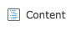
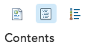
OR

You are now able to see all the map layers available to view with a check mark next to the layer name that tells you the layer is turned on and visible in the map. The layer that is turned on is on top of the Topographic basemap layer that displays the oceans.

Task 2: Look at Antarctica

- Click the check box in front of the Continents Layer to turn it on. (It may take a few seconds for the layer to draw on your map.

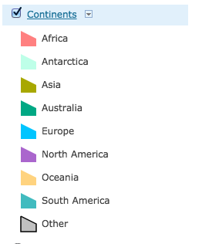
- Click on the Continents Layer name in the Contents and click on the Show Legend icon to to expand its legend.
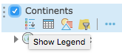

Take a look at the continent where the melted water will come from. (You may need to zoom out and pan the map to see Antarctica.) Scientists believe that the first area to melt will be the Western Ice Shelf of Antarctica. The western part of Antarctica is on the left side of the map. It is considerably smaller than the eastern portion. It lies on the west of the Transantarctic Mountain Range and basically covers all the land to the west of the prime meridian. The prime meridian is the line that runs north south on the map.

Because the map is based on a geographic map projection, which is a flat projection of the spherical earth, some parts of it are skewed (out of shape). This can affect the size of features (such as landforms), their shape, or the distance or direction between them.

Answers to questions in this activity should be recorded on the answer sheet.

- Q1: Do you think this map gives you a realistic representation of Antarctica? Explain.

- Click the check box in front of Projections in the Contents to turn on that layer.

- Click each of the eight pushpins to see the Earth in different projections.

- Q2: Do any of these projections work well for viewing Antarctica?

Task 3: View the South Pole

As you reviewed the various projections, you may have thought that none of them would give you a good perspective of the South Pole, or you may have wanted to flip the map upside down or change its center. The recommended projection is the polar orthographic projection, which centers the map on the South Pole.
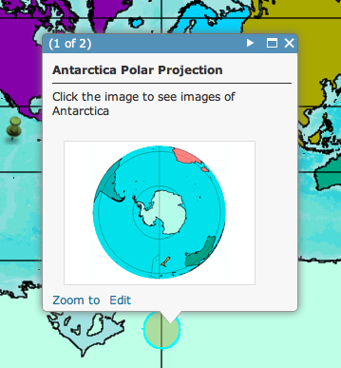
- Pan the map up. Click the circle popup positioned over Antarctica. If you do not see the circle, pan down until you see the circle.

- Click on the polar image of Antarctica that you see in the popup.

A new map window opens up with a map project entitled Module7 Lesson1 B.

- Close the first map project entitled Module 7 Lesson1 A by clicking the X on the first tab.

- Q3: Does this projection work well for viewing Antarctica? Explain.

**You can do just the Antarctica session without opening the prior map by clicking on this link:

http://education.maps.arcgis.com/home/webmap/viewer.html?webmap=b91e45f37d684d0f8583bc34461ee6c0

Task 4: Picture Antarctica

- Click the Content button.

- Zoom in one more level to see Antarctica up close.

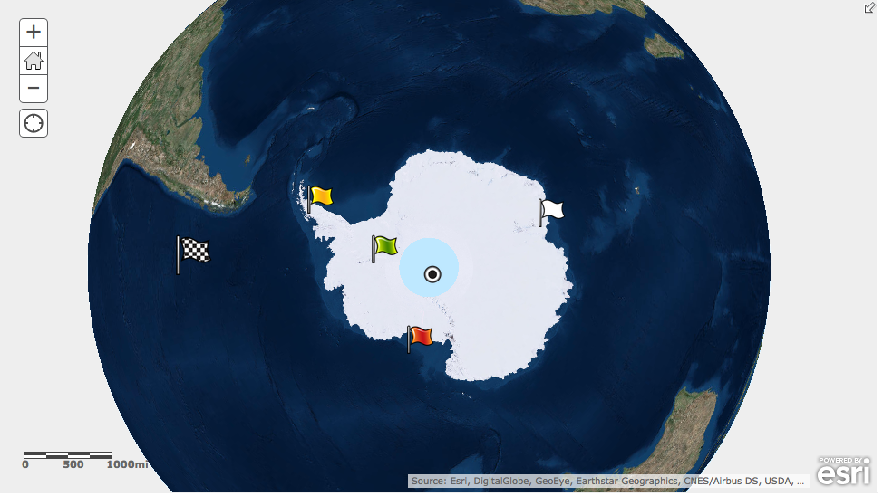

Each of the five sites marked on the map are linked to an image. When you click the image on each popup (indicated with a flag or circle), you will zoom into a larger image via your web browser.

- Click on the yellow flag that represents the Larsen Ice Shelf. A popup window will appear.

- Click on the small image of the Larsen Ice Shelf in the popup to view a larger image and read the caption at the bottom of the photograph to learn more.

- Find out more about what Antarctica looks like by clicking on the other points on the map with the mouse cursor. Read the caption at the bottom of each image. Remember to click on each image in the popup to see the images and captions at a larger size. When you have looked at all the images, close the popup and any tabs that have opened with the larger images.

Task 5: Explore Water World

Antarctica has two major ice sheets: the western and the eastern. The western sheet is smaller than the eastern and covers Antarctica from the Transantarctic Mountains westward. The eastern sheet is on the opposite side of the mountain range and includes the majority of the continent. Both of these enormous sheets of ice are moving from the continental center toward the ocean. For example, as the western ice sheet moves into the ocean, it forms the Ross and Ronne ice shelves, which float on top of the ocean. It is here that the ice begins to break apart and melt.

You will now examine what might happen to the water levels of the oceans if parts of these ice sheets were to melt.

- Pan your map to the east (to the right) and click on the checkered flag on the west side of the Antarctica map.

- Click on the image of the entire world in the popup.

A new map window opens up with a map project. Entitled Module7 Lesson 1 C.

- Close the prior map project entitled Module7 Lesson1 B.

**You can do just the Antarctica session without opening the prior maps by clicking on this link:
http://education.maps.arcgis.com/home/webmap/viewer.html?webmap=416413224be846c1aa2c21135e0749f8

- Click the Show Contents of Map button to display the legend of the map.

OR

- Click in the box next to the Country Outlines layer to turn it on. (You may have to wait a few seconds for the country outlines to appear.)

You see country outlines in the year 2007. You also see a layer named “Antarctica 20K Years.” This layer shows an elevation map of Earth as scientists believe it looked 20,000 years ago. At that time, sea level was 400 feet lower than it is today. The projection of this map is in the Robinson projection that is commonly used for world maps.

- Zoom and pan the map as needed to answer the following question.

- Q4: What significant differences do you see between current landmass outlines and those of 20,000 years ago? List at least three

Task 6: Analyze global sea levels that would result if Antarctic ice sheets melted

If the western ice sheet melted, scientists predict that the oceans would rise about 5 meters. If the eastern ice sheet melted, sea level would rise about 50 meters. If all the ice at the South Pole melted, including all the ice shelves and glaciers, sea level would increase by 73 meters.

- One by one, turn on the layers Today, Plus 5 Meters, Plus 50 Meters, and Antarctic Total Thaw and make observations in the table on your answer sheet.

Remember, ArcGIS Online Map Viewer draws the layers starting with the bottom of the Table of Contents and moves upward. Therefore, a layer that’s turned on at the top of the Table of Contents will “draw over” a layer below it.

- Q5: One at a time, observe the changes on each continent as sea levels rise from those of today to total thaw. Record one observation about each continent in the table on your
Answer sheet.

Task 7: View changes in water levels

- Zoom out to see the entire world. Turn off all layers except Antarctica Plus 50.

- Turn on Rivers and Lakes.

- Center your map view on South America and zoom in as close as you can to answer the following questions. (You may turn the Country Outlines on and off to remind you where you are looking at.)

- Q6: What kinds of changes do you see in the rivers? Provide a specific example.

- Q7: With a sea level increase of 50 meters, what kinds of consequences do you foresee for the major river ecosystems of South America? Provide a specific example.

- Q8: Some inland areas around the globe are below current sea level. One of them is in South America. Hypothesize how these low-lying areas were formed.

Task 8: View changes in political boundaries

The oceans of the world form the coastlines of many nations. You will now focus on coastal boundaries and how the 50-meter rise would affect political boundaries.

- Pan and zoom the map to Southwest Asia.

- Turn on the Major Cities data layer.

The dark blue dots represent cities. Note how some of them are now in the water or on water’s edge.

- Turn on Country Outlines so you can view current country boundaries. Take note of significant changes in the amounts of land remaining in different countries.

- Q9: Predict possible consequences of the 50-meter rise in sea level to the populations living in the Southwest Asia (political disputes, trade and economic issues, transportation problems, etc.). Record those consequences in the first row of the table on the answer sheet.

- Click the Full Extent button (house button). Repeat the process of zooming and identifying potential consequences of the rising sea level for the other major regions of the world (use the Zoom, Pan, and Identify tools as needed).

- Q10: Record your predictions in the table in Q9.

- Q11: List other possible layers of data you might want to analyze to study the impact of rising sea levels.

In this activity, you used ArcGIS Online to investigate the continent of Antarctica. You also explored the potential effect that the thawing of the Antarctic ice sheets would have on the global environment.

