Module 6, Lesson 1
The wealth of nations

Economists generally classify a country as “developing” or “developed” by determining the percentage of gross domestic product (GDP) engaged in each of three sectors of the economy — agriculture, industry, and services. A country with a high percentage of its GDP in agriculture is categorized as developing, while a country with a high percentage of its GDP in services and industry is categorized as developed.

In this activity, you will use maps of percentages of GDP in the three sectors to explore patterns of development around the world. You will also examine two other economic indicators — energy use and GDP per capita — and compare the maps of GDP in economic sectors to the maps of GDP per capita and energy use. You will evaluate whether or not the economic sector criteria are good indicators of a country’s economic status.

Task 1: Open the map

- Launch an internet browser.
- Go to this link:
- http://www.arcgis.com/apps/Compare/storytelling_compare/index.html?appid=a8435ff7778645af958595e18337681e

When the map document opens, you see three maps side by side.

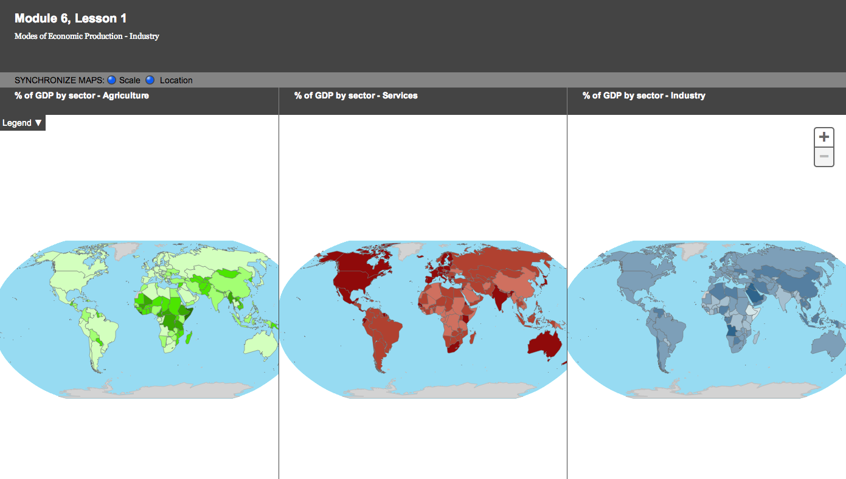

Task 2: Examine the legends and patterns of the maps

GDP is defined by the CIA World Factbook as the “value of all final goods and services produced within a nation in a given year.” The main categories are agriculture, services, and industry.
M61
Remember to think of the percentages of GDP in agriculture, services, and industry as percentages of the total value of goods and services produced in a country and not as percentages of a country’s total workforce.
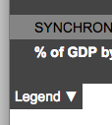
- Turn on and look at the Legends in the Map Information area at the top left of the map viewer window.

Answers to questions in this activity should be recorded on the answer sheet.

- Q1: What do the darkest colors represent?

- Q2: What do the lightest colors represent?

- Study the “% of GDP by sector – Agriculture” map.

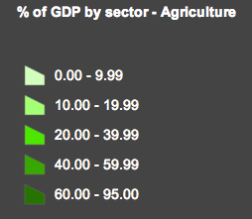
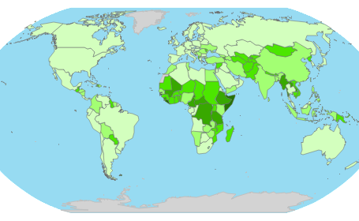
Q3: What is the range of percentages for the darkest color of the agriculture layer in the table of contents?

- Q4: Most countries with >40% of GDP in agriculture are located on which continent?

- Q5: On which continents do all countries have ≤40% of GDP in agriculture?

- Study the “% of GDP by sector – Agriculture” map.

- Q6: On which continents do all countries have >40% of GDP in services?

- Q7: Most countries with ≤40% of GDP in services are located on which continents?

- Q8: What relationship, if any, do you see between the agriculture and services maps?

- Study the “% of GDP by sector – Agriculture” map.

- Q9: Which continent has the most countries with ≤20% of GDP in industry?

- Q10: According to the three economic sector maps and your answers in Q4–Q9, where are most of the developing countries located?

Task 3: Analyze data for Ecuador

- Drag the continent of South America to the center of the “% of GDP by sector – Industry” window.
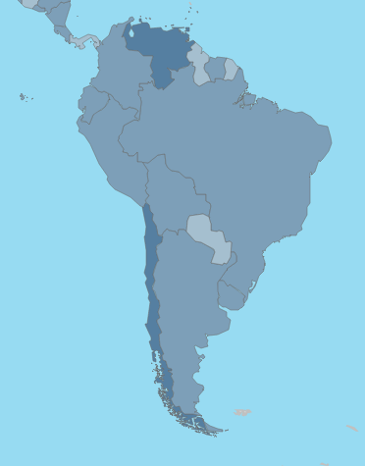
- Double click on South America twice to fill the window.

- Note that all three maps are now zoomed in and centered on South America automatically since SYNCHRONIZE MAPS: Scale radio button is selected.

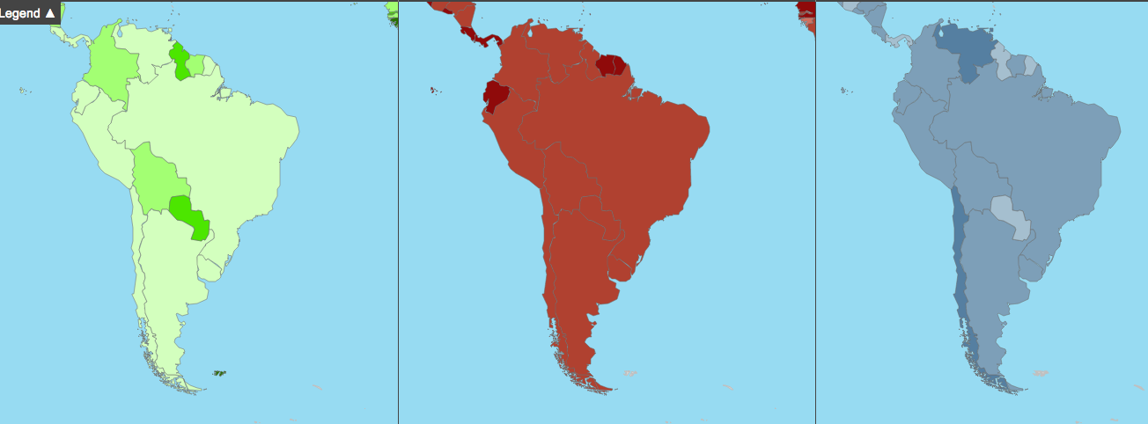

- Click on the country of Ecuador on the northwest portion of the continent. If you don’t find Ecuador on the first try, close the Identify window and click on the country to the north or the south of it until you find the correct country.

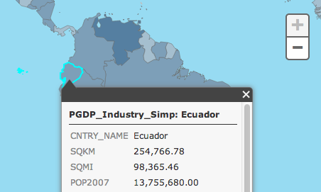

- Pan the map up or down until the entire Identify window is visible.

- Click on Ecuador in the Agriculture and Services windows.

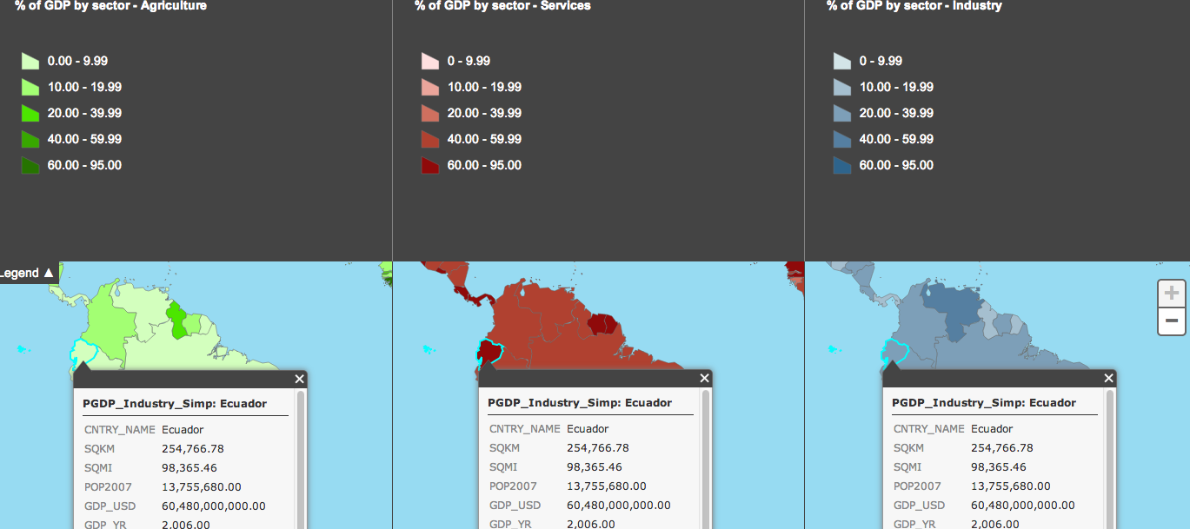

- Scroll down the right side of each of the Identify windows to the rows showing percent GDP in agriculture (PGDP_AG), industry (PGDP_IN), and services (PDGP_SV).

- Q11: What percentage of Ecuador’s GDP is in agriculture?

- Q12: What percentage of Ecuador’s GDP is in industry?

- Q13: What percentage of Ecuador’s GDP is in services?

- Q14: Assuming that a country can be considered “developed” if it has a high percentage of its GDP in industry and services and lower percentages of its GDP in agriculture, would you classify Ecuador as a developed or developing country? Explain.

- Click on the X in the top right of each identify window to close them.

- Q15: Place a check mark for Ecuador under Developed or Developing in the table on the answer sheet.

Task 4: Analyze data for other countries
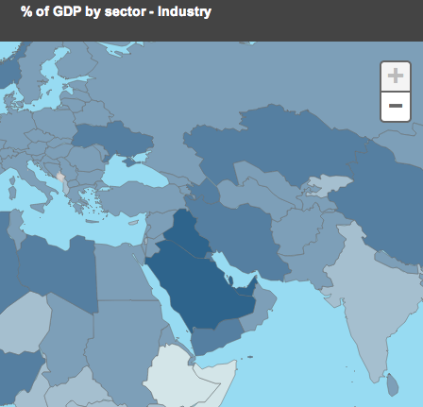
- Pan and zoom the Industry map with the Middle East centered on the map.

Once again, all three maps should adjust to the same scale and location as the Industry map.

- Click on Saudi Arabia in the Industry map and pan the map if you cannot see the entire Identify window.

- Click on Saudi Arabia in the Agriculture and Services maps.

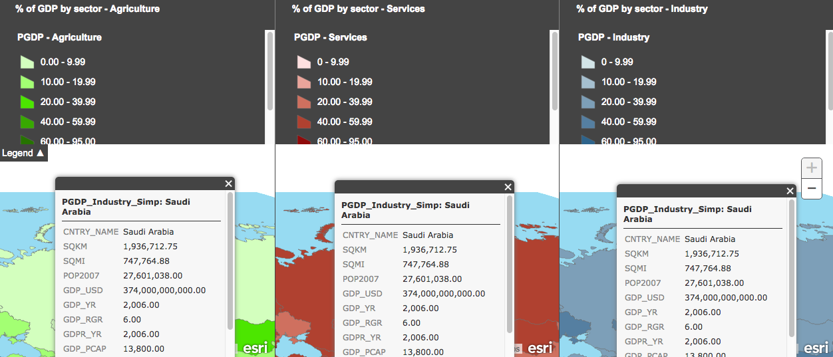

- Q16: Record the category for Saudi Arabia’s percentage of GDP in agriculture in the table in Q15 using the following scale:

Percent | Category
0 – 20 | Low
20 – 40 | Moderate
40 – 100 | High

L1
- Q17: Record the category for Saudi Arabia’s percentage of GDP in industry in the table in Q15.

- Q18: Record the category for Saudi Arabia’s percentage of GDP in services in the table in Q15.

- Q19: Place a check mark for Saudi Arabia under Developed or Developing in the table in Q15 (refer to the criteria given in Q14).

- Q20: Fill in the information for Australia, South Korea, Ukraine, and People’s Democratic Republic of Congo (Congo, DRC) in the table in Q15 (repeat steps 1–5 for each country). (If you don’t know where the countries are, use an atlas to help you find them.)

- Close the Identify windows.

Task 5: Thematically map GDP per capita and energy use

You will now add GDP per capita data and energy use data and determine whether this data supports your initial conclusions about which countries are developed and which are developing.

Remember, GDP is the total value of all goods, services, and products produced in a given country. Typically, developing countries have a low GDP per capita. The total amount of energy consumed in a given country is also an indicator of development. If a country has a low level of energy consumption, it tends to be a developing country. Developed countries are high in both GDP per capita and energy use.

- In a new browser window or tab, go to this link:

http://education.maps.arcgis.com/home/webmap/viewer.html?webmap=e3bc6184b7db4328a4fdcb58dab667cf

- Click on the Modify Map button on the top right corner above your map.

- If you would like to complete this lesson and save your work, click on the Save As button, provide your login and password and provide a new name for your Map. If you do not want to save your work, proceed to Step 21 without clicking on the Save As button.

Note: if you have issues saving your document, go to this link and follow further instructions.
http://education.maps.arcgis.com/home/item.html?id=431f6bc3b0474f5e8933f8ba81bdc925

- Click on the Show Contents of Map at the top of the Contents area on the left of the map.

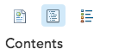
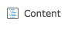

OR

GDP per capita is the gross domestic product per person in a given year (we will use the data for 2007). It is calculated by dividing the GDP of a country by the country’s total population.

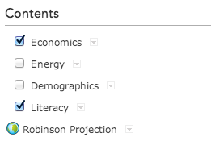
- Turn on the Economics layer in the Contents box on the left.

- Click on the Economics layer and click the Change Style button.

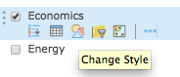

- In the pull down menu for Choose an attribute to show choose GDP_PCAP per the diagram below and click the Counts and Amounts (Color) OPTIONS button.

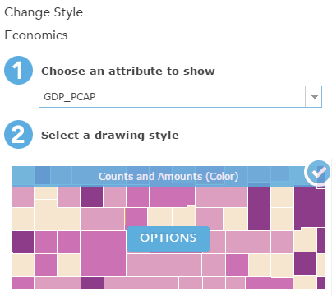

- Scroll down and click the Classify Data box matching the diagram below.

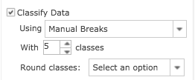

- In the same window, click Symbols. Select the green ramp in the third row and click on Invert color ramp icon (so darkest color represents highest value). Click OK.

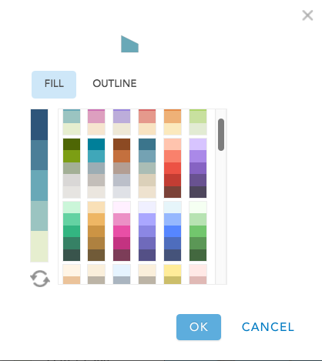
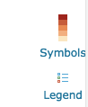
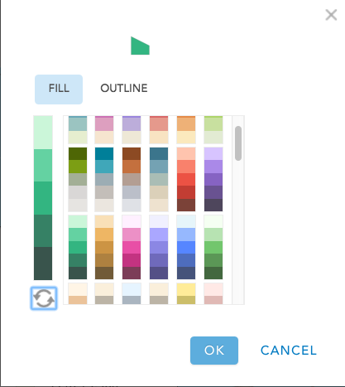

- Do not close the entire Change Style window yet.

GDP per capita values are divided into five groups, or classes. For some countries no data is available for GDP per capita. For those countries, the GDP_PCAP field has a value of –99. Because the value of –99 represents no data, it typically should not be included in the range of GDP per capita values.

- Click on the -99 below the histogram that indicates values from -99 to 69,900.

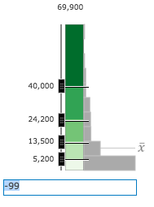
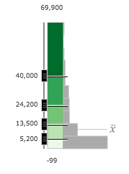

- The lowest value in this GDP per capita data is 0 so type 0 in this field.

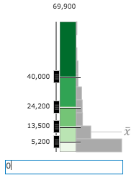

- Place a checkmark in the Draw features with out of range or no value. This will draw any country in gray that has a -99 on the map.

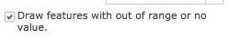

- Your map classification should look like this image.

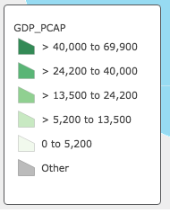

- Click OK to close the Classify window.

- Click DONE to close the Change Style window.

- Click on the layer name Economics and the Show Legend icon to expand the legend. (Note the caption “GDP_PCAP” which is the field header you chose to map.)

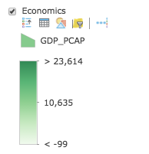

- Turn off Economics - GDP per capita and turn on Energy.

- Repeat steps 23 – 34 using the information below:
- Choose an attribute to show: ENER_USE
- Drawing Style: Counts and Amounts (Color)
- OPTIONS
  - Classify Data using Natural Breaks
  - With: 5 classes
- Draw features with out of range or no value on
- Change -99 to 0
- Symbols: Orange ramp – first row, fifth choice

Task 6: Analyze GDP per capita and energy use data

Now you will take this new data on GDP per capita and energy use into consideration, and you will reevaluate how you classified countries as developed or developing.

- Arrange the two browser windows, Module 6, Lesson 1 A and Module 6 Lesson1 B, so they are side by side or so you can see all four maps.

- On the Module 6, Lesson 1 B, turn off Energy Use and turn on GDP per capita.

- On both Module 6, Lesson 1 B and 1 A, navigate to and zoom in to Ecuador.

- Q21: What is Ecuador’s GDP per capita?

- Turn off GDP per capita and turn on Energy Use.

- Q22: What is Ecuador’s annual amount of energy use?

- Q23: Based on this new information, should Ecuador be classified as a developing or developed country?

- Q24: Why does energy use increase when a country develops?

You will now look at GDP per capita and energy use data for the other countries that you earlier classified as developing or developed.

- Q25: Complete the table on the answer sheet (repeat items 1–3 for each country). Categorize countries with <$16,000 as low GDP/capita and countries with <11 quadrillion BTUs as low on energy use.

- Q26: Name a country that you classified in Q15 as developed on the basis of economic sector data and in Q25 as developing on the basis of GDP per capita and energy use data.

- Q27: Based on the data you collected on these six countries, do you feel that the economic sector criteria are good indicators of a country’s economic status? Explain your answer.

In this lesson, you used economic sector data to determine whether countries should be classified as developed or developing. You added new data, thematically mapped the data, and reevaluated your previous classifications.

