Module 4, Lesson 1
The March of Time
A global perspective

Lesson overview
Students will analyze the locations and populations of the world’s largest cities from the year 100 CE through 2005 CE, describe spatial patterns of growth and change among the world’s largest urban centers during the past two thousand years, and speculate on possible reasons for the patterns they observe.

Estimated time
Two 45-minute class periods

Materials
- Internet connection with access to arcgis.com and the online map
- Student Instructions document
- Student Answer Sheet document

Objectives
After completing this lesson, a student is able to do the following:
- Describe the locations and sizes of the world’s largest cities over time
- Identify historical events and periods that influenced the locations of cities throughout history
- Explain the ever-increasing pattern of growth among the world’s urban populations in the past two thousand years
- Define agglomeration and how that differs from city proper

GIS Tools and Functions
- Learn more about a selected feature Clear selected features
- Label selected features in a layer
- Move or unselect a graphic label
- View the Legend
- Zoom to the full extent of the map

Module 4: Lesson 1
- Open a map in arcgis.com map viewer
- Turn layers on and off
- Symbolize features by unique symbols
- Zoom to a layer’s extent
- Open the attribute table for a layer

National Geography Standards
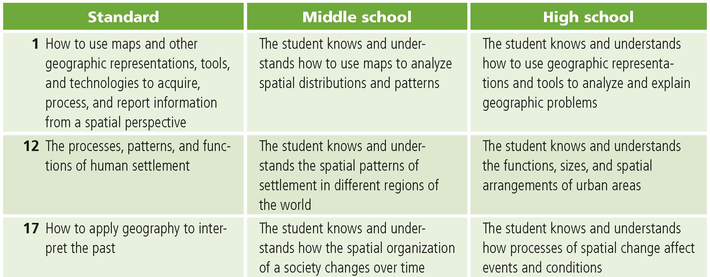

Teaching the lesson

Introducing the lesson
Begin the lesson by briefly reviewing terms defining urban settlements. For example:

A city is a place where many people live close together.

An urbanized area is a cluster of cities, usually a large central city surrounded by some smaller cities.

An urban agglomeration is where many large and small cities have merged into a very large, extended urban area.

A city’s extent can be defined by its legal boundary, as a continuously built-up area, or as a functional area. Explain that in the past, cities had well-defined borders but rapid growth of urban areas in recent history has made it challenging to define their extent and to measure their population. This means that population data collected by different countries or organizations can vary drastically depending on how they define a city’s extent.

Next, divide the students into pairs. Challenge each group to name the ten most populated cities in the world today. After five minutes, each group should share their list with the rest of the class. Use the blackboard or an overhead projector to tally the cities mentioned as each group reports. Based on the tally, circle the cities that were listed most often. Tell the class that they are going to do a GIS investigation that will use real data to identify the 10 most populated cities in the world from the last two thousand years.

Finally, engage students in a discussion about the cities circled on their list.

- What do they know about these cities?
- In what countries are these cities located?
- How many people live in these urban centers?
- Has anyone ever visited one of these cities?
- Can they think of any reasons why some cities grow to be so large?

Student activity
We recommend that you complete the activity yourself before presenting the lesson in class. Doing so will allow you to modify the activity to accommodate the specific needs of your students. If they will not be working on individual computers, be sure to explain any necessary modifications.
Distribute the activity to the students. Explain that in this activity they will use GIS to observe and analyze the locations and sizes of the world’s ten largest cities in eight different time periods from 100 CE to the year 2005 and then examine population density. They will identify changes in both location and size of the world’s largest cities and speculate on possible reasons for the patterns they observe.
The following are things to look for while the students are working on this activity:
- Are the students answering the questions?
- Are students asking thoughtful questions?

Concluding the lesson
Summarize student observations as they share and discuss their observations with the class. Use this discussion as a forum to elaborate on relevant themes in world history (such as the decline of the Roman Empire or the Industrial Revolution) and the value of using geography’s spatial perspective to interpret the past. Ideally, this discussion should take place in the classroom with a projection device that displays the ArcGIS.com map as students discuss it. If this is not possible, you might want to conduct the discussion while students are still working on the computer.

Middle School Assessment.
Students will create a line graph of the most populous cities for the time periods studied and use the graph as a reference for writing an essay comparing two of the time periods. The essay will illustrate their understanding of the changes in spatial patterns of major population centers.

Extending the lesson
Challenge students to try the following:
- Explore the relationship between physical characteristics of the landscape and the locations of the world’s most populated cities exploring layers reflecting world climate data (module 3) and ecoregions data (module 7).
- Conduct research on the historic cities and time periods mentioned in the lesson.
- Reflect on the questions this activity has raised in your mind and conduct further research and spatial analysis to answer those questions.
- See the “Resources by Module” section of this book’s Web site—www.esri.com/ourworldgiseducation— for print, media, and Internet resources on the topics of population, historical time periods, and ancient cities.

Answer Key

Task 2: Look at cities in 100 CE
Q1. Where are the ten largest cities in the world in 100 CE located on the earth’s surface? Many of the cities are at about the same latitude (north of the Tropic of Cancer, or approximately 30 degrees north latitude). All of the cities are in the Northern and Eastern hemispheres.
Q2. Where are they located in relation to each other? Five of the cities are located on the Mediterranean Sea. All but three of the cities are in Asia. None of the cities is located in North or South America or Australia.
Q3. Where are they located in relation to physical features? All of the cities are located near rivers or near the coast.
Q4. What are possible explanations for the patterns you see on this map? Answers will vary and may include the influence of climate, the extent of the Roman Empire, trade, suitability for agriculture.

Task 3: Find historic cities and identify modern cities and countries
Q5. Complete the information in the table below.
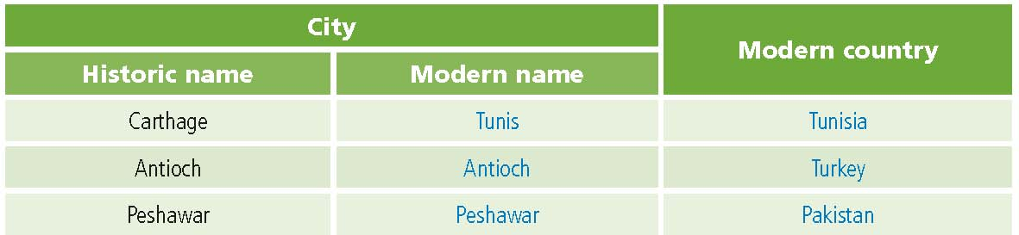

Task 4: Find the largest city of 100 CE
Q6. What’s your estimate of how many people lived in the world’s largest city in 100 CE? Answers will vary.
Q7. What was the largest city in 100 CE? Rome
Q8. What was the population of the world’s largest city in 100 CE? 450,000

Task 5: Look at cities in 1000 CE
Q9. What notable changes can you see from 100 CE to 1000 CE? All the cities have changes from 100 CE to 1000 CE. The Mediterranean Sea is no longer the site of half the world’s largest cities.
Q10. What similarities can you see between 100 CE and 1000 CE? Cities still cluster around 30 degrees north latitude. The population of each of the cities is under 1,000,000. Nearly all of the cities are in Asia. None of the top 10 cities is located in the Americas or Australia.

Task 6: Compare other historical periods and formulate a hypothesis
Q13. Complete the table below.
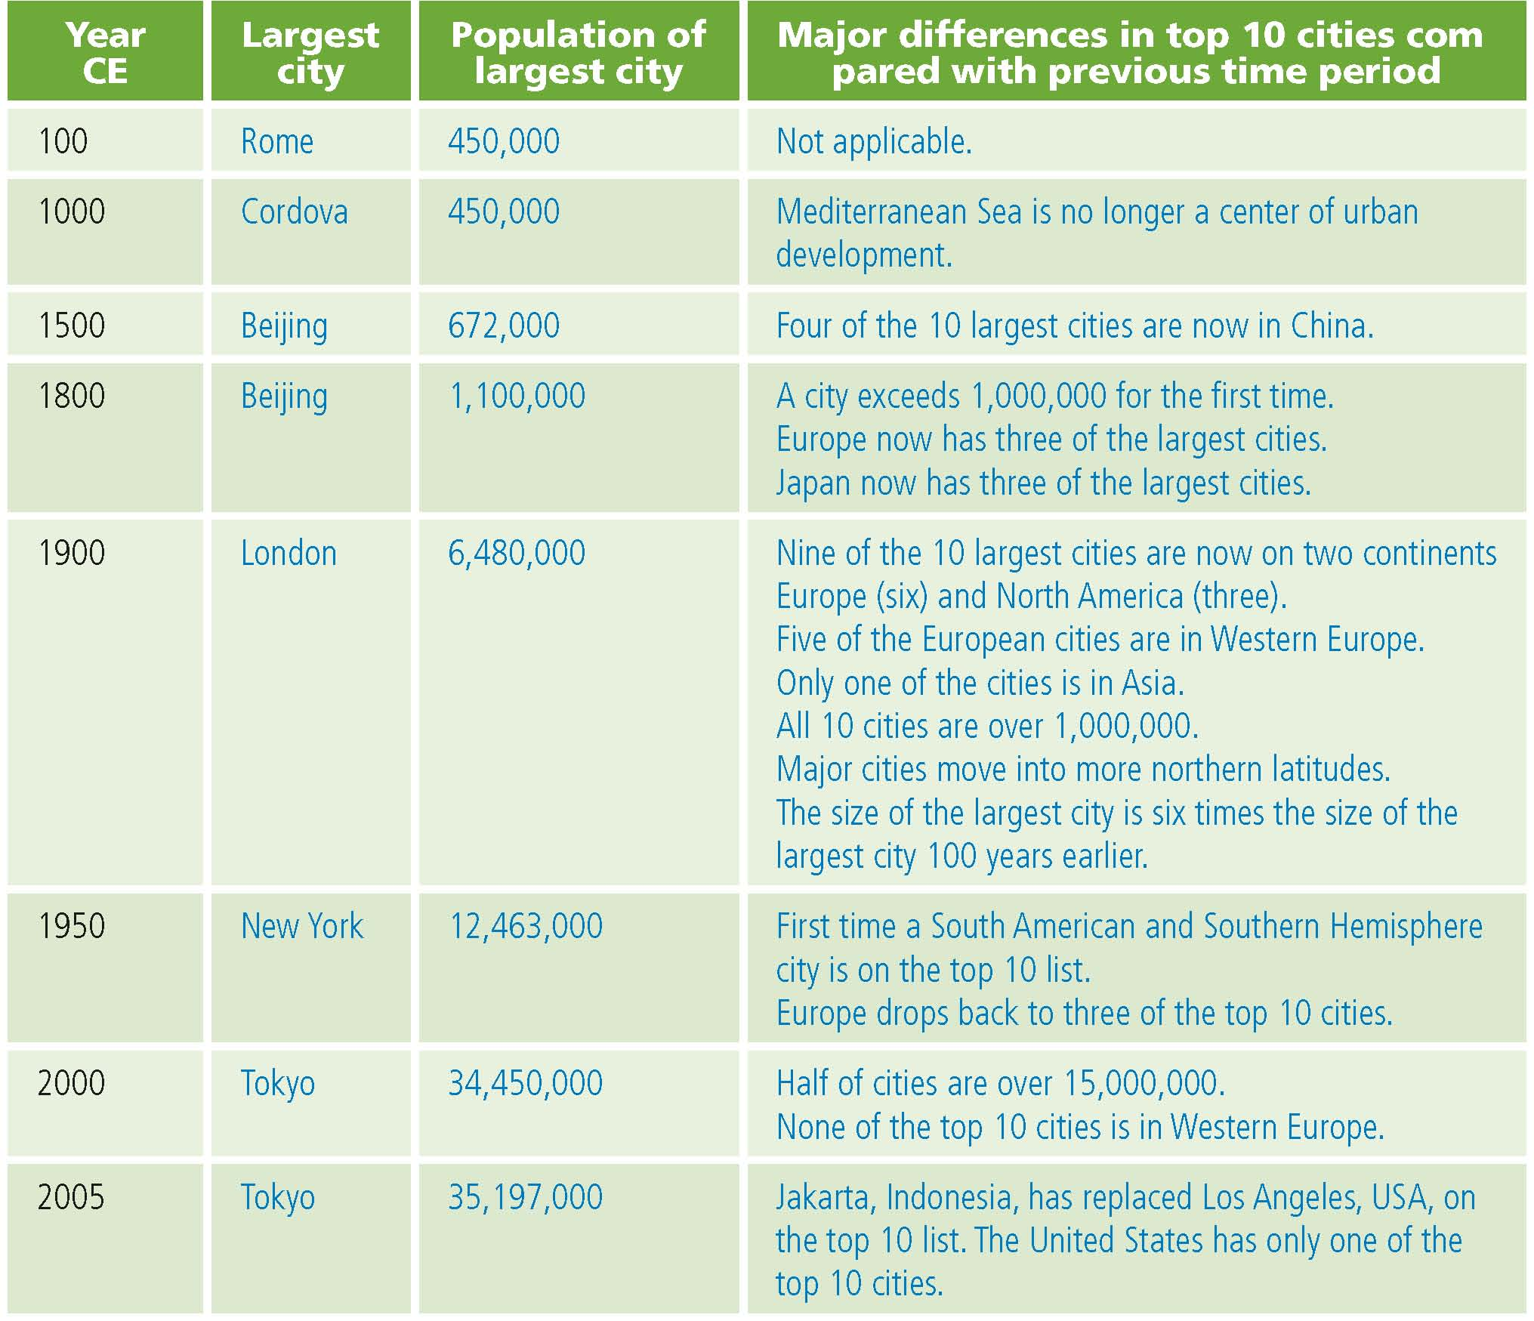
Q14. Using the map document and your answers in Q13, identify historical periods associated with the greatest changes and provide possible explanations for the changes.
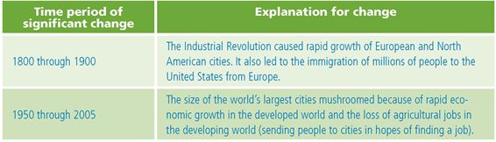

Task 7: Investigate cities in the present time
Q15. How many of your original guesses are among the Top 10 Cities, 2000 CE? Answers will vary.
Q16. Which cities did you successfully guess? Answers will vary.

Q17 How do the top 10 2005 CE cities compare to the population density in the world? Answers will vary.
Q18 Explain why very dark (dense) areas on the population density map might not make the “largest cities” list for today? Answers will vary.
Q19 Based on the population density maps and what you have learned about city growth patterns, what cities will be on the top 10 list in ten years? Answers will vary.

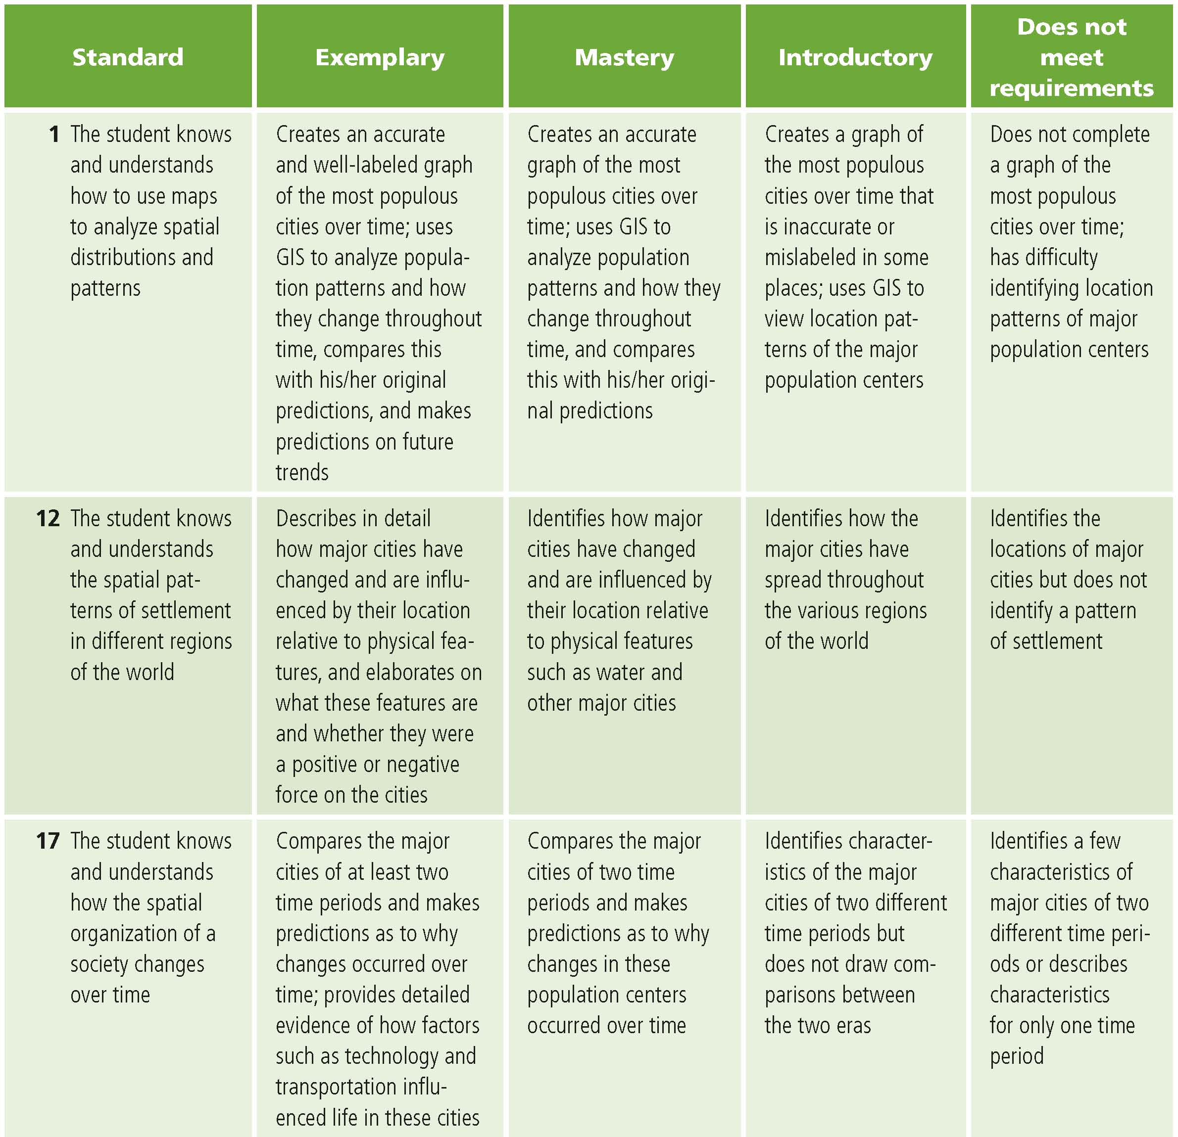
This is a four-point rubric based on the National Standards for Geographic Education. The mastery level meets the target objective for grades 5–8.

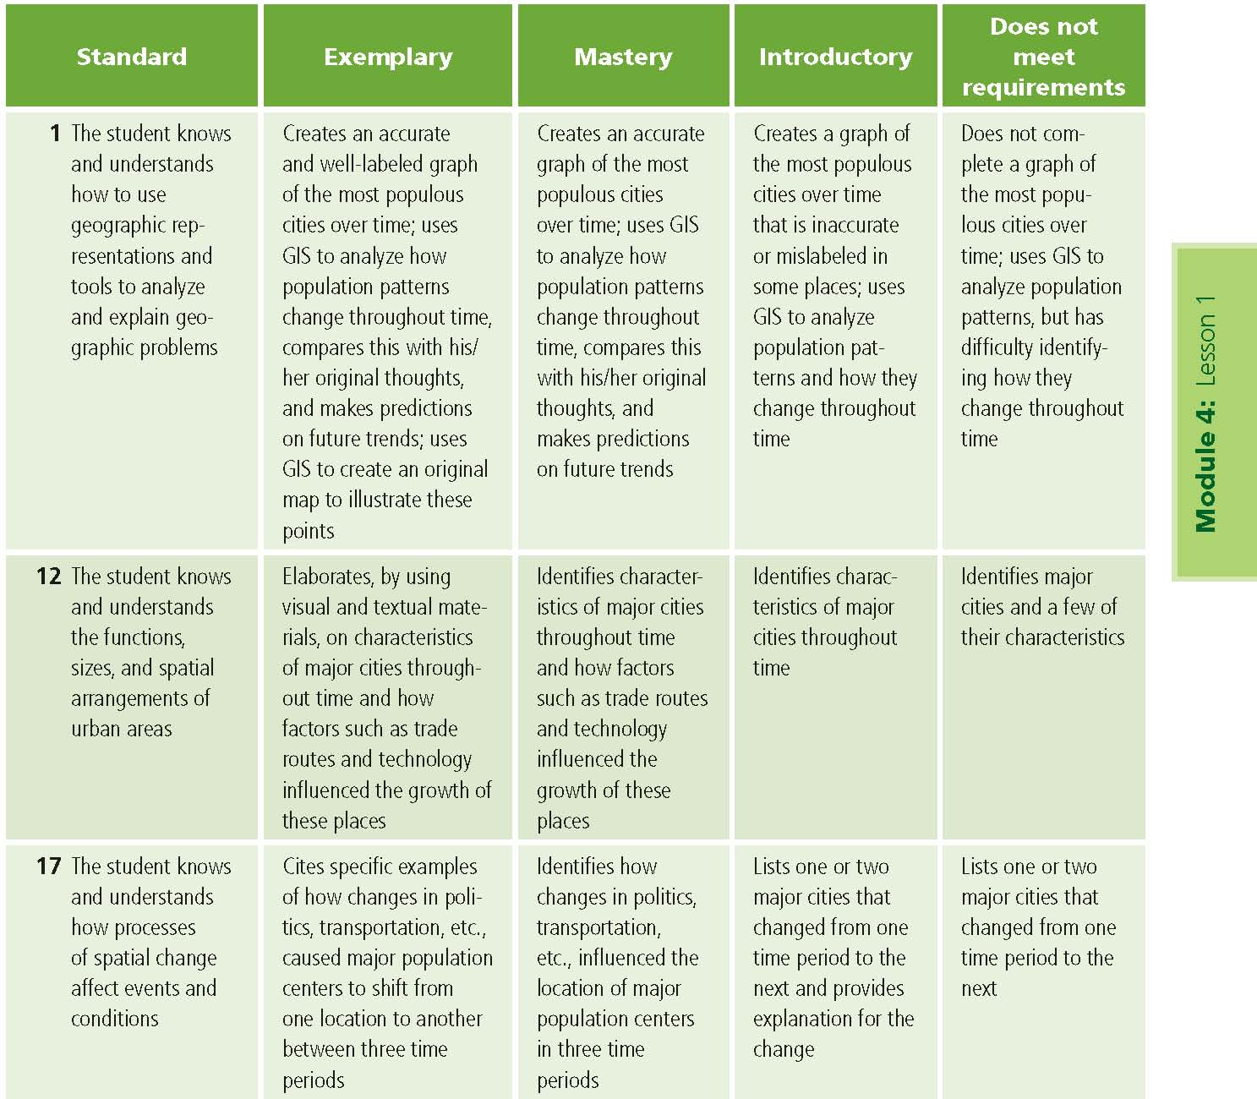

This is a four-point rubric based on the National Standards for Geographic Education. The mastery level meets the target objective for grades 9–12.
