Module 2, Lesson 2
Life on the edge

In this activity, you will investigate the Pacific Ocean’s Ring of Fire, with particular focus on earthquake and volcanic activity in East Asia, where millions of people live with the daily threat of significant seismic or volcanic events.

Task 1: Open the map and identify cities

- Launch an internet browser.
- Go to this link:
- http://www.arcgis.com/home/webmap/viewer.html?webmap=96f0fe57ff1f49f4b0b5306f36953cb2

A map document has been created for you to use in this exercise. When the map document opens, you see a map of much of Asia. The ArcGIS Online map viewer title is in the top left corner of the window.

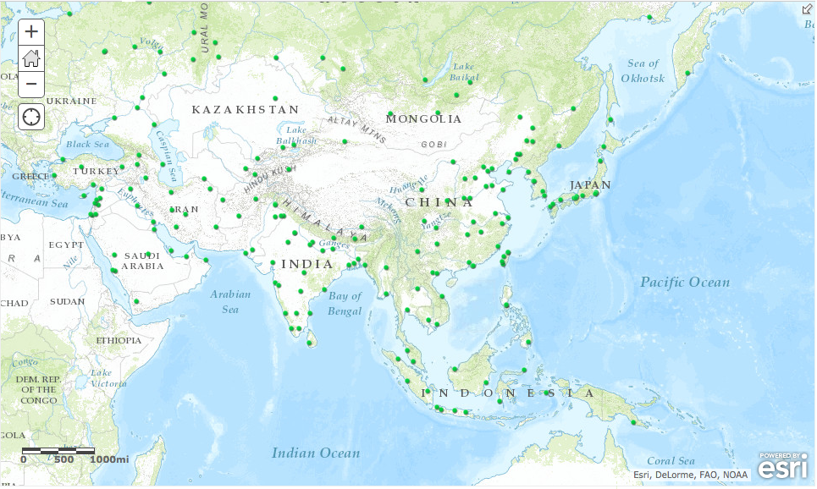

- Click on the Modify Map link on the top right corner above your map.

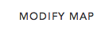

- If you would like to complete this lesson and save your work, click on the Save As button, provide your login and password and provide a new name for your Map. If you do not want to save your work, proceed to Step 4 without clicking on the Save As button.

Note: if you have issues saving your document, go to this link and follow further instructions.
https://www.dropbox.com/s/25g07fiof7ceq9q/Opening%20the%20right%20map.pdf

To identify each city on the map, you simply click on the green dot that represents a city.

- Click on any green dot on the map. The popup box appears similar to the graphic here.

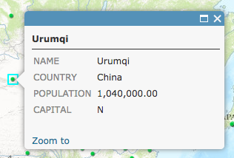

The box tells you the name of the city, the country it’s in, its population, and whether or not it’s the capital city. In the example above, N = No (Urumqi is not the capital of China).

Answers to questions in this activity should be recorded on the answer sheet.

- Q1: Identify one city in India and one in Japan. Record each city’s name and population in the table on your answer sheet.

- Close the popup window by clicking the X in the upper right corner of the window.

Task 2: Look at population density and earthquake magnitudes

- Click on the Show Contents of Map button.

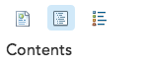
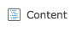

OR

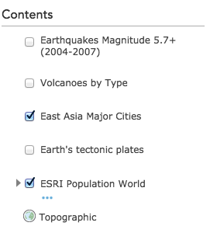
- Turn on the Esri Population World layer by clicking the box next to its name.

A check mark appears, and the layer is drawn on the map. The darker areas on the map represent areas of high population density, as measured by the number of people per square kilometer.

- Q2: Identify two East Asian cities in areas where population density is greater than 250 people per square kilometer (dark red).

- Close the Identify window.

- Turn off the East Asia Major Cities layer by clicking the box next to its name.

- Q3 Describe the general pattern of population density in East Asia.

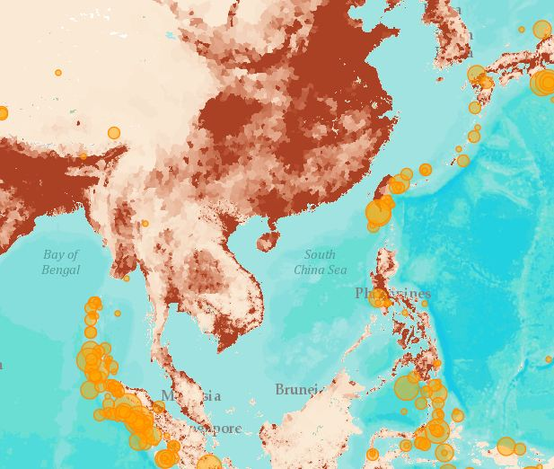
- Turn on the Earthquake Magnitude 5.7+ (2004-2007) layer.

The orange dots indicate earthquake locations, with larger dots corresponding to stronger earthquakes. Only earthquakes with a magnitude of 5.7 or greater on the Richter scale are included in this layer.

- Q4 In general, where did earthquakes with a magnitude of ≥ 5.7 occur?

- Q5 Did these earthquakes occur near densely populated areas? Where?

Task 3: Measure the distance between active volcanoes and nearby cities

- Turn off the Earthquake Magnitude 5.7+ (2004-2007) layer.

- Turn on the Volcanoes by Type and East Asia Major Cities layers.

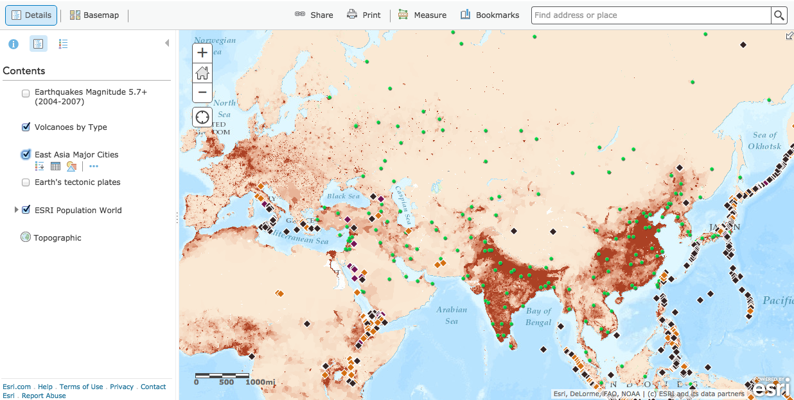

- Hover over the layer name Volcanoes by Type and click on the Show Legend icon to expand the legend.

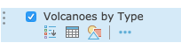

The volcanoes are grouped in three types: active, potentially active, and solfatara state (venting primarily hot gases). Note the different symbols used for each type of volcano.

- Choose a city that’s located near an active volcano.

- Zoom In to get a closer look.

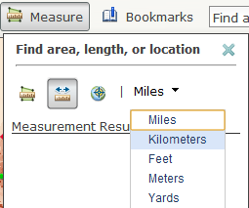
- Use the Measure tool to determine the distance between the active volcano and the city. Click the Measure tool, select the ruler and select Kilometers as the units.

- Click the active volcano that is close to your chosen city. Now move your mouse pointer over to the city. A line is attached from the point where you first clicked to where you move your mouse pointer. (Move your map if the Measure window is covering up your city.)

- Once you have reached the city, double-click to end the line. The distance in kilometers appears in the Measure box.

If you accidentally clicked the wrong spot, you can double-click to end the line and start over.

- Use the Measure tool to determine the distance from other cities to nearby active volcanoes.

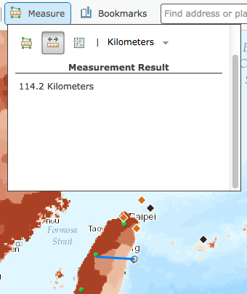

- Q6: What is the closest distance you found between an active volcano and a city? Record that city, the volcano, and the distance between them.

- Q7: Are there many active volcanoes located close to cities?

- Q8: What patterns do you see in the locations of volcanoes, and how do they compare with the earthquake patterns? (Turn the Earthquake Magnitude layer on and off as needed.)

- Next to the measure tool, click Bookmarks, and click East Asia. This takes you back to the view of East Asia.

Task 4: Look at plate boundaries

- Turn off all layers and turn on the Earth’s Tectonic Plates layer.
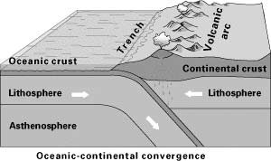
- Click on the plates to discover their names.

- Q9: Record the names on the Supplement map.

Many of the plate boundaries around the Pacific Rim have areas called subduction zones, where one plate is diving underneath another one. Subduction zones can be identified by underwater trenches and island arcs, which are formed at these boundaries.

To get a closer look at physical features at plate boundaries, you will add world imagery. This is a composite satellite image of the earth. It will allow you to see physical features in detail.

Task 5: Add imagery

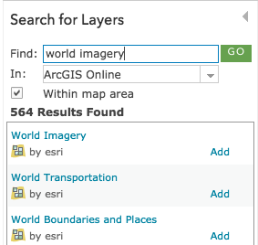
- Turn off the Earth’s Tectonic Plates layer.

- Click the Add Content to Map button.

- Select Search for Layers.

- Type world imagery in the search field and click Go.

- Make sure that ArcGIS Online is selected in the In: box.

- Click Add next to the World Imagery by Esri layer and click on Done Adding Layers. The image is displayed beneath the cities and plates layers.

Find areas where subduction may be occurring. Remember, subduction zones are characterized by deep trenches and volcanic-island arcs and occur along plate boundaries. Turn the Plate Boundaries layer on and off as needed.

- Q10: On the Supplement map, draw the zones of subduction.

Task 6: Investigate your map

- Use the Zoom button to get a closer look at all the physical features on the World Imagery map.

- Turn Volcanoes by Type and Earthquakes Magnitude 5.7+ on and off as needed to identify the names of volcanoes or cities near plate boundaries.

- Explore one of the plate boundaries in detail, identifying cities and physical feature in its vicinity.

- Q11: Record the name of the plate you investigated. List three cities and three physical features in the vicinity.

In this lesson, you used different layers to determine where earthquakes and volcanic eruptions are likely to occur in East Asia. You were then able to identify cities at risk.

