Module 5, Lesson 1
Crossing the Line

Boundaries are invisible lines on Earth’s surface. They divide the surface area into distinct political entities. In this activity, you will use GIS to investigate different types of international boundaries, explore the implications of various boundary configurations, and observe boundary changes that occurred in recent years.

Task 1: Open the map

- Launch an internet browser.
- Go to this link:
- http://www.arcgis.com/home/webmap/viewer.html?webmap=38bd2ee61fef42e3b22b1aecc33800cc

The map document opens, and you see a satellite image of the world.
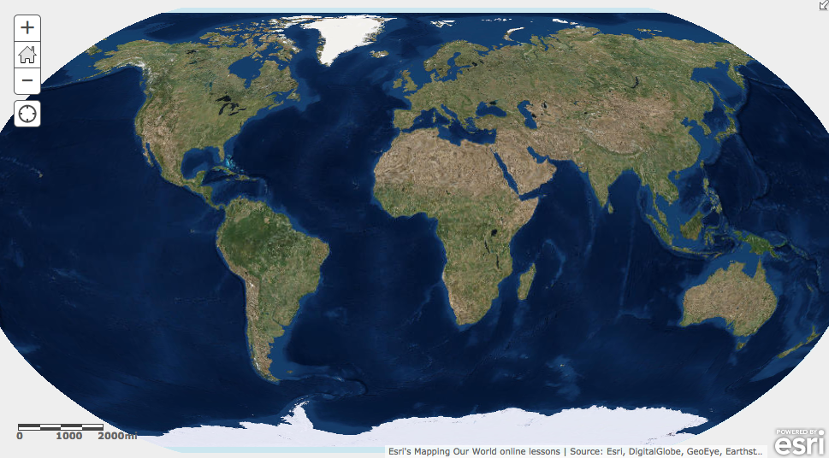

- Click on the Modify Map button on the top right corner above your map
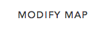

- If you would like to complete this lesson and save your work, click on the Save As button, provide your login and password and provide a new name for your Map. If you do not want to save your work, proceed to Step 4 without clicking on the Save As button.

Note: if you have issues saving your document, go to this link and follow further instructions.
http://education.maps.arcgis.com/home/item.html?id=431f6bc3b0474f5e8933f8ba81bdc925

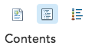
- Click on the Show Contents of Map at the top of the Contents area on the left of the map.
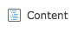
OR

You are now able to see all the map layers available to view with a check mark next to the layer name. The checkmark tells you the World Imagery layer is turned on and visible on the map.

Task 2: Explore mountain ranges as physiographic boundaries

As astronaut Russell L. Schweickart said, “If you could view the world from space, you would see no boundary lines. Boundaries are human-made lines that define the world’s political entities.”

There are several types of boundaries between countries. For example, physiographic boundaries follow landscape features such as mountain ranges or rivers.

- Click on the map and pan until Western Europe is centered on the map.

- Click the plus zoom two or three times. Be sure Europe is still in the center of the map.

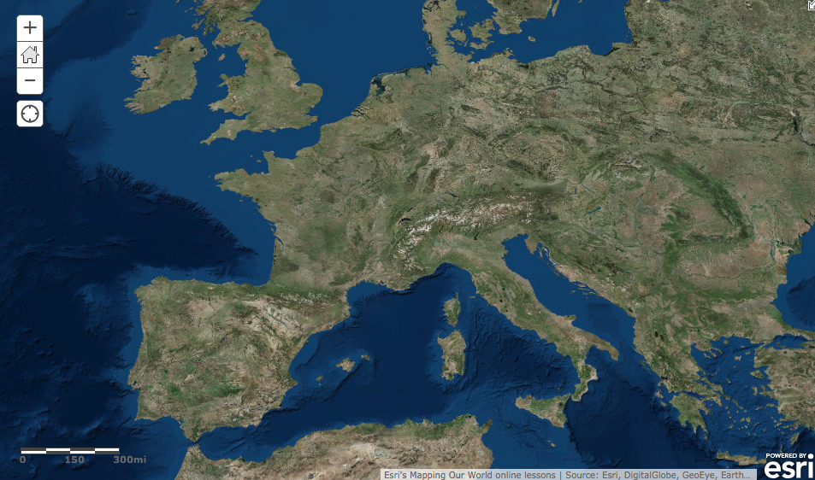

- Turn on and off the World Shaded Relief to see the physical features in greater detail.

Locate Europe’s mountain ranges in the satellite image. Notice that ranges such as the
Pyrenees Mountains in northeastern Spain form a natural boundary. You will use the Add Features tool to draw a line where you see a mountain range forming a natural boundary between different parts of the continent.

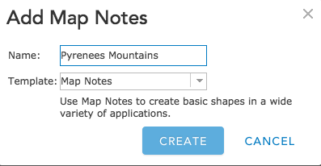
- Click on the Add button and Add Map Notes.

- Change the Name of new layer to Pyrenees Mountains.

- Click on the Create button.

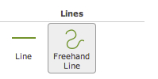
- Click on Freehand Line in the Add Features box to the left of the map.

Now you are ready to draw a physiographic boundary in Europe.

- Click the westernmost end of the Pyrenees Mountains to start your line. While continuously pressing your left mouse button, continue moving along the path of the mountain range until you reach its easternmost edge (you will see a red line as you are moving your mouse). Let go of your mouse button to complete the line.

- A light green line is displayed on the map and a Lines window will pop up. Accept the title and the symbol color by clicking on the Close button. The Lines window will disappear. Click anyplace on the map and the “handles” around the line you drew will disappear. The line you drew will now be visible.

- Click the Edit button in the top left of your screen to exit the Add Features window.

- Turn on the Country Boundaries 2007 layer. You see that your line corresponds to a border between two countries. (Hint: you may have to wait a few seconds for the country layer to draw)

- Click the country that borders the Pyrenees Mountains to the north.

A popup window shows the layer name and the country name. You can also see all the attributes for that country that are in the attribute table.

Answers to questions in this activity should be recorded on the answer sheet.

- Q1: The Pyrenees Mountains are the border between which two countries?

- Uncheck the Pyrenees Mountains layer to turn off the boundary line you previously drew.

- Pan to other Western European countries where physiographic boundaries created by mountains corresponds to actual political boundaries. Click a country to see its information in the Identify window.

- Q2: Complete the table on the answer sheet. Consult an atlas to learn the names of mountain ranges you don’t know.

Task 3: Explore bodies of water as physiographic boundaries

- Turn on the Rivers and Lakes layers.

Wherever countries have physiographic boundaries based on rivers, the red boundary line disappears beneath the blue river on the map. Look closely at Europe to see if you can find any boundaries that are rivers.

- Click a country that has a river as part of a boundary (you may want to zoom or pan the map). Click on the country to identify it.

- Q3: In the table on the answer sheet, record the names of three pairs of countries that share a boundary that’s a river (to identify the names of the rivers, click on the rivers on the map to view its information in the popup window).

Coastlines are also physiographic boundaries. Countries that do not have a coastline are said to be landlocked.

- Zoom or pan so that Western Europe is in your full view.

- Q4: Name three landlocked countries in Western Europe. Use the Identify tool if you don’t know the name of a specific country (remember to have Countries 2007 turned on).

Task 4: Explore geometric boundaries

Another type of boundary is a geometric boundary. Geometric boundaries consist of straight lines that do not correspond to physical features on the earth’s surface.

- Zoom and pan so you can see the entire world map in the map view.

- Pan so that Africa is in the middle of your map and then zoom in on Africa.

You see many rivers that overlap boundaries throughout the African continent.

- Look at the map and locate countries with a shared geometric boundary.

- Click on the countries to view the information about those countries.

- Q5: List three pairs of countries with a shared geometric boundary.

Task 5: Explore anthropographic boundaries based on language and religion

A third type of boundary is anthropographic. Anthropographic boundaries are based on societal characteristics such as language, religion, or ethnicity.

- Turn off Rivers, Lakes, and Country Boundaries 2007.

- Turn on the Languages layer.

- Pan the map and observe the pattern of anthropographic boundaries based on language.

- Q6: Click on the color on the map representing the principal language group in South America and Western Europe. Write these on your answer sheet.

- Hover over and click on the three vertical dots to the left of the Languages checkbox and drag the layer down below the Country Boundaries 2007 layer.

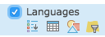
- Then click on the word Languages (shows as a blue link) and the Show Legend icon to expand the legend. The distribution of major language groups in the world is displayed.

- Turn on Country Boundaries 2007.

- Q7: Pan and zoom to locate countries separated by an anthropographic boundary based on language. List three pairs of such countries on the answer sheet.

- Zoom out until you can see all countries displayed on the map. Turn off the Country Boundaries 2007 and Language layers. Click on the Languages Show Legend icon again to collapse the legend.

- Turn on the Religions layer.

- Click on the three vertical dots to the left of the Religions checkbox and drag the layer down below the Country Boundaries 2007 layer.

- Click on the word Religions (shows as a blue link) and the Show Legend icon to expand the legend. The distribution of major religion groups in the world is displayed.

- Observe the pattern of anthropographic boundaries based on religion throughout the world.

- Q8: Use the Identify and Zoom tools to determine the principal religions in North America and Africa. Record them on the answer sheet.

- Turn on Country Boundaries 2007.

- Q9: Pan and zoom to locate countries separated by an anthropographic boundary based on religion. List three pairs of such countries on the answer sheet.

Task 6: Review physiographic, geometric, and anthropographic boundaries

- Q10: List additional examples of countries separated by physiographic, geometric, or anthropographic boundaries for each continent in the table on the answer sheet.

Task 7: Explore the effects of boundary shape, cultural diversity, and access to natural resources

Boundaries define a country’s size and shape, or territorial morphology, which may be related to the cohesiveness of that country. Small compact nations or ones that are circular or hexagonal, for example, are likely to be more united than ones that are elongated or fragmented.

- Close a popup window if one is still open.

- Zoom back to see the whole world again. Turn off all layers except for Country Boundaries 2007 and World Imagery and collapse the Religion legend in the Contents.
- In the Find dialog box type Chile and click the search icon.

- Q11: The table on the answer sheet illustrates six types of countries based on shape and gives an example of each. Chile is listed as an example of an elongated country. Use the Find, Zoom, and Pan tools to locate another example of each type of country. Record the countries in the Example 2 column. Remember, you can use the Identify tool to find the names of countries that you do not know.

Another factor that influences cohesiveness is cultural diversity.

- Zoom out until you see the entire world. Turn on Country Boundaries 2007, if it is turned off, and Languages.

- Q12: Identify three culturally uniform countries on the basis of language group.

- Q13: Identify three culturally diverse countries on the basis of language groups.
L1
Boundaries also influence economic activities. Earlier in this activity, you identified landlocked countries in Western Europe. Historically, these countries were limited in their ability to trade directly with other nations because imports and exports had to pass through other countries en route to their destination.

- Zoom out until you see the entire world. Turn off Languages. Turn on Lakes.

- Q14 Record an example of a landlocked country for each continent listed in the table on the answer sheet. For a continent that does not have a landlocked country, write “None.”

- Close the Find dialog box if it is still open.

Boundaries also influence a country’s economic activities dependent on access to natural resources.

- Zoom out until you see the entire world. Turn on the Oil and Gas layer.

- Zoom and pan to focus on Southeast Asia.

- Q15: Name two Southeast Asian countries that do not have any oil and gas resources within their land borders (pan, zoom and click on countries to obtain information).

- Q16: Name two Southeast Asian countries that have oil and gas resources within their land borders.

- Turn off the Oil and Gas layer.

- Zoom out until you see the entire world.

Task 8: Explore boundary changes that occurred in the 1990s

Political boundaries can change in many ways. A large country may split into smaller ones, small countries may combine to form a larger one, and territories that were once part of one country may be incorporated into another.

- Turn on the 1992 layer.

- The international boundaries from 1992 are displayed as yellow lines.

- Because the Country Boundaries 1992 boundaries cover the Country Boundaries 2007 on the map, the only 2007 boundary lines (red) that are visible are those that did not exist in 1992.

- Q17: Describe three political-boundary changes between 1992 and 2007 (use the Zoom and Pan tools to get a closer look, and the Identify tool to identify countries).

Group A | Group B
Czech Republic (Czechia) | Russia
Slovakia | Belarus
Slovenia | Ukraine
Croatia | Moldova
Bosnia and Herzegovina | Armenia
Serbia | Azerbaijan
Montenegro | Georgia
Macedonia | Kazakhstan
Eritrea | Uzbekistan
 | Tajikistan
 | Turkmenistan
 | Kyrgyzstan
- Q18: Name two countries that existed in 1992 but do not exist in 2007.

Countries in groups A and B below are new countries that have emerged since 1992.

- Q19: Select three countries from group A and three from group B and complete the table on the answer sheet. Use the map and your GIS skills to obtain the information.

- Click on the Save button if you have previously logged into an ArcGIS Online account. If you do not want to save, you can now close the Module5 Lesson1 map tab.

In this exercise, you used ArcGIS online to explore the various types of political boundaries and their impact on the countries they define. You drew a new layer and used the Find, Zoom, and Pan tools to investigate the maps. You observed and analyzed boundary changes between 1992 and 2007.

