Module 6, Lesson 2
Share and share alike

Lesson overview
Students will explore trade between the three countries participating in the North American Free Trade Agreement (NAFTA): Canada, Mexico, and the United States. They will look at exports from each of the NAFTA countries for the past 16 years and use this information to identify trends and to assess NAFTA’s effectiveness. They will create a layout containing a map and graphs that support their opinions.

Estimated time
Two 45-minute class periods

Materials
- Internet access to arcgis.com
- Student instructions
- Student answer sheet
- Student assessments

Objectives
After completing this lesson, a student is able to do the following:
- Explain the concept of trade balance
- Evaluate the effectiveness of NAFTA
- Create a layout displaying the results of the student’s research

GIS tools and functions
- Display attributes for a specific feature
- Select a feature on the map
- Zoom out a fixed amount on the map
- Move elements in a layout
- Move the map to bring a different portion of it into view
- Open the attribute table for a layer
- Open a graph and display data for a specific map feature

National Geography Standards
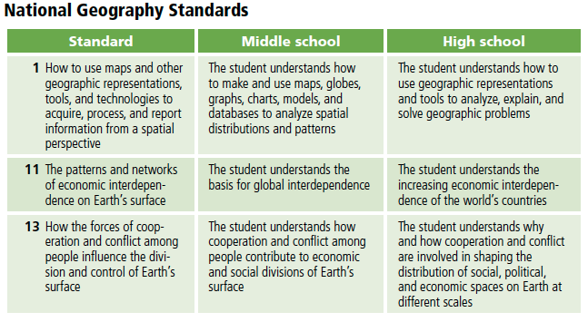

Teaching the lesson
This lesson is intended to supplement a unit on NAFTA. In addition to background information on NAFTA, students should have a working knowledge of basic economics. Make sure they are familiar with the terms trade, imports, exports, trade balance, and tariffs. Basic graph-reading skills will also be essential.

Introducing the lesson
Begin with a discussion of the NAFTA Objectives supplement. Ask students to explain the objectives of NAFTA in their own words. This exercise could be done as a class activity on the board or in groups with several sets of goals being developed. You may want to save the goals so students can refer to them when they evaluate NAFTA near the end of the lesson and in the assessment.

When you are satisfied that students have a basic understanding of NAFTA, discuss the flow of goods into and out of a country and the concept of trade balance. Introduce the following formula for trade balance:

Exports – Imports = Trade Balance

When exports exceed imports, you have a Trade Surplus.
When imports exceed exports, you have a Trade Deficit.

Ask students to predict trade balances for each of the NAFTA countries.

Student activity
We recommend that you complete the activity yourself before presenting the lesson in class. Doing so will allow you to modify the activity to accommodate the specific needs of your students. If they will not be working on individual computers, be sure to explain any necessary modifications.

Explain that in this activity students will create graphs and maps to explore and report on the patterns of trade over the past 16 years between the NAFTA countries. Note that the first three years of data (1991–1993) are prior to the inception of NAFTA. Students will use the graphs to identify whether NAFTA has achieved its goals as outlined in the objectives discussed in class.

The following are things to look for while the students are working on this activity:

- Are students using a variety of tools?
- Are they answering the questions?
- Do they need help with the lesson’s vocabulary?

In Q24 students are asked to save their work according to the teacher’s instructions. This is a good spot to stop the class for the day and to pick up the activity the next day. You might want to let students know in advance how to rename their project and where to save it.

Concluding the lesson
Have students present to the class their layouts and their initial predictions. Ask them to describe the trade balances and whether they think NAFTA has succeeded in achieving its goals. The students should also take a position on whether or not NAFTA should remain in place. Tally up the results and report to the class what their combined opinion suggests.

Middle School Assessment. Students will create and present layouts that illustrate the changing trade balances between Mexico, Canada, and the United States, using maps they have made, graphs, text, and graphics. They will assess whether NAFTA has achieved its goals and take a position on whether it should remain in place, using information in their layouts to support their positions.

High School Assessment. Students will create and present layouts that illustrate the changing trade balances between Mexico, Canada, and the United States, using maps they have made, graphs, text, and graphics. They will assess whether NAFTA has achieved its goals and take a position on whether it should remain in place, using information in their layouts to support their positions. They will also write a paragraph describing how they would change NAFTA to improve or enhance trade for all three countries in the future.

Extending the lesson
Challenge students to try the following:
- Research the history of NAFTA.
- Acquire similar data for the European Union, Organization of Petroleum Exporting Countries (OPEC), and the Organization of American States, and compare and contrast the outcomes of NAFTA and the unification of Europe.
- Research the Central American Free Trade Agreement (CAFTA) and compare it with NAFTA.
- Map the movements of commodities from the NAFTA countries in which they were produced to countries that bought them.
- Go to the Statistics Canada, U.S. Census Bureau, and Instituto Nacional de Estadística Geografía e Informática (INEGI) Web sites to obtain information on total international exports and map it.
- Research employment trends since the advent of NAFTA. Have the NAFTA countries experienced increased employment or unemployment since 1994?

Answer key

Task 2: Examine the map and attribute table
Q1) For which years does the layer contain data? 1991 to 2006

Q2) How many attributes are there for each year? Six

Q3) What was the value of goods and services exported from Canada to the United States in 1991? $91,064,000,000

Task 3: Examine export graphs
Q4) What does each column in the graph represent? Exports from Canada to the United States for each year 1991 to 2006

Q5) Which country exported more goods and services to Canada: Mexico or the United States? United States

Q6) Why does the data display zeros in some of the fields? A country doesn’t export goods to itself.

Q7) What happened to the popup? Only the data for Mexico (the selected country) is displayed.

Q8) How many years of data are represented on the graph at the bottom of the popup? 16

Q9) What year does the first bar on the left represent? 1991

Q10) Look at the numbers on the y-axis. Are the numbers on the graph in thousands, millions, or billions of dollars? (Remember that the attributes of the NAFTA Countries values are in millions of dollars.) Millions

Q11) Looking at the graph, how would you describe the trend of Mexican exports to Canada over the 16-year period? The exports increased significantly.

Q12) What was the approximate value of Mexican exports to Canada in 1991? $2,300,000,000 ($2.3 billion) In 2006? $14,000,000,000 ($14 billion)

Q13) Approximately how many times greater is the 2006 amount of Mexican exports to Canada than the 1991 amount? 6

Q14) How would you describe the trend of Mexican exports to the United States over the 16-year period? They increased significantly.

Q15) Approximately how many times greater is the 2006 amount of Mexican exports to the United States than the 1991 amount? 6 or 7

Task 5: Examine a trade balance graph

Q16) Did Mexico have a trade surplus or deficit with the United States for 1992? Deficit

Q17) What was the approximate value of the trade balance for 1992? $–5,000,000,000 ($–5 billion)

Q18) What was the first year that Mexico exported more to the United States than it imported from the United States? 1995

Q19) Describe the trend of Mexico’s trade balance with the United States over the
16-year period. Small deficits in 1991–1994; significantly increasing surpluses in 1995–2006.

Q20) Did Canada have a deficit trade balance with the United States anytime during the
16-year period? No

Q21) In 1998, was Canada’s trade balance with the United States greater, smaller, or about the same as Mexico’s? About the same

Q22) In 2006, was Canada’s trade balance with the United States greater, smaller, or about the same as Mexico’s? Greater

Q23) What was the exact value of Canada’s trade balance with the United States in 2006? $72,836,000,000 surplus

Q24) Write the map document’s new name and location.

Document Example ABC_Region6

Location Example ArcGIS Online personal folder name “Module 6 Lesson 2”

Task 6: Evaluate the effectiveness of NAFTA
Q25) Determine from the graphs the approximate value of exports in 2006 for each pair of countries in the table below. Record the values in the middle column.
Approximate answers are listed in the table.

Direction of export flow | Value of exports  (million $) | Total volume between partners (million $)
United States to Mexico | 135,000 | 335,000
Mexico to United States | 200,000
United States to Canada | 230,000 | 530,000
Canada to United States | 300,000
Canada to Mexico | 5,000 | 20,000
Mexico to Canada | 15,000

Q26) Add the export values together for each pair of countries (for example, exports from the United States to Mexico plus exports from Mexico to the United States). Record the totals in the last column in the table in Q25.

Q27) Rank the trading partners by total volume of trade. Use 1 for the partners trading the most and 3 for the partners trading the least.

United States–Mexico: United States–Mexico: 2

United States–Canada: United States–Canada: 1

Canada–Mexico: Canada–Mexico: 3

Q28) Did NAFTA have a positive (+), negative (–), or neutral (N) effect on trade volume between partner countries?

United States–Mexico: United States–Mexico: +

United States–Canada: United States–Canada: +

Canada–Mexico: Canada–Mexico: +

Q29) Do you think that any one of these three countries benefited more than the other two from NAFTA? If so, which country? Explain your answer. Answers will vary because students are asked to speculate.

Q30) What country has a healthier trade balance with Canada: Mexico or the United States? Mexico

Q31) On what graph do you find a set of bars that looks like a mirror image of those for the U.S. trade balance with Canada? Trade Balance with U.S.

Q32) What country had the most dramatic change for the better in trade after NAFTA came into being in 1994? Mexico

Q33) Estimate U.S. trade deficits with Canada and Mexico for 2004 and 2006 and record them (in billion dollars) in the table below. Approximate answers are listed in the table.

Trading partner | U.S. trade deficit ($)
 | 2004 | 2006
Mexico | –45 billion | –64 billion
Canada | –66 billion | –73 billion
Combined | –111 billion | –137 billion

Q34) Did the U.S. combined trade balance get better or worse between 2004 and 2006? Worse By how much? $26 billion

Assessment Rubrics

Middle School
This is a four-point rubric based on the National Standards for Geographic Education. The mastery level meets the target objective for grades 5-8.

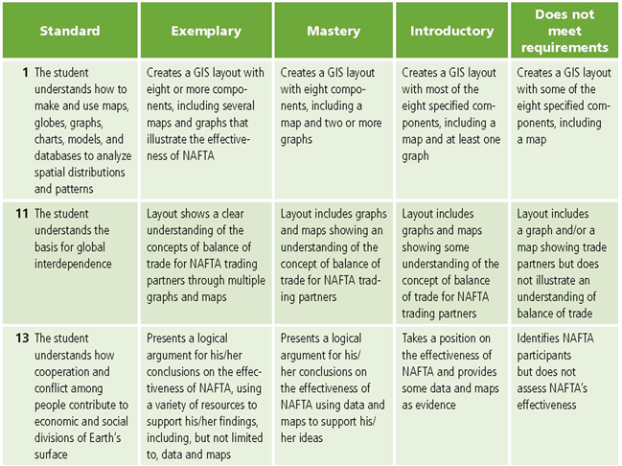

High School
This is a four-point rubric based on the National Standards for Geographic Education. The mastery level meets the target objective for grades 9-12.

