Saving documents, logged in environment
Best practices

In each activity you will use GIS to explore the world with ArcGIS Online, you may wish to save your map for completion or analysis at a different time. To accomplish this, you must complete the following steps prior to starting each Mapping Our World ArcGIS Online activity.

- If you want to save in your account:
- In the Mapping Our World lesson you wish to work on, click on the map link in Task 1.1b.
- Click on the Sign in button on the top right corner of your map and login to your ArcGIS Online account.
- Save the map document into your My Contents area of your account area. If you wish, you can create a folder for your Mapping Our World projects.

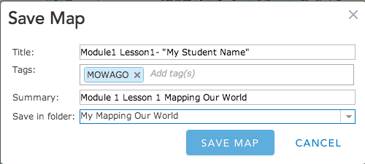

- Start the Mapping Our World activity. Ignore any reference to clicking on the Modify Map button. You will have accomplished that by the login process you just completed.

