Module 7, Lesson 2
In the eye of the storm

October 21, 1998
A tropical storm is brewing in the Atlantic Ocean. It began as a tropical wave a few weeks earlier, off the coast of western Africa. Today it is causing some rain and thunderstorms over the Caribbean. Later, the barometric pressure of the system will continue to drop and it will soon be identified as a tropical depression — the beginning of a hurricane. By the time Hurricane Mitch leaves the Central America region, more than 11,000 people will have died and between 11,000 and 18,000 will be missing.

Task 1: Open the map

- Launch an internet browser.
- Go to this link:
- http://www.arcgis.com/home/webmap/viewer.html?webmap=3651057c935a48ac87052b25c11bfa6c

The map document opens, and you see a map of Central American countries centered on the map.

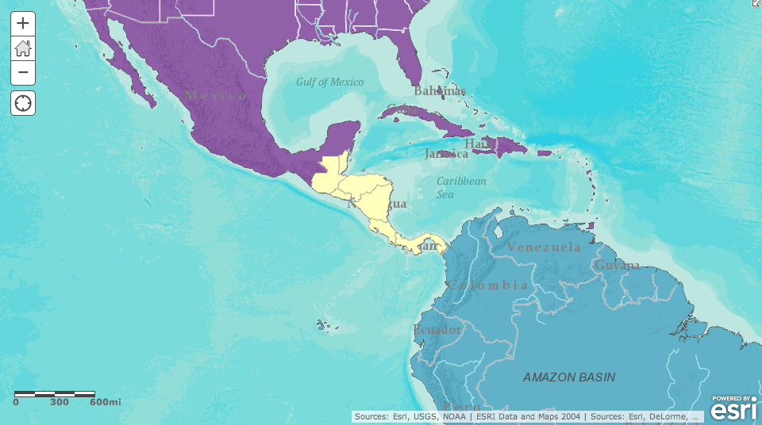

- Click on the Modify Map button on the top right corner above your map.
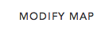

- If you would like to complete this lesson and save your work, click on the Save As button, provide your login and password and provide a new name for your Map. If you do not want to save your work, proceed to Step 4 without clicking on the Save As button.

Note: if you have issues saving your document, go to this link and follow further instructions.
http://education.maps.arcgis.com/home/item.html?id=431f6bc3b0474f5e8933f8ba81bdc925

- Click on the Show Contents of Map at the top of the Contents area on the left of the map.

OR

- Scan down in the Contents on the left side of the map.

Check marks next Central American Countries, Continents, and Terrain with Labels tell you that these layers are turned on and therefore are displayed in the map view. (You cannot uncheck a basemap “Terrain with Labels”.)

Answers to questions in this activity should be recorded on the answer sheet.

Task 2: Identify the capital cities of Central America

- Click on the Central American Countries layer name, click the three ellipses that appear, and click Zoom to. The map centers on Central America.

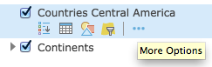

Before looking at the effects of Hurricane Mitch, you will collect data on Central America prior to Mitch.

- Turn on the Capitals layer by clicking the box next to the layer name.

You can find the names of the capitals by clicking on the star for each capital.

- Q1: Record the capitals of Central American countries in the first column of the table on the answer sheet (if you don’t know the name of a country, click on the country to identify it). The information for the country of Belize has been completed for you as an example of the data you will need to find.

Task 3: Investigate Central America prior to Hurricane Mitch

- Turn on the following layers one by one and analyze the geographic distribution patterns that you see: Populated Places, Railroads, and Airports. (You may need to zoom in and out once if a layer does not display immediately.) Refer to the Task 2 Q1 table on the Student Answer sheet for an example of distribution patterns of populated places in Belize.

- Turn off Populated Places, Railroads, and Airports.

- Q2: Fill in the Populated places Distribution column and the two Transportation columns in the table in Q1.

Remember, layers that are near the top of the Contents and some layers will cover up layers that are listed lower in the Contents. Turn on each layer individually to see it clearly. Click on each country to see the country name.

Three layers of data will be explored next; Agriculture, Precipitation, Terrain with Labels.

- Turn on Precipitation layer.

The annual precipitation data appears on the map and you can view each country’s average precipitation data.

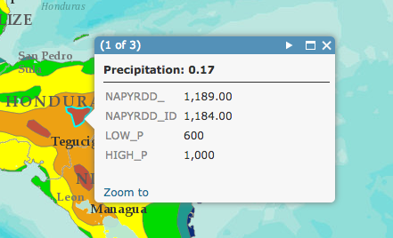
- In each country, click on each area of precipitation to see how many millimeters of rainfall there was in that area of the country.

- Q3: Analyze the annual precipitation for each country and fill in the Precipitation column in the table in Q1.

- Turn off Precipitation and turn on Agricultural Use. Analyze the types of agricultural use of each country.

- Q4: Fill in the last column in the table in Q1.

- Q5: Which country has the largest proportion of its area devoted to crops?

- Turn off the Agricultural Use layer.

- Turn off the Central American Countries and Continents layers.

- Zoom in two or three times and observe the mountains on the Terrain with Labels basemap layer.

- Q6: Which country is the most mountainous?

- Zoom in one or two levels and pan to each Central American country so you can view the road networks in country. (Roads are indicated with red lines.)

- Q7: Fill in the Transportation Roads column in the table in Q1. Which country has the largest proportion of its territory covered by roads?

- Close this map and continue with Task 4.

Task 4: Track Hurricane Mitch

October 24–26, 1998
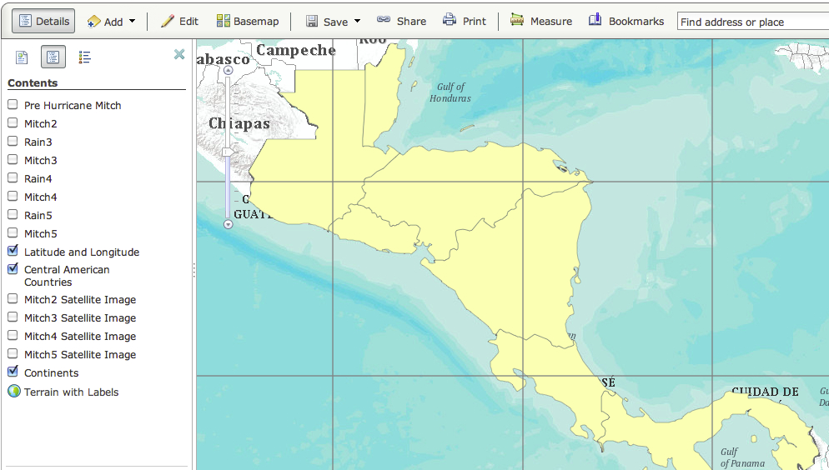
In a span of less than two days, Tropical Storm Mitch develops into a category 5 hurricane with winds in excess of 155 knots (about 180 miles per hour). Category 5 is the deadliest rating on the Saffir-Simpson Hurricane Potential Damage Scale. Barometric pressure dropped to 905 millibars, tying with Hurricane Camille (1969) for the lowest pressure ever observed in the Atlantic basin.

- Launch an internet browser.
- Go to this link:

http://education.maps.arcgis.com/home/webmap/viewer.html?webmap=147d31b4750844f591f4f352ddacf430

If you decided to save your map earlier, you should still be logged in and can save this map with a new name.

- Click on the Modify Map button on the top right corner above your map.

- Click on the Show Contents of Map at the top of the Contents area to the left of the map.
OR

- The layers Latitude & Longitude, Central American Countries, and Continents are turned on.

- Turn on the Pre-Hurricane Mitch and Mitch2 layers.

- Click the layer names Pre Hurricane Mitch and Mitch 2 (they display as blue links) and then the Show Legend icons to expand the legend for these two layers.

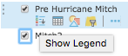
Both of these layers (and similarly named layers to follow) show the locations of the center, or eye, of the storm at different time points. For locations when Mitch was a hurricane, the legend indicates Mitch’s category.

- Click the mouse on the most southeastern dark square representing Tropical Storm Mitch.

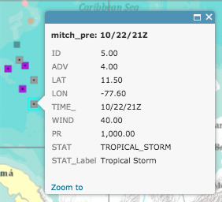
A popup window displays latitude and longitude (LAT and LON), time, wind velocity in miles per hour, pressure (PR) in millibars, and status on the Saffir-Simpson scale. The time is given in the format month/day/hour (24-hour clock); the Z stands for Zulu time, which is the time at 0° longitude, used as a standard reference for anywhere on the globe.

- Q8: When was Tropical Storm Mitch at this location?

- Q9: What was Mitch’s wind speed at this location?

- Click the location of category 1 Hurricane Mitch on the map. (Remember to refer to the legend for Mitch2 to find this location.)The Identify window updates. You may have to close the popup to see the category 1 dot on the map.

- Click on the Measure tool and the Location button to find the latitude and longitude of this location. (The latitude and longitude in the screenshot is not accurate.)

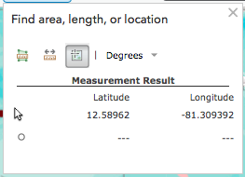

- Q10: What are the latitude and longitude coordinates for Hurricane Mitch at this location?

- Q11: When was Hurricane Mitch at this location?

- Q12: What was Mitch’s wind speed at this location?

- Click the last mapped location of category 5 Hurricane Mitch.

- Q13: When was Hurricane Mitch at this location?

- Q14: What was Mitch’s wind speed at this location?

Now you will determine how much time it took Mitch to develop from a tropical storm to a category 5 hurricane.

- Close any popup windows that are open and the Measure window.

The following table is the attribute table of data for each point in the Mitch2 layer. Scan down the table and note that the two rows that are highlighted indicate the last point where Hurricane Mitch was identified as a tropical storm and the first time it was identified as a category 5 hurricane.
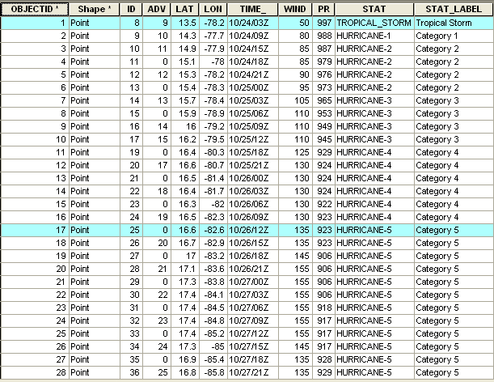

- Q15: How long did it take for Tropical Storm Mitch to become a category 5 hurricane? On the answer sheet, write down the time for each event and determine the time difference. Remember, the time is given in the format month/day/hour (24-hour clock).

- Scan down the column entitled Wind.

- Q16: What was Hurricane Mitch’s maximum wind speed during this period?

Task 5: Measure the size of the storm

National Oceanic and Atmospheric Administration (NOAA), in partnership with the National Aeronautics and Space Administration (NASA), used special storm-tracking satellites to take several high-resolution photographs of Mitch from space. You will view these images and measure the massive size of this storm.

- Turn off the Central American Countries layer and turn on the Mitch2 Satellite Image layer.

Now you can see the highlighted locations of Tropical Storm Mitch and category 5 Hurricane Mitch. The category 5 point is almost directly over the eye of the storm on the satellite image. The eye is the center of the cloud mass and looks like a doughnut hole.

- Turn off Mitch2 and Pre-Hurricane Mitch so you have a better view of the eye of Hurricane Mitch.

- If needed, zoom in one level and pan so the satellite image fills the map display. Do not zoom in too close or the satellite image will disappear.
- Click the Measure tool. In the measure dialog box click the distance button and change the units to Miles.

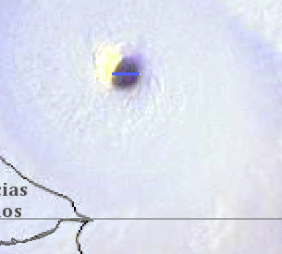
- Click the left edge of the eye once and move the cursor directly across the eye. Double-click when your cursor is at the right edge of the eye (if you accidentally clicked the wrong spot, you can double-click to end the line and simply start over).

The length of the segment in miles appears in the Measurement Result area at the bottom of the Measure box.

- Q17: What is the diameter of the eye of Hurricane Mitch?

- Zoom out until you can see the entire image of the storm and measure the total diameter of the storm at its widest point and the distance between the eye and the coastline of Honduras (zoom and pan as needed).

- Q18: Fill in the first row in the table on the answer sheet.

- Turn off Mitch2 Satellite Image.

Now that you have recorded data for Mitch 2 Satellite Image, you will follow the same procedure for adding the remaining satellite images of Mitch at later time points and measuring the storm as it moved inland. (When the eye reaches landfall, just put “zero” in the distance between the eye and Honduras.)

- Turn on Mitch 3 Satellite Image and repeat steps 30 - 34. Do the same for Mitch 4 Satellite Image and Mitch 5 Satellite Image.

- Q19: Fill in the rest of the table above.

Task 6: Analyze rainfall from Hurricane Mitch

Once Hurricane Mitch made landfall, the winds weakened to the point where it was downgraded to a tropical storm. Nonetheless, Mitch still had not done its worst damage. In the days that followed, Mitch poured more than 30 inches of rain on the region. You will now take a closer look at the precipitation that fell on October 30 and 31, 1998.

- Turn off all layers except Country Outlines and Mitch3 Satellite Image.

- Turn on the Rain3 layer. The rain pattern is overlaid on top of Mitch 3 Satellite Image. Zoom and pan to position map so you can see the entire satellite imagery along with the rain pattern.

- Q20: What pattern do you notice in the amount of rainfall?

- Q21: Is this a pattern you expected to find? Why or why not?

- Turn remaining rain and satellite layers on and off as needed to answer the following questions. (Make sure to turn on Mitch 4 with Mitch4 Satellite Image and Mitch5 with Mitch5 Satellite Image.)

- Q22: What is the highest range of rainfall in the Rain4 layer?

- Q23: Which country received the majority of this heavy rain?

- Q24: Describe the difference between the rainfall patterns on October 30 (Rain4 layer) and October 31 (Rain5 layer).

- Q25: What kind of damage do you expect to find with this type of storm? What aspects of the region will be most affected? Use the table in Q1 as a resource.

In this activity, you used ArcGIS.com map viewer to analyze a large region of Central America and to track Hurricane Mitch as it made landfall. In the assessment you will assume the role of an exchange student living in the Central American region before and after Hurricane Mitch and create a journal describing your experiences.

