Module 5, Lesson 1
Crossing the line

Lesson overview

Students will explore the nature and significance of international political boundaries. Through an investigation of contemporary political boundaries, they will identify boundary types, compare patterns of territorial morphology (size and shape), and explore the relationship of boundaries to national cohesiveness and economic potential. By comparing 1992 and 2007 world political boundaries, students will observe the evolution of boundaries over time.

Estimated time
Two to three 45-minute class periods

Materials
- Internet access to arcgis.com
- Student instructions
- Student answer sheet
- Student supplements
- Student assessments
- a world atlas or map of Europe showing names of mountain ranges (optional)

Objectives
After completing this lesson, a student is able to do the following:
- Define and give examples of physiographic, geometric, and anthropographic boundaries
- Describe the political and economic implications of a country’s size and shape
- Explain the relationship between boundary characteristics and national cohesiveness
- Explain international boundary changes that occurred in the late twentieth century

GIS tools and functions
- Identify a feature to learn more about it
- Zoom in on the map
- Search for layers
- Add layers
- Measure distances between points on the map
- Utilize Bookmarks
- Pan the map to view different areas
- Turn layers on and off

National Geography Standards

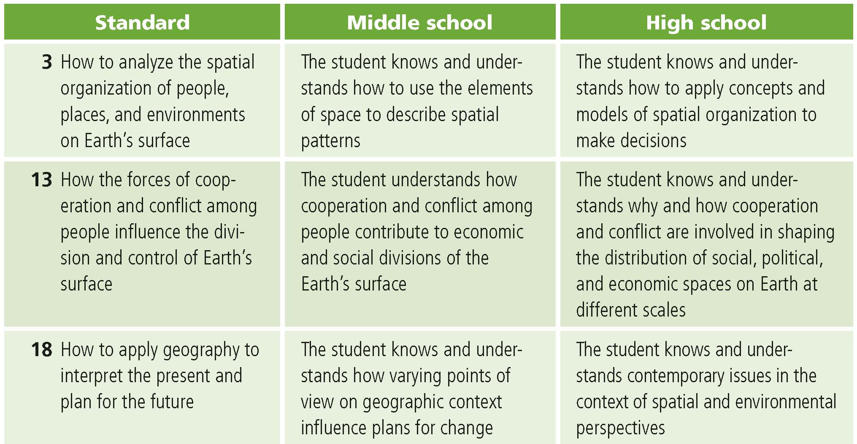

Teaching the lesson

Introducing the lesson
Write the following quotation on the board:
“When you go around the Earth in an hour and a half . . . you look down there and you can’t imagine how many borders and boundaries you cross, again and again and again, and you don’t even see them . . . from where you see it, the thing is a whole, and it’s so beautiful.”
Russell L. Schweickart -Apollo 9, March 3–13, 1969 (From The Overview Effect, 1998)

Use this quotation as a springboard to discuss the following questions:
- What are boundaries?
- Who draws the boundary lines?
- What purpose do boundaries serve?
- If boundaries are invisible lines, how do you know when you’ve crossed one?
- Once you’ve crossed one of these invisible lines, what has changed?
- Can you think of any problems that boundaries may cause?

Throughout the discussion, emphasize that although most boundaries are unmarked and invisible, they determine our perception of spaces and places on the earth. Boundaries between countries help maintain order in the world because they define internationally recognized and sovereign political entities. Conflict can result when boundary lines are disputed. Boundaries are also potential sources of conflict because they are the point of contact between neighboring people.

Challenge students to identify places in the world where international boundaries have changed or are in conflict. What do students know about the reasons for those boundary changes and conflicts? Tell the class that they are going to do a GIS investigation that will explore the characteristics of modern international boundaries and investigate recent boundary changes.

Student activity
We recommend that you complete the activity yourself before presenting the lesson in class. Doing so will allow you to modify the activity to accommodate the specific needs of your students. If they will not be working on individual computers, be sure to explain any necessary modifications.
Distribute the activity to the students. Explain that in this activity, they will use GIS to investigate different types of international boundaries, explore the implications of various boundary configurations, and observe recent boundary changes.
The following are things to look for while the students are working on this activity:
- Are the students using a variety of GIS tools?
- Are the students answering the questions?
- Are students asking thoughtful questions?

Focus on the following aspects of the activity in your discussion:
- Where did students observe the coincidence of political and physiographic boundaries?
- What examples of territorial morphology (country shapes and sizes) did the students find? Ask students to speculate on ways that a country’s size and shape could influence its cohesiveness.
- How can a country’s boundaries influence its economic advantage?
- What kinds of problems are likely to arise when political and anthropographic (cultural) boundaries do not coincide?
- What is the nature of the boundary changes that occurred between 1992 and 2007? Based on student responses in Q21, which of the new countries do students believe are in the strongest position today in terms of cohesiveness?

Middle school assessment. Students have to identify a current international boundary that they predict could change in the next 25 years, prepare a map of the projected boundary change, and describe the impact of the change.
High school assessment. Students have to identify two current international boundaries that they predict could change in the next 25 years (one involving the splitting of a country and one involving a merging of countries), prepare a map of the projected boundary changes, and compare the effects of the changes.

Extending the lesson
Challenge students to try the following:
- Conduct research on world boundary changes during the twentieth century. Use GIS software to prepare a sequence of layouts reflecting those changes.
- Explore the nature of political boundaries in your own community and state. What kinds of boundaries are they? How does the shape of your town or state affect its cohesiveness? What are the economic advantages and disadvantages of your town’s or state’s boundary configuration? How have your town or state’s boundaries changed over time?
- Search newspapers and magazines (both on- and offline) for coverage of border conflicts and related issues around the world. Create a GIS map to illustrate these conflicts.
See the “Resources by Module” section of this book’s Web site—www.esri.com/ourworldgiseducation— for print, media, and Internet resources on the topics of climate and global temperatures.

Answer key
Task 2: Explore mountain ranges as physiographic boundaries
Q1) The Pyrenees Mountains are the border between which two countries?

Spain and France

Q2) Complete the table below:

Countries that have mountain ranges as political boundaries | Mountains that form the boundary
Italy and Switzerland | Alps
Italy and France | Alps
Poland and Czech Republic | Sudeten Mountains

Task 3: Explore bodies of water as physiographic boundaries
Q3) Record the names of three pairs of countries that share a boundary that’s a river.

Countries that have a river as a boundary | River that forms the boundary
France and Germany | Rhine
Romania and Bulgaria | Danube
Romania and Serbia | Danube
Belarus and Ukraine | Dnieper
Switzerland and Germany | Rhine

Q4) Name three landlocked countries in Western Europe.

Possible answers: Switzerland, Austria, Luxembourg, Czech Republic, Slovakia, Hungary, Serbia.

Task 4: Explore geometric boundaries
Q5) List three pairs of countries with a shared geometric boundary.
Possible answers:
Egypt and Sudan
Sudan and Chad
Libya and Chad
Niger and Algeria
Libya and Sudan
Algeria and Mali
Namibia and Botswana
Algeria and Mauritania
Angola and Zambia

Task 5: Explore anthropographic boundaries based on language and religion
Q6) Determine the principal language group in South America and Western Europe.

South America: Indo-European
Western Europe: Indo-European

Q7) Use the Pan and Zoom tools to locate countries separated by an anthropographic boundary based on language. List three pairs of such countries.

Georgia and Russia
North Korea and China
Kazakhstan and Russia
Finland and Sweden
Brazil and Paraguay
Thailand and Laos
Botswana and Zimbabwe
Q8) Determine the principal religions in North America and Africa.
North America: Protestant, Roman Catholic, Indigenous
Africa: Sunni Muslim, Indigenous
Q9) Use the Pan and Zoom tools to locate countries separated by an anthropographic boundary based on religion. List three pairs of such countries.

Possible answers: India and China/Myanmar/Pakistan/Bangladesh
Thailand and Malaysia Vietnam and Cambodia/Laos
Kazakhstan and Russia
Iran and Pakistan/Iraq/Turkmenistan
Finland and Russia
Ireland and United Kingdom
Germany and Czech Republic

Task 6: Review physiographic, geometric, and anthropographic boundaries
Q10) List additional examples of countries separated by physiographic, geometric, or anthropographic boundaries for each continent in the table.

See Q5, Q7 and Q9 for possible answers

Task 7: Explore the effects of boundary shape, cultural diversity, and access to natural resources
Q11) Locate another example of each type of country. Record the countries in the
Example 2 column.

Type of country | Example 1 | Example 2
Elongated | Chile | Vietnam, Panama
Fragmented | Philippines | Indonesia, Japan
Circular/hexagonal | France | Uruguay, Zimbabwe
Small/compact | Bulgaria | Costa Rica, Belgium
Perforated (has a “doughnut hole”) | South Africa | Italy
Prorupted (has a “panhandle”) | Namibia | Thailand, Afghanistan

Q12) Identify three culturally uniform countries on the basis of language group.

Possible answers: Japan, France, Argentina, Italy, Hungary.
Q13) Identify three culturally diverse countries on the basis of language groups.

Possible answers: Canada, Spain, Nigeria, Burkina Faso, Syria, Turkey, India, Sudan, Sri Lanka, Namibia.

Q14) Record an example of a landlocked country for each of the following continents. For a continent that does not have a landlocked country, write “None.”

Continent | Landlocked country
North and Central America | None
South America | Bolivia, Paraguay
Africa | Mali, Burkina Faso, Niger, Chad, Central African Republic, Rwanda, Burundi, Uganda, Zambia, Zimbabwe, Botswana, Lesotho, Ethiopia, Malawi, Swaziland
Asia | Afghanistan, Nepal, Bhutan, Laos, Mongolia, Kyrgyzstan, Tajikistan, Armenia
Q15) Name two Southeast Asian countries that do not have any oil and gas resources within their land borders.

Possible answers: Cambodia, Laos, Vietnam

Q16) Name two Southeast Asian countries that have oil and gas resources within their land borders.

Possible answers: Cambodia, Laos, Vietnam

Task 8: Explore boundary changes that occurred in the 1990s
Q17) Describe three political-boundary changes between 1992 and 2007.

Answers will vary but should focus on the changes in Eastern Europe and the former Union of Soviet Socialist Republics (USSR).

Q18) Name two countries that existed in 1992 but do not exist in 2007.

Possible answers: USSR, Czechoslovakia, Yugoslavia

Q19) Select three countries from group A and three from group B and complete the following table.
Answers will vary. One possible answer from each group is shown here.
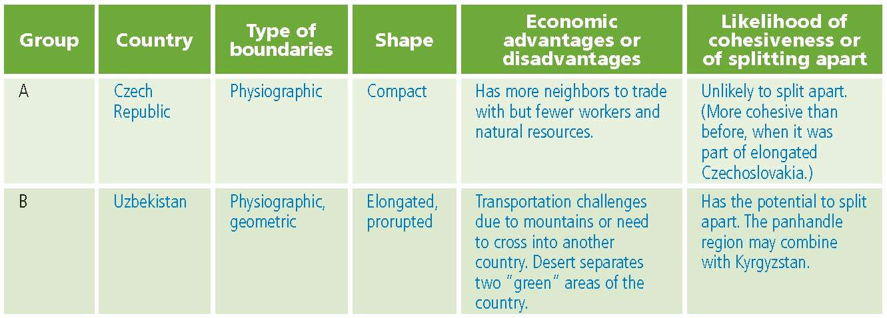

Assessment Rubrics

Middle School
This is a four-point rubric based on the National Standards for Geographic Education. The mastery level meets the target objective for grades 5-8.

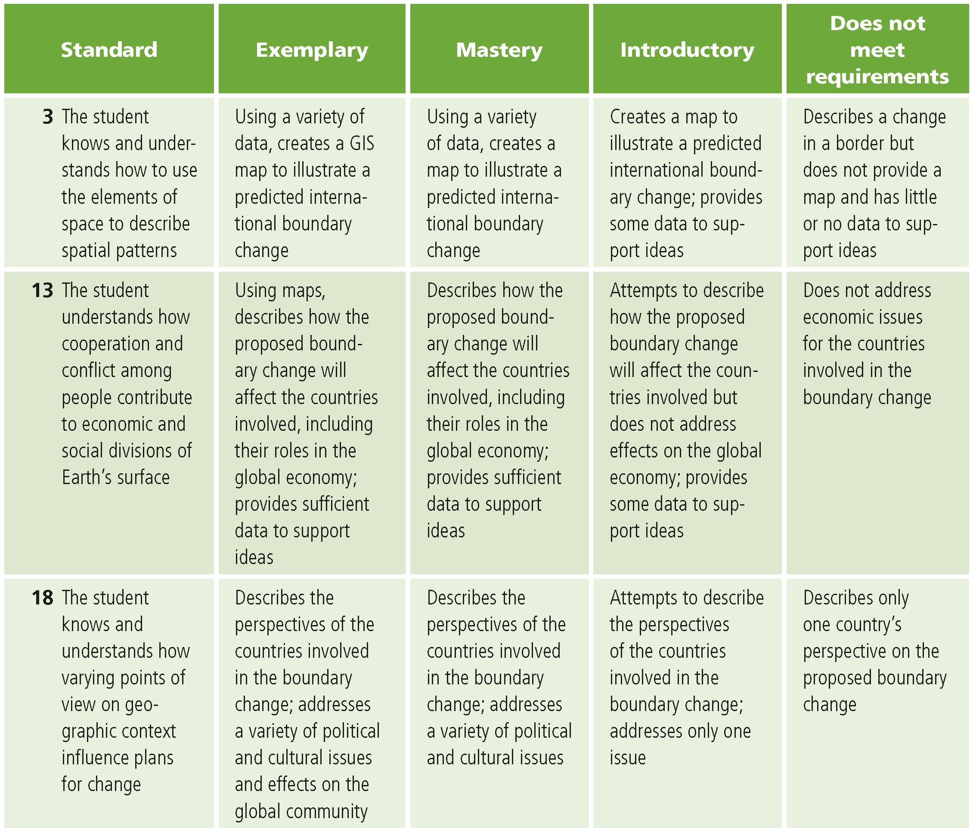

High School
This is a four-point rubric based on the National Standards for Geographic Education. The mastery level meets the target objective for grades 9-12.

