Module 7, Lesson 1
Water world
A global perspective

Lesson overview
Students will investigate changes that might occur to the surface of the Earth if the major ice sheets of Antarctica melted. They will begin their exploration at the South Pole by studying the physical geography of Antarctica. They will consider the consequences of projected changes on human structures, both physical and political. The assessment asks students to create an action plan for a major city that would be flooded in the event of a catastrophic polar meltdown.

Estimated time
Two 45-minute class periods

Materials
- Internet access to arcgis.com
- Student Instructions document
- Student answer sheet document
- Student assessments

Objectives
After completing this lesson, a student is able to do the following:
- Compare locations on a map to photos and satellite imagery using GIS
- Analyze the impact on major human systems (such as transportation networks) that would be caused by the melting of various parts of the Antarctic ice sheet, causing a significant rise in sea level
- Predict how such a catastrophe might change the nature of cities and societies around the world, and propose ways to minimize danger and hardship

GIS tools and functions
- Zoom in and out of the map
- View a hyperlink to an image
- Add layers to the map

National Geography Standards
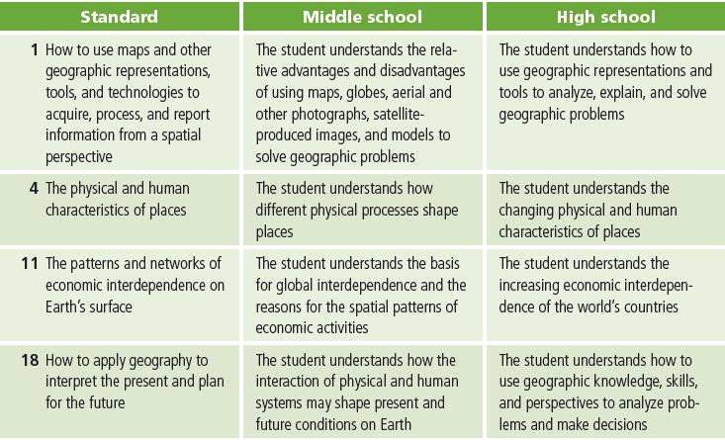dle school High school

Teaching the lesson

Introducing the lesson
Begin the lesson with a discussion of Antarctica. Use these questions as a guide:

- What is the climate of Antarctica like?
- What does the place look like?
- Are there any human settlements there?

After a brief discussion introducing the subject, share with your students some of the work that scientists have been doing in the region. You may want to have students explore some of the Internet sites associated with this lesson on the book’s Web site. These resources provide information on the latest research into snow and ice melt in Antarctica and its impact on mean sea level.

In the activity, students will look at visual representations of the rising sea level and analyze current data about cities and important human structures. They will be challenged in the closing assessment to save a major city from rising floodwaters by using the data they gather in the course of their investigation.

Student activity
We recommend that you complete the activity yourself before presenting the lesson in class. Doing so will allow you to modify the activity to accommodate the specific needs of your students. If they will not be working on individual computers, be sure to explain any necessary modifications.

After investigating Antarctica, students will explore how changes in sea level could affect important human structures. If you have only one class period at computers, you can focus on map projections of Antarctica and stop before task 5 or you can begin at that point if you want to focus on the rise in sea level.

The following are things to look for while the students are working on this activity:

- Are the students using a variety of tools?
- Are the students answering the questions?
- Are the students beginning to ask their own questions?

Concluding the lesson
Briefly discuss the observations students have made on the repercussions of rising sea levels. How similar or different are these observations?

Middle school assessment. Divide students into teams of three. Each team will select (or you can assign to them) a city from a list of those likely to be greatly affected by a 50-meter rise in sea level and create an action plan for relocating the city and its resources. They will focus on basic modes of transportation such as major roads and railways and may also address effects on utilities. Each team should have a leader, a cartographer, and a data expert with the following responsibilities:

- Leader — organizes the group and coordinates creation of the final product.
- Cartographer — primarily responsible for manipulating the GIS and printing any maps for the final product.
- Data expert — focuses on research and determines which data is best to use.

Results can be presented orally, in writing, or in a science-fair-type poster.

High school assessment. Divide students into teams of three. Each team will select (or you can assign to them) a city from a list of those likely to be greatly affected by a 50-meter rise in sea level.

They will then create an action plan to relocate the city, shift the city’s national and international roles to another city, adapt the city to its new environment, or develop another strategy. They must take into account transportation, utilities, economics, and trade relations in their solutions. Each team should have a leader, a cartographer, and a data expert. Results can be presented orally, in writing, or in a science-fair-type poster.

Extending the lesson

Challenge students to try the following:

- Research the affected cities and countries by obtaining additional data from outside sources such as the Internet.
- Create action plans for an entire country. One group could focus on political boundaries, another on transportation, another on export and trade. After each group presents its findings, the class can explore how the different plans would work together.
- Identify a city along the Mississippi River that frequently floods. Research and analyze its flood disaster plans. How could those plans be improved?

See the “Resources by Module” section of this book’s Web site—www.esri.com/ourworldgiseducation—for print, media, and Internet resources on the topic of Antarctica and global warming.

Answer key
Task 2: Look at Antarctica
Q1. Do you think this map gives you a realistic representation of Antarctica? Explain.
Answers will vary but should mention that the map of Antarctica is very skewed in size, shape, and distance.
Q2. Does this projection give you a better view of the South Pole region? Why or why not? No.
The South Pole region is distorted in size.
Q3. Do any of these projections work well for viewing Antarctica? No. None of the projections represents Antarctica in a realistic way.
Task 5: Activate the Water World data frame
Q4. What significant differences do you see between current landmass outlines and those of 20,000 years ago? List at least three. Possible answers: Alaska was connected to Russia,
Florida was much larger; Australia was connected to the islands of Indonesia.
Task 6: Analyze global sea levels that would result if Antarctic ice sheets
melted
Q5. Record your general observations for each layer in the table below.
Possible answers are listed in the table.
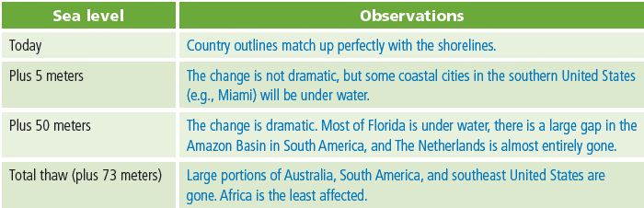
Q6. What kinds of changes do you see in the rivers and lakes? Provide a specific example.
Answers will vary. A large lake in the north-central area is the result of the increased
water level of the Amazon River. The Parana River in Argentina and the Amazon River
are significantly shorter.

Q7. With a sea level increase of 50 meters, what kinds of consequences do you foresee for the major river ecosystems of South America? Provide a specific example.
Answers will vary.
The Amazon River may flood the rain forests of central South America.

Q8. Some inland areas around the globe are below sea level. One of them is in South America. Hypothesize how these low-lying areas were formed.
Answers will vary. One explanation is that plate boundaries are drifting apart at that location. Another is that the land surrounding the Amazon Basin could have risen up due to tectonic activity.

Task 8: View changes in political boundaries
Q9. Predict possible consequences of the 50-meter rise in sea level to the populations living in the Southwest Asia (political disputes, trade and economic issues, transportation problems, etc.). Record those consequences in the first row of the table below. A possible answer is listed in the table below.
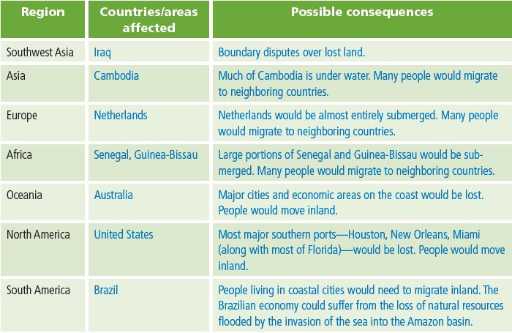
Q10. Record your predictions in the table above. Possible answers are listed in the table above.

Q11. List other possible layers of data you might want to analyze to study the impact of rising sea levels. Answers will vary. See the Assessment table “Data Sources” for a list of available
data.

Assessment rubrics

Middle school
This is a four-point rubric based on the National Standards for Geographic Education. The mastery level meets the target objective for grades 5–8.
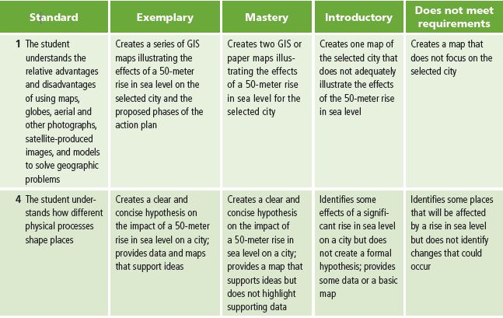
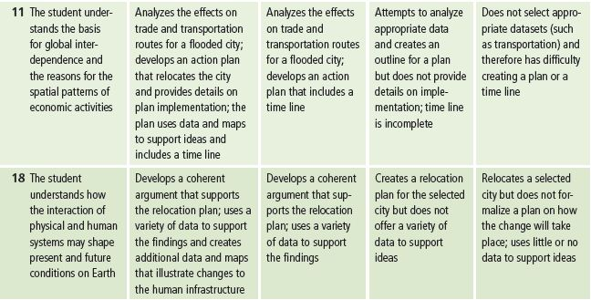

High school
This is a four-point rubric based on the National Standards for Geographic Education. The mastery level meets the target objective for grades 9-12.
