Module 6, Lesson 1
A line in the sand

Lesson overview
Students will look at three modes of economic production—agriculture, industry, and services—as the initial criteria for determining a country’s level of economic development. They will add layers of data representing additional economic indicators—energy use and gross domestic product (GDP) per capita—and draw their own conclusions on how economically developed certain countries are.

Estimated time
Two 45-minute class periods

Materials
- Internet access to arcgis.com
- Student instructions
- Student answer sheet
- Student assessments

Objectives
After completing this lesson, a student is able to do the following:
- Define the three sectors traditionally used to determine the level of economic development
- Evaluate production by sector as a suitable measurement of economic development
- Understand additional economic indicators of economic development: energy consumption and GDP per capita
- Define “developed” and “developing”

GIS tools and functions
- Identify a feature to learn more about it
- Zoom in on the map
- Measure distances between points on the map
- Utilize Bookmarks
- Pan the map to view different areas
- Turn layers on and off

National Geography Standards
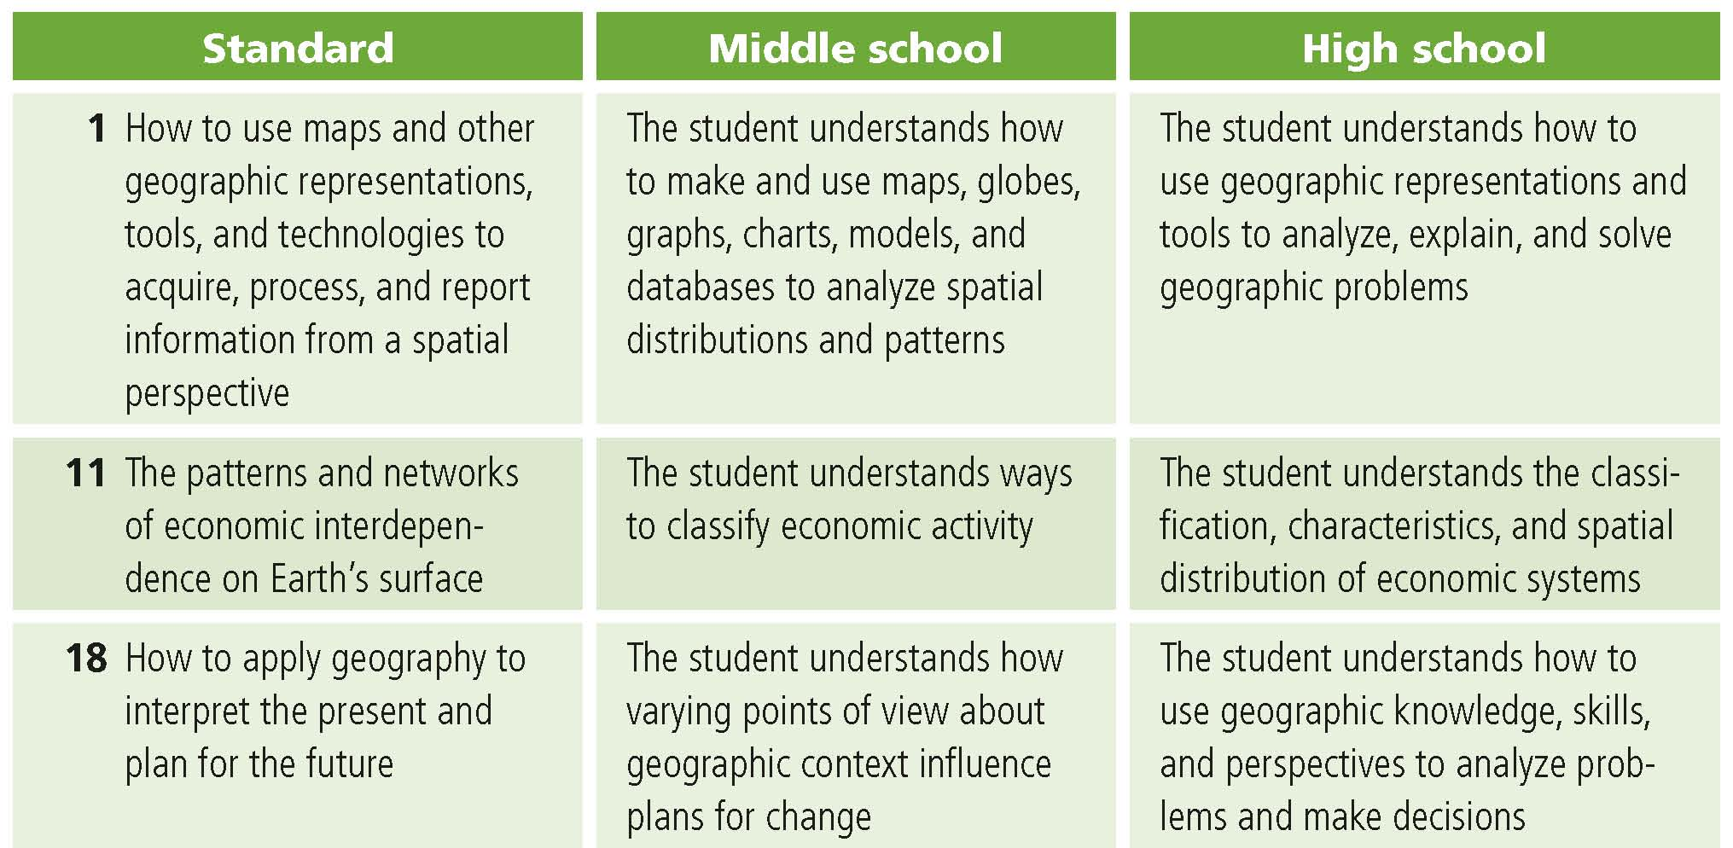

Teaching the lesson

Introducing the lesson
Begin with a discussion of the three economic production sectors: agriculture, industry, and services. Explain to students that economists generally rate a country as developing or developed by how much of its GDP is generated by agriculture, industry, and services. Generally, countries with a high percentage of GDP in agriculture (whether it be subsistence, commercial, or another type) are placed in the category of “developing.”

Ask the following questions to elicit knowledge, beliefs, or ideas your students may already have about countries around the world:

- Name several countries that have a high percentage of GDP in agriculture
- Name a country that has a high percentage of GDP in services
- Which countries do we generally think of as highly industrialized (with high percentages of GDP in industry)?
- What other factors might be helpful in determining whether a country is developed or developing?

Student activity
We recommend that you complete the activity yourself before presenting the lesson in class. Doing so will allow you to modify the activity to accommodate the specific needs of your students. If they will not be working on individual computers be sure to explain any necessary modifications.

Explain that in this activity they will use GIS to explore a region of the world where a boundary dispute has been recently settled after 65 years of conflict. They will explore alternatives for boundaries between the countries involved and analyze the underlying physiographic and cultural considerations that played a part in the resolution of that conflict.

The following are things to look for while the students are working on this activity:

- Are the students using a variety of tools?
- Are they answering the questions?
- Are they experiencing any difficulty managing the display of information in their map as they turn layers on and off?
- Are students experiencing any difficulty plotting latitude/longitude points or finishing their sketch when creating the Saudi–Yemeni boundary line feature?

Concluding the lesson
After the students complete the lesson and the assessment, discuss their findings. If you have time, you can have each group share findings on an overhead projector and explain how they came to their conclusions. Students can also take turns presenting the thematic maps they have created, either in printed format or on a computer projection device from the front of the room. Conclude the lesson by asking the students to explain which factors they feel are most important in deciding if a country is developed or developing and to provide support for their choices. Do they feel this two-class system (developed and developing) is adequate? What alternative or additional classes can they suggest to describe a country’s economic status?

Assessment. Students are asked to choose one country they believe is developed and another they believe is developing. Students will use the thematic mapping skills they have learned in this lesson to map additional indicators and draw conclusions about the two countries. They will write an essay on measuring economic development.

Extending the lesson
Challenge students to try the following:
- Look at jobs advertised in the local newspaper and classify them as agriculture, industry, or services. Which type(s) of employment predominates in your community?
- Research job openings in two counties and compare the counties in terms of percentages of jobs in agriculture, industry, and services.
- Compute GDP per capita for the top 10 trading partners of the United States and map it.
- Analyze standard-of-living and economic indicators for any country and present findings orally.

See the “Resources by Module” section of this book’s Web site—www.esri.com/ourworldgiseducation—for print, media, and Internet resources on the topics of Saudi Arabia, Yemen, and the Treaty of Jeddah.

Answer key

Task 2: Examine the legends and patterns of the maps
Q1. What do the darkest colors represent? Highest percentage of GDP in that sector
Q2. What do the lightest colors represent? Lowest percentage of GDP in that sector
Q3. What is the range of percentages for the darkest color of the agriculture layer in the table of contents? 60.1-100%
Q4. Most countries with >40% of GDP in agriculture are located on which continent? Africa
Q5. On which continents do all countries have ≤40% of GDP in agriculture? North America,
South America, Europe, Australia
Q6. On which continents do all countries have >40% of GDP in services? North America, South America, Australia
Q7. Most countries with ≤40% of GDP in services are located on which continents? Africa and Asia
Q8. What relationship, if any, do you see between the agriculture and services maps? They are generally opposite: where one is high, the other is low.
Q9. Which continent has the most countries with ≤20% of GDP in industry? Africa
Q10. According to the three economic sector maps and your answers in Q4–Q9, where are most of the developing countries located? Africa
Task 3 Analyze date for Ecuador
Q11. What percentage of Ecuador’s GDP is in agriculture? 6.3%
Q12. What percentage of Ecuador’s GDP is in industry? 33.5%
Q13. What percentage of Ecuador’s GDP is in services? 60.2%
Q14. Would you classify Ecuador as a developed or developing country? Explain. Developed.
Students should support their answer with the data.
Q15. Place a check mark for Ecuador under Developed or Developing in the table. See the table below.
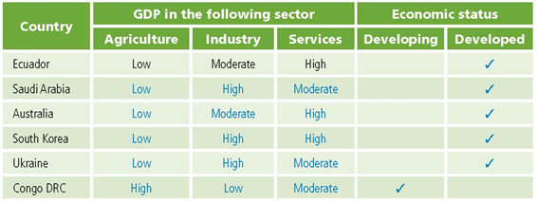

Q17. Record the category for Saudi Arabia’s percentage of GDP in industry in the table in Q15.
See the table on the previous page.
Q18. Record the category for Saudi Arabia’s percentage of GDP in services in the table in Q15.
See the table on previous page.
Q19. Place a check mark for Saudi Arabia under Developed or Developing in the table in Q15.
See the table on previous page.
Q20. Fill in the information for Australia, South Korea, Ukraine, and People’s Democratic Republic of Congo (Congo, DRC) in the table in Q15. See the table on previous page.

Task 6: Analyze GDP per capita and energy use data

Q21. What is Ecuador’s GDP per capita? $600–6,400 (the lowest category)
Q22. What is Ecuador’s annual amount of energy use? 0–2 quadrillion BTUs (the lowest category)
Q23. Based on this new information, should Ecuador be classified as a developing or developed country? Developing
Q24. Why does energy use increase when a country develops? Energy is used more when countries build infrastructure and establish manufacturing plants than when the primary mode of economic production is agriculture. Industry- and service-oriented production consumes more energy than agriculture.
Q25. Complete the following table. Categorize countries with <$16,000 as low GDP/capita and countries with <11 quadrillion BTUs as low on energy use.
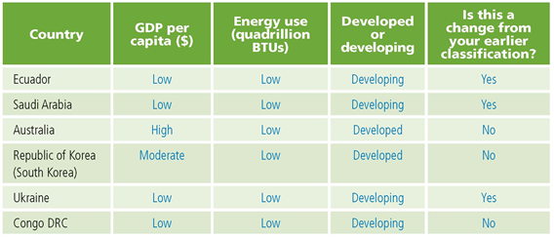

Q26. Name a country that you classified in Q15 as developed on the basis of economic sector data and in Q25 as developing on the basis of GDP per capita and energy use data. Possible answers: Ukraine, Saudi Arabia, and Ecuador
Q27. Based on the data you collected on these six countries, do you feel that the economic sector criteria are good indicators of a country’s economic status? Explain your answer. Answers will vary. Economic sector criteria appear to be good indicators of developing or developed status in some cases, but not all. Students should realize that many factors make up a country’s economic status, and as different factors are included as criteria, a country’s classification may change. Although Ukraine, Saudi Arabia, and Ecuador have high percentages of their GDPs in industry and services, they have low GDPs per capita and low energy use. Inclusion of these additional factors makes the three countries lean toward a “developing” classification.

Assessment Rubrics

Middle School
This is a four-point rubric based on the National Standards for Geographic Education. The mastery level meets the target objective for grades 5-8.

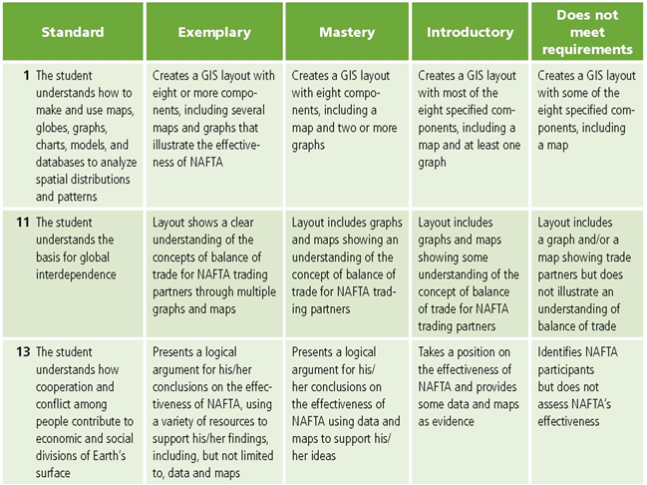

High School
This is a four-point rubric based on the National Standards for Geographic Education. The mastery level meets the target objective for grades 9-12.

