Middle school assessment
Module 2, Lesson 1
The earth moves

Create a risk map
On the Assessment map:

Mark all plate boundaries and label the plates.
Label five physical features associated with volcanoes or earthquakes.
From the following list, identify five cities at high risk for a volcanic or seismic disaster. Mark and label them on your map.

San Francisco, USA
Bombay, India
Jakarta, Indonesia
Manila, Philippines
Bogotá, Colombia
Addis Ababa, Ethiopia
Mexico City, Mexico
Rome, Italy
Seattle, USA
Houston, USA
Madrid, Spain
Tokyo, Japan
Hong Kong, China
Reykjavik, Iceland
Sydney, Australia
Cairo, Egypt

Analyze the map
On a separate piece of paper, write a paragraph for each of the following items:

- Describe the relationships you see between tectonic plate boundaries and areas at high risk for volcanic or seismic activity.
- Explain why you selected each city on your map.
- Rank your five cities in the order of risk, with 1 being the highest risk, and explain why you ranked them that way.
- Compare your Supplement map to your Assessment map.
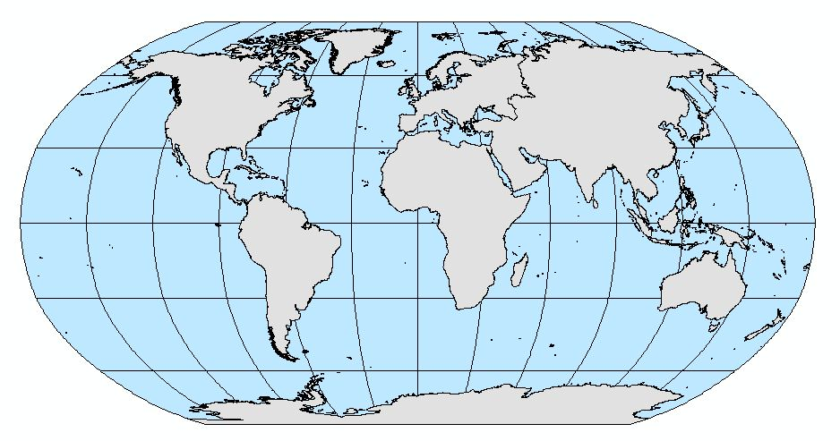
High school assessment
Module 2, Lesson 1
The earth moves

Create a risk map
On the Assessment map:

- Mark all plate boundaries and label the plates.
- Label five physical features associated with volcanoes or earthquakes.
- From the following list, identify five cities at high risk for a volcanic or seismic disaster. Mark and label them on your map.

San Francisco, USA
Bombay, India
Jakarta, Indonesia
Manila, Philippines
Bogotá, Colombia
Addis Ababa, Ethiopia
Mexico City, Mexico
Rome, Italy
Seattle, USA
Houston, USA
Madrid, Spain
Tokyo, Japan
Hong Kong, China
Reykjavik, Iceland
Sydney, Australia
Cairo, Egypt

Analyze the map
On a separate piece of paper, write a paragraph for each of the following items:

- Provide evidence that each of the cities you selected is at high risk for a major earthquake or volcanic eruption.
- Choose at least two of the cities on your map and research how these cities are prepared (or not prepared) for a seismic disaster. For each city, write a complete paragraph outlining the city’s preparedness.
- Elaborate on your answers in Q12 as to how the five physical features you selected have formed.

