Module 4, Lesson 1
The March of Time
In this activity you will use GIS to identify the world’s largest cities at different times during the past 2000 years. You will look for patterns in their locations and speculate on reasons for changes in the patterns.

Task 1: Open the Map

- Launch an internet browser.
- Go to this link:
http://www.arcgis.com/home/webmap/viewer.html?webmap=f70aa36d2b1643a7b710113492e8dacf

- The map will open in your web browser.

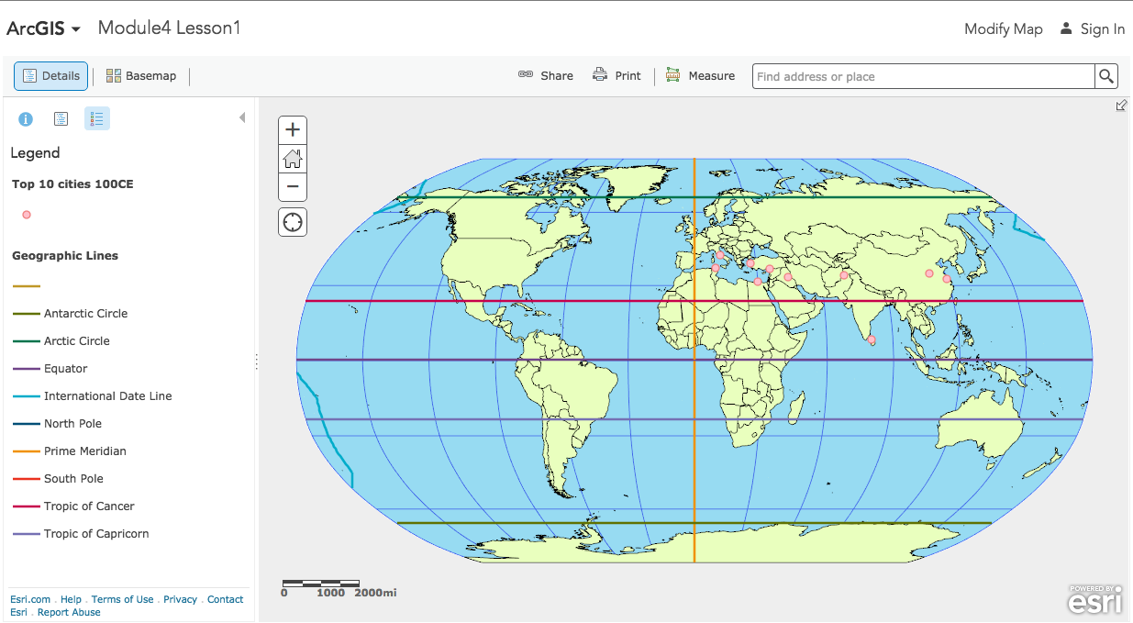

- Click on the Modify Map link on the top right corner above your map.
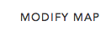

- If you would like to complete this lesson and save your work, click on the Save As button, provide your login and password and provide a new name for your Map. If you do not want to save your work, proceed to Step 5 without clicking on the Save As button.

Note: if you have issues saving your document, go to this link and follow further instructions.
http://education.maps.arcgis.com/home/item.html?id=431f6bc3b0474f5e8933f8ba81bdc925

Task 2: Look at cities in 100 CE

- Click the Show Contents of Map button to see the layers available in this map.

OR

- Top 10 cities 100 CE (CE stands for Common Era) is already turned on and represented by the pink dots.

- Click the box next to World Imagery to turn on an aerial image of the world.

Answers to questions in this activity should be recorded on the answer sheet.
L1
- Q1 Where are the ten largest cities in the world in 100 CE located on the earth’s surface?

- Q2 Where are they located in relation to each other?

- Q3 Where are they located in relation to physical features?

- Q4 What are possible explanations for the patterns you see on this map?

Task 3: Find historic cities and identify modern cities and countries

Many cities have changed names or no longer exist since 100CE. We can identify information about cities on the map in multiple ways. Let’s utilize the information in the data table via the popups to help us identify cities on the map.
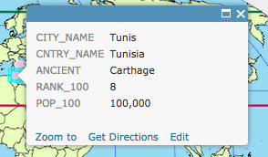
- Turn off the World Imagery layer.

- Click a city point on the map. The pop-up information shows that city’s data that is stored in the attribute table.

- Q5 Complete the table on the answer sheet.

Task 4: Find the largest city of 100 CE

- Q6 What’s your estimate of how many people lived in the world’s largest city in 100 CE?

Let’s utilize the information in the actual data table to help us identify population on the map.

- Click on the Top 10 cities 100CE layer. Notice a series of buttons show up below the layer name.

- Click on the Show Table button.

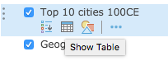

- Click on the field header for Pop_100 and click on Sort Descending.

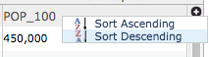

- Q7 What was the largest city in 100 CE?

- Q8 What was the population of the world’s largest city in 100 CE?

Task 5: Look at cities in 1000 CE

- Close the data table by clicking on the X on the top right of the table.

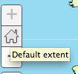
- Click the Default extent button.

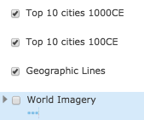
- Turn on the Top 10 cities 1000 CE layer.

Look for similarities and differences between these points and the cities of 100 CE in the locations and distribution of the world’s largest cities.

- Q9 What notable changes can you see from 100 CE to 1000 CE?

- Q10 What similarities can you see between 100 CE and 1000 CE?

- Q11 What was the largest city in 1000 CE?

- Q12 What was the population of the world’s largest city in 1000 CE?

Task 6: Compare other historical periods and formulate a hypothesis

- Click the Default extent button.

- One at a time, turn on each of the remaining six layers representing the years 1500, 1800, 1900, 1950, 2000, and 2005. Using the popups and table sorting skills you learned previously in this lesson, complete the following answers.

- Q13 Complete the table on the answer sheet. Refer back to Q7–Q12 to get information for 100 CE and 1000 CE. (You may need to turn layers on and off or move them up or down in the Table of Contents.)

- Q14 Using the map and your answers in Q13, identify historical periods associated with the greatest changes and provide possible explanations for the changes.

Task 7: Investigate population density in the present time

- As a class, before you began the lesson, you made a guess about the Top 10 cities in the world in 2005.
- Zoom out to the Default extent of the map so that you see the entire globe and leave only the Top 10 Cities, 2005 CE layer on.

- Q15 How many of your original guesses are among the Top 10 Cities, 2005 CE?

- Q16 Which cities did you successfully guess?

In this exercise, you explored population data from 100 CE through the year 2005. You used the ArcGIS.com Map Viewer to find, identify, and explore the world’s most populous cities during different time periods. After analyzing this data, you explored population density and predicted future population growth.

