Module 5, Lesson 2
A line in the sand

Lesson overview
Students will study the creation of a new border between Saudi Arabia and Yemen. Using data from the June 2000 Treaty of Jeddah, they will draw the new boundary established by the treaty and analyze the underlying physiographic and cultural forces that influenced the location of that boundary. In the process they will come to understand how any map of the world must be considered a tentative one as nations struggle and cooperate with each other.

Estimated time
Two to three 45-minute class periods

Materials
- Internet access to arcgis.com
- Student instructions
- Student answer sheet
- Student assessments

Objectives
After completing this lesson, a student is able to do the following:
- Describe the physical and population characteristics of the Arabian Peninsula
- Define and describe the Empty Quarter
- Explain major elements of the Treaty of Jeddah boundary agreement between Saudi Arabia and Yemen
- Identify physical and cultural characteristics of the Arabian Peninsula that are reflected in the new Saudi–Yemeni border agreement

GIS tools and functions
- Identify a feature to learn more about it
- Zoom in on the map
- Search for layers
- Add layers
- Draw features
- Measure distances between points on the map
- Utilize Bookmarks
- Pan the map to view different areas
- Turn layers on and off

National Geography Standards

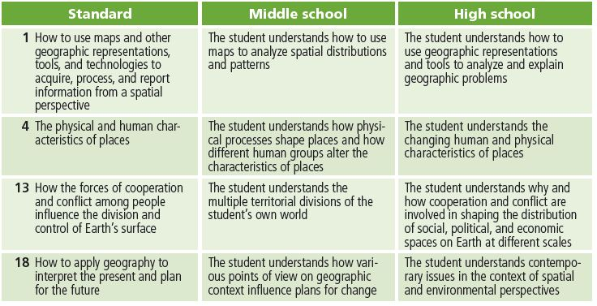

Teaching the lesson

Introducing the lesson
Divide the class into small groups. Explain to students that the lesson is about drawing boundary lines. In order to identify some of the important considerations in the demarcation of boundaries, each group will take five minutes to consider the following hypothetical scenario.
Size limitations in the school building require that your classroom be divided to create two new, smaller classrooms. Other than the wall dividing the two classrooms, there will be no new construction. Each group is charged with two tasks:

- Identify the features of the present classroom that are valuable to the teachers and students who use that room (windows, for example).
- Suggest a possible boundary line to divide the classroom and identify the features of the original classroom that each of the new classrooms will have.

When five minutes have passed, make a list on the blackboard or an overhead projector of the valuable classroom features that students identified in the first Task. Let each group report on the boundary they propose. Use this activity as a springboard for a discussion of the issues involved in the creation of national boundaries. Be sure to include the following points in the discussion:

- Certain features of the physical environment have greater value than others to the people who will occupy and use that space.
- The human uses of a place influence the perceived value of its physical features.
- When a boundary line is drawn, it may not be possible to divide the valuable features evenly between the parties involved.

Tell the class that this activity will explore a twenty-first century case of the demarcation of a boundary between two countries. Although at a much different scale, this decision involved some of the same issues they faced in drawing a hypothetical boundary in their classroom.

Student activity
We recommend that you complete the activity yourself before presenting the lesson in class. Doing so will allow you to modify the activity to accommodate the specific needs of your students. If they will not be working on individual computers be sure to explain any necessary modifications.

Explain that in this activity they will use GIS to explore a region of the world where a boundary dispute has been recently settled after 65 years of conflict. They will explore alternatives for boundaries between the countries involved and analyze the underlying physiographic and cultural considerations that played a part in the resolution of that conflict.

The following are things to look for while the students are working on this activity:

- Are the students using a variety of tools?
- Are they answering the questions?
- Are they experiencing any difficulty managing the display of information in their map as they turn layers on and off?
- Are students experiencing any difficulty plotting latitude/longitude points or finishing their sketch when creating the Saudi–Yemeni boundary line feature?

Concluding the lesson
Refer your students to the activity that introduced this lesson: the creation of a hypothetical boundary line that divides their classroom into two new rooms. Review their conclusions and ask them to identify parallel issues in the settlement of the boundary dispute between Saudi Arabia and Yemen.

- Certain features of the physical environment have greater value than others to the people who will use that space. On the Arabian Peninsula, areas that get enough precipitation for agriculture, areas of grassland for grazing, sources of water, and areas with the strategic advantage of mountain peaks have greater value.
- The human uses of a place influence the perceived value of its physical features. On the Arabian Peninsula, livestock herding and farming are examples of traditional human uses.
- When a boundary line is drawn, it may not be possible to divide the valuable features evenly between the parties involved. On the Arabian Peninsula, most of the areas that get enough precipitation for agriculture, areas of grassland for grazing, and sources of water went to Yemen.

Ask students to identify issues that played a role in the Saudi–Yemeni border conflict that were not present in the classroom boundary scenario.

For example:

- Historic boundaries and patterns of political control in the region played an important part in the Saudi–Yemeni border conflict. Discuss important historical events and periods such as the Ottoman Empire, the consequences of World War I in this region, international interest in the region during the twentieth century, and the British Protectorate of Aden.
- Nomadism and strong identity with regional tribal traditions are at odds with the delineation of a fixed boundary in this region. Discuss the various factors that influence a community’s or a region’s sense of itself.

Students may wonder why the Saudis were willing to yield so much territory to Yemen. Ask them to speculate on possible reasons for this apparent generosity. The Treaty of Jeddah states that the two countries will negotiate if sources of “shared natural wealth” are discovered in the border region. This means that Saudi Arabia reserves the right to reopen negotiations in the event that something that they value very highly — oil or gas, for example — is discovered near the new boundary. Also, Saudi Arabia has long been interested in constructing a pipeline to the Arabian Sea across the southern part of the peninsula. The Saudis may have been hoping that a generous settlement with Yemen on the border issue could make the Yemenis more willing to agree to a Saudi pipeline across their territory.

Middle school assessment. Students will write a newspaper article reporting on the settlement of the Saudi–Yemeni border dispute by the Treaty of Jeddah, which was agreed to in June 2000.
The article, written from either a Saudi or a Yemeni perspective, should describe the new boundary established by the treaty and analyze underlying physiographic and cultural considerations that influenced the location of that boundary. Students will also prepare a map to go with the article.

High school assessment. Students will write a newspaper article reporting on the settlement of the Saudi–Yemeni border dispute by the Treaty of Jeddah, which was agreed to in June 2000. The article, written from either a Saudi or a Yemeni perspective, should describe the new boundary established by the treaty and analyze underlying physiographic and cultural considerations that influenced the location of that boundary. The article should also include information about historical factors that contributed to this 65-year-old boundary conflict. A map should accompany the article.

Extending the lesson
Challenge students to try the following:
- Negotiate with each other in the introductory activity to arrive at a mutually satisfactory boundary for the two new classrooms.
- Use the Internet to identify other areas of the world where international boundaries are in dispute.
- Research the events of World War I on the Arabian Peninsula. Create an ArcGIS Online map illustrating these events.
- Use ArcGIS Online map viewer to compare the countries of the Arabian Peninsula by mapping and analyzing relevant economic and demographic data.

See the “Resources by Module” section of this book’s Web site—www.esri.com/ourworldgiseducation—for print, media, and Internet resources on the topics of Saudi Arabia, Yemen, and the Treaty of Jeddah.

Answer key

Task 2: Identify countries that border the Arabian Peninsula
Q1) What countries border the Arabian Peninsula to the north?
Jordan, Iraq, Kuwait
Task 3: Investigate the physical characteristics of the Arabian Peninsula
Q2) Is any part of the Arabian Peninsula mountainous? Yes
Q3) If so, where are the mountains located? Along the west (Red Sea) coast and the northeast (Gulf of Oman) coast.
Q4) Are there any parts of the Arabian Peninsula that do not have any water at all? If so, where are these regions? Yes. The south-central part of the peninsula has no permanent bodies of water or streams.
Q5) Do you see any relationship between landforms and the availability of water?
Mountains and areas of higher elevation have more surface water.
Q6) Describe the bodies of water in terms of their connectedness or disconnectedness.
The permanent bodies of water look like a maze of rivers and lakes.
Q7) How many millimeters equal 10 inches? 254 mm
Q8) Based on the amounts of rainfall displayed on the map, do you think there is much farming on the Arabian Peninsula? Explain.
No. Most of the Arabian Peninsula is so dry that agriculture wouldn’t be possible without an alternative source of water such as a river. (Egypt, for example, is just as dry, but the Nile River provides water for agriculture.)
Q9) Approximately what percentage of the Arabian Peninsula is desert? 70–90%
Q10) What is the approximate range of temperatures across the Arabian Peninsula during September through November? 14 to 30°C, 57 to 86° F
Q11) Which season is the hottest? Summer (June–August)

Q12) What is the approximate range of temperatures across the Arabian Peninsula during the hottest season? 18 to 40ºC, 66 to 104º F
Q13) What relationship do you see between the Arabian Peninsula’s ecozones and its patterns of landforms, precipitation, and temperature?
The limited zones of temperate grassland on the Arabian Peninsula are found in the mountains, where there is more precipitation and milder temperatures.
Q14) List three observations for each physical characteristic in the table.
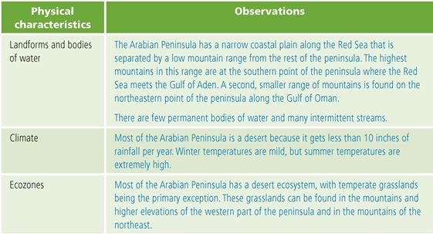

Q15) In your opinion, which of the region’s physical characteristics would be considered “valuable” in a boundary decision? Explain. Grassland ecosystems, areas with greater than 500 mm (about 20 inches) of annual precipitation, and areas with access to permanent bodies of water or springs. Students may also mention mountains and passes important for defense or trade.
Task 4: Investigate the population characteristics of the Arabian Peninsula
Q16) What is the principal agricultural activity on the peninsula? Nomadic herding
Q17) Based on what you now know about the physical characteristics of the region, why do you think the agricultural activity is so limited? Most of the region does not have sufficient water for farming. Livestock can be herded from place to place depending on the seasonal availability of water and pastureland.
Q18) How does Yemen compare to the rest of the Arabian Peninsula in population density?
Southwestern Yemen has the largest area of relatively high population density (more than 50 people per km2).
Q19) Describe the overall population density of the Arabian Peninsula. Most of the Arabian Peninsula has fewer than 25 people per km2, and at least half of that area has a density of less than 1 person per km2.
Q20) Speculate about the ways water is most commonly used at these springs and water holes.

Answers will vary. Because of the prevalence of nomadic herding, a logical conclusion is that most of the springs and water holes are used to water livestock.
Q21) Use your answers from Q16–Q20 and analysis of the maps to list two observations for each population characteristic in the table.

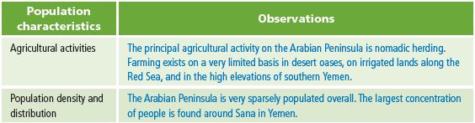

Q22) If an international boundary were to be drawn across some part of the Arabian Peninsula, how would these population characteristics influence the perception of certain regions as being more valuable than others? Nomadic herders would place a high value on having access to sources of water and grazing land. The population density of a region is a direct reflection of the ability of land to support life. Areas with very low population density would be least valuable, and those with high population density would be most valuable.

Task 5: Investigate the Empty Quarter
Q23) List two observations on the physical characteristics of the Empty Quarter and two observations on its population characteristics.
Physical characteristics: It’s a desert region with virtually no permanent bodies of water
and less than 3 inches of rainfall per year.
Population characteristics: The region has no agricultural activity and is virtually uninhabited: most of it has less than one person per square kilometer, and about one third has no people at all. The lack of roads indicates minimal human presence.
Q24) What difficulties would an area like this present if an international boundary must cross it?
Insufficient residential population to draw from for boundary enforcement. The lack of permanent landmarks (due to shifting sand dunes) makes the line difficult to mark and see. Nomadic herders would want easy access throughout the border area.
Task 6: Explore Saudi Arabia’s southern boundaries
Q25) Are the boundaries what you expected them to be? Answers will vary.

Q26) Which boundary remained unsettled? The border between Saudi Arabia and Yemen

Q27) What does the area between the green and purple lines represent? It is claimed by both
Saudi Arabia and Yemen—it is the disputed territory between these two countries.

Q28) What is the principal economic activity of the regions in dispute? Nomadic herding

Q29) Describe the population distribution in the disputed territory. The disputed territory is mostly uninhabited, with a density of less than 1 person per km2. The only area with a higher concentration of people is the western part of the territory with 1–25 people per km2.
Task 7: Draw the Saudi–Yemeni boundary
Q30) Does the brown line go through any cities or towns? (You may need to zoom in again.) If yes, approximately how many does the boundary pass through? Answers will vary. The boundary passes through fewer than 10 villages but within a mile or two (approximately 1.25 km) of many more.

Q31) How would you decide on which side of the town to put the boundary? Remember, this decision would determine whether the residents of that village would be citizens of Saudi Arabia or Yemen. Answers will vary. One way is to survey villagers to find out whether they feel a closer affiliation with Yemen or Saudi Arabia. Such affiliations are often based on long-standing tribal traditions.

Q32) Does the new line seem to favor Yemen or Saudi Arabia? Explain. The new border seems to favor Yemen. It gained control of all the disputed territory and gained even more territory beyond the previous boundary.
Task 8: Add the maritime portion of the boundary
Q33) What body of water does the maritime boundary traverse? The Red Sea

Q34) How does the actual boundary established by the Treaty of Jeddah compare with the boundary you drew earlier (black line)? Answers will vary. In most cases, students will find that the Treaty of Jeddah gave more land to Yemen than they predicted.

Q35) Write three observations about the boundary line created by the Treaty of Jeddah (turn on Agriculture and Population Density as needed). Possible answers: The new boundary increased Yemen’s territory. Most of Yemen’s new territory is land used by nomadic herders and desert. The border settlement probably did not have a significant impact on Yemen’s overall population as most of the new territory is uninhabited or very sparsely settled.

Task 9: Define the pastoral area
Q36) How many miles is 20 kilometers? (1 kilometer = 0.6214 miles) 12.428 miles

Q37) In which portion of the Saudi-Yemeni border will the pastoral area be most significant? Explain. In the western portion, where nomadic herding is found. The remainder of the new boundary is north of the nomadic herding areas.

Q38) Why do you think the Treaty of Jeddah created a pastoral area? Answers will vary, but students should understand that the establishment of a pastoral area recognizes that nomadic herding is incompatible with fixed and finite boundaries. The pastoral area represents a compromise between the need to clearly define the boundary between Saudi Arabia and Yemen and the reality that the border area is populated by people whose nomadic traditions include territory on both sides of that boundary.

Assessment Rubrics

Middle School
This is a four-point rubric based on the National Standards for Geographic Education. The mastery level meets the target objective for grades 5-8.

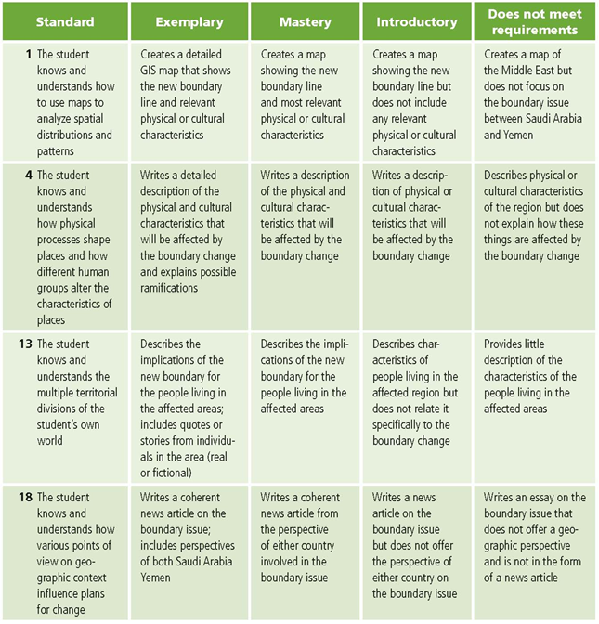

High School
This is a four-point rubric based on the National Standards for Geographic Education. The mastery level meets the target objective for grades 9-12.

