Middle school assessment
Module 2, Lesson 2
Life on the edge
Create a risk map
Use the map document from the activity and your class notes to do the following on the Assessment A map:
- Mark zones at high risk for volcanic activity with one color and zones at low risk with another color. Take into account the following factors: • Population density • Proximity of active volcanoes to major cities
- Mark zones at high risk for seismic activity with one color and zones at low risk with another color. Take into account the following factors: • Population density • Proximity of recent earthquakes to major cities
- Create a map legend that identifies the four zones.
Analyze the map
On a separate piece of paper, write a paragraph for each of the following items:
- Describe the criteria you used to define zones of risk for volcanic and earthquake activities.
- Describe the relationships you see between tectonic plate boundaries and areas at high risk for volcanic and seismic activities.
- Describe physical features around the Pacific Rim and identify their common characteristics.
- Develop an emergency action plan for a city in one of the high-risk zones.

Assessment map A: East Asia
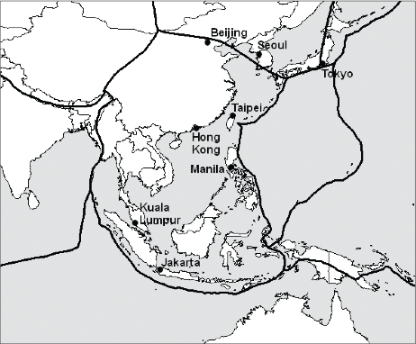

High school assessment
Module 2, Lesson 2
Life on the edge
Create a risk map
Use the map document from the lesson and your class notes to do the following on the Assessment B map:
- Mark zones of high, medium, and low risk for volcanic activity with different colors. Take into account the following factors: • Population density • Proximity of active volcanoes to major population centers • Locations of plate boundaries and subduction zones
- Mark zones of high, medium, and low risk for seismic activity with different colors. Take into account the following factors: • Population density • Magnitude of earthquakes from 2004 to 2007 data • Locations of plate boundaries and subduction zones
- Create a complete map legend.
- Mark and label major cities in the high-risk zones (use the Find tool as needed), plate boundaries, and subduction zones.
Analyze the map
On a separate piece of paper, write a paragraph for each of the following items:
- Describe the criteria you used to define zones of risk for volcanic and earthquake activities.
- Describe the relationships you observe between tectonic plate boundaries and areas at high risk for volcanic and seismic activities.
- Explain how subduction zones affect three different Pacific Rim physical features.
- Develop an emergency action plan for a city in one of the high-risk zones.

Assessment map B: East Asia
