Module 3, Lesson 2
Seasonal Differences

Lesson overview
Students will observe patterns of monsoon rainfall in South Asia and analyze the relationship of those patterns to the region’s physical features. The consequences of monsoon season on human life will be explored by studying South Asian agricultural practices and patterns of population distribution.

Estimated time
Two to three 45-minute class periods

Materials
- Internet access to arcgis.com
- Student instructions
- Student answer sheet
- Student supplements
- Student assessments
- Four large pieces of butcher paper
- Four or more markers

Objectives
After completing this lesson, a student is able to do the following:
- Describe the patterns of monsoon rainfall in South Asia
- Explain the influence of landforms on patterns of precipitation
- Describe the impact of climate and physical features on agriculture and population density

GIS tools and functions
- Identify a feature to learn more about it
- Zoom in on the map
- Search for layers
- Add layers
- Measure distances between points on the map
- Utilize Bookmarks
- Pan the map to view different areas
- Turn layers on and off

National Geography Standards

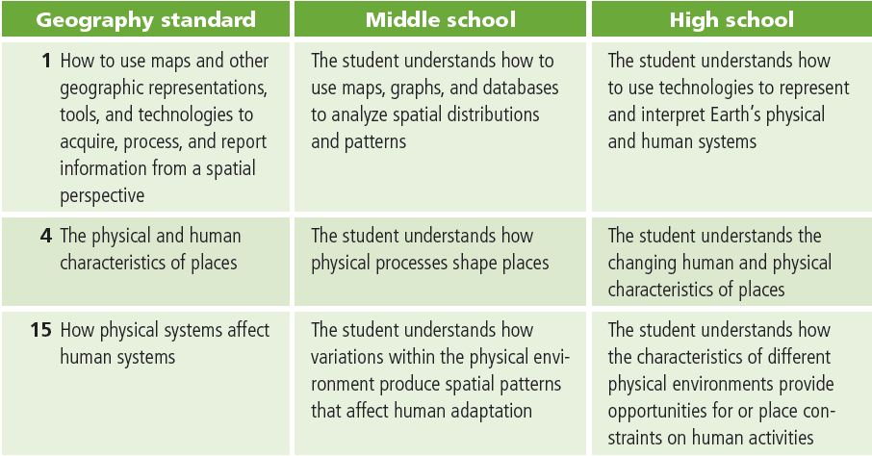

Teaching the lesson

Introducing the lesson
Tell your students that they are going to explore seasonal differences in South Asia. They may be surprised to learn that students in South Asia would probably describe their year in terms of three seasons rather than four. Engage them in a discussion of local and personal perceptions and assumptions about seasons. Tack up four large pieces of butcher paper and have them list images, descriptions, and memories relating to each season.
- How does the physical environment change from season to season?
- How are those changes reflected in activities, foods, and clothing?
- To what extent do seasonal changes in their environment affect their day-to-day lives?

Student activity
We recommend that you complete the activity yourself before presenting the lesson in class. Doing so will allow you to modify the activity to accommodate the specific needs of your students. If they will not be working on individual computers, be sure to explain any necessary modifications.
Explain to students that in this activity they will use GIS to analyze yearly and monthly temperature patterns in cities around the world. They will identify global and regional temperature variations and speculate on possible reasons for the patterns observed.
The following are things to look for while the students are working on this activity:
- Are students using a variety of GIS tools?
- Are students answering the questions?
- Are students experiencing any difficulty navigating between windows in the map document?

Concluding the lesson
When the class has finished the activity, lead a discussion that summarizes the conclusions the students reached. Be sure to highlight patterns and relationships. Focus on the following concepts about South Asia’s monsoon climate in your discussion:
- Rainfall is limited to one season of the year in South Asia except in the desert west, where little rain falls at all. (This would be an excellent point at which to elaborate on the seasonal shift in monsoon winds that produce the patterns of rainfall students observed in the maps.)
- Typically, the rainy season lasts from June through September, although the actual length of the season and amounts of rainfall vary across the subcontinent. (Be sure to note the orographic patterns of precipitation along India’s southwest coast and in northeast India on the southern slopes of the Himalayas.)
- Agricultural activities are directly related to patterns of rainfall.
- In general, population density varies with patterns of rainfall. However, the importance of South Asia’s rivers as an additional source of water for agriculture is apparent from the high density of population along their paths.
Close the lesson by challenging student to identify the three seasons in South Asia. In general the three seasons are:
- The rainy season (June-September)
- The dry lush season after the rains when everything is growing and green (October-January)
- The dry dusty season before the rains come (February-May)
Middle school assessment
Students will assume the role of an American student living for a year in South Asia as an exchange student. They can choose to live in or around Mumbai, Delhi or Kolkata. They will write a letter to friends back home on January 1, April 1, July 1 and October 1. Each letter will describe the seasonal changes in their location and ways that their daily lives and the lives of people around them reflect those changes.
High school assessment
Students will assume the role of an American student traveling for a year in South Asia. They will write a letter to friends back home on January 1, April 1, July 1 and October 1. Each letter will be from a different South Asian city. Their letter will describe the seasonal characteristics in each city and ways that their daily lives and the lives of people around them reflect those characteristics.

Extending the lesson
Challenge students to try the following:
- Collect additional temperature data for cities in one region. Use that data to create a map document of that region and a regional temperature profile.
- Bring in more data from ArcGIS online.
- Research South Asian farming methods to find out how activities such as planting and harvesting are coordinated with rainfall patterns.
- Research the monthly and yearly rainfall patterns in your own location and compare these to what you observed in South Asia.
See the “Resources by Module” section of this book’s Web site—www.esri.com/ourworldgiseducation— for print, media, and Internet resources on the topics of climate and global temperatures.

Answer key
Task 2: Observe patterns of rainfall
Q1) Which month gets the most rainfall in Mumbai? July
Q2) Which months appear to get little or no rainfall in Mumbai? December–April
Q3) Approximately how much rainfall does Mumbai get each year (in millimeters)? 2100
Q4) Write a sentence summarizing the overall pattern of rainfall in Mumbai in an average year.
Mumbai gets more than 2,100 millimeters of rain per year in a concentrated period from
June to September.
Q5) Analyze the graphs and fill in the Mangalore section of the table below.

City | Months with rainfall  > 50mm | Highest monthly rainfall (mm) | Total annual rainfall (mm)
Mangalore | May-November | 1000 | 3500
Mumbai | June-October | 650 | 2000
Ahmadabad | June-September | 300 | 800

Q6) Complete the rest of the table above. Use estimates.
Q7) As you move northward along the subcontinent’s west coast, how does the pattern of rainfall change?
The rainy season gets shorter. It starts later in the year and ends earlier. The
monthly and yearly rainfall totals decline.
Q8) Although the monthly rainfall amounts differ, what similarities do you see among the overall rainfall patterns of these three cities? The rainy season occurs at the same time of year in all three cities; so does the dry season. In each city, July has the highest rainfall total of any month, and the period from December through March is dry.

Task 3: Compare coastal and inland cities
Q9) Complete the table below.

City | Months with rainfall  > 50 mm | Highest monthly rainfall (mm) | Total annual rainfall (mm)
Bangalore | May-November | 175 | 900

Q10) How does the rainfall pattern of Bangalore compare with that of Mangalore?
Similarities: The two cities have a rainy season between May and November.
Differences: Mangalore gets approximately four times as much rain in a year as Bangalore
Q11) What is the distance between the two cities? Approximately 270 kilometers
Q12) How can the data in the Physical Features layer help you explain the differences between patterns of rainfall in inland Bangalore and coastal Mangalore?
Mangalore is on the coast, while Bangalore is on the interior (Deccan) plateau. A narrow coastal mountain range (the Western Ghats) separates the two cities. The significant difference in total and monthly rainfall results from the orographic effect produced by the Western Ghats. Moist monsoon winds are forced to rise to go over these mountains as they come ashore. Condensing in the cooler upper atmosphere, most of the monsoon’s moisture falls on the windward side of the mountains, leaving the inland side much drier.

Task 4: Compare eastern and western South Asian cities
Q13) Analyze the graphs and complete the table below.

City | Months with rainfall  ≥ 20 mm | Highest monthly rainfall (mm) | Total annual rainfall (mm)
Kabul | December –May | 70 | 280
Herat | December-April | 55 | 245

Q14) Describe the pattern of rainfall in these two cities.
Both of these cities are extremely dry. What little rainfall they do receive falls in the early months of the year.
Q15) How do you think Afghanistan’s rainfall pattern affects the way of life in that country?
There is not enough rainfall to support crop farming. They have to rely on nomadic herding and extraction of natural resources.

Q16) Analyze the graphs and complete the table below.

City | Months with rainfall  ≥ 20mm | Highest monthly  rainfall (mm) | Total annual  rainfall (mm)
Kolkata | February-November | 338 | 1633
Dhaka | February-November | 399 | 1996

Q17) Describe the pattern of rainfall in these two cities.
These two cities have significant annual rainfall totals and a distinct rainy season that lasts longer than the rainy season on the southwest coast. The majority of the rain falls between May and October.
Q18) What is happening to the patterns of rainfall as you move from west to east across South Asia?
The amount of annual rainfall increases as you move eastward, and the rainy season gets longer.
Task 5: Observe yearly precipitation
Q19) Which regions of South Asia get the least rainfall?
The northwest (Afghanistan and Pakistan)
Q20) Which regions of South Asia get the most rainfall?
The southwest coast and the northeast
Q21) In Q18 you were comparing Herat, Delhi, Kolkata, and Dhaka. Does the map of yearly rainfall that is on your screen now reflect the observation you made at that time? Explain.
Answers will vary, but essentially, students should observe that precipitation does increase as you move from west to east across South Asia.
Q22) What relationships do you see between South Asia’s patterns of yearly rainfall and its physical features?
The region’s heaviest rainfall is on the windward side of the Western Ghats and
the Himalayas. Orographic lift is responsible for these areas of heavy rainfall. Cities on the
Deccan Plateau, in the interior of the subcontinent, get significantly less rainfall because
they lie in the rain shadow of the mountains.
Task 6: Explore the monsoon’s impact on agriculture and population density
Q23) Which regions or countries of South Asia are suitable for crop farming and which are not? Explain.
Answers will vary. The western section of South Asia (Afghanistan, Pakistan, and
western India) does not get enough rainfall to support crop farming. Additionally, much
of Afghanistan and Pakistan is in the mountains, making crop farming unlikely there.
Most of the remainder of the subcontinent is suitable for crop farming because it gets sufficient rainfall and is either a plain or plateau.
Q24) In which regions of South Asia do you expect to see the lowest population density? Explain.
Answers will vary. Students should expect the dry mountainous west to have the lowest
population density because the region cannot produce enough food to support a large
population.
Q25) In which regions of South Asia do you expect to see the highest population density? Explain.
Answers will vary. Students should recognize the importance of rivers to agriculture (alluvial floodplain, fertile deltas, and a steady source of water) and predict a high population density there.
Q26) Does the Agriculture layer reflect the predictions you made in Q23? Explain.
Answers will vary depending on the answers in Q25. However, the data does illustrate lack of crop farming in the dry mountainous regions.
Q27) Why are grazing, herding, and oasis agriculture the major activities in Afghanistan?
Mountainous terrain and scarce rainfall make these the only viable economic activities for most people.
Q28) What do you know about rice cultivation that would help explain its distribution on the agriculture map?
Students familiar with rice cultivation will note that this is a crop that is often grown in flooded fields (wet rice cultivation) and requires a lot of water. Therefore, it makes sense that rice is cultivated in areas with significant rainfall.
Q29) Is there any aspect of the agriculture map that surprised you? Explain.
Answers will vary. Some students may be surprised about the agricultural activity in Pakistan, since the area is so dry.
Q30) Does the Population Density layer reflect the population predictions you made in Q24 and Q25? Explain.
Answers will vary
Q31) Why is Afghanistan’s population density so low?
Its mountainous terrain and lack of rain make this an area that cannot support a large population.
Q32) Since most of Pakistan gets little to no rainfall, how do you explain the areas of high population density in that country?
The Indus River provides a rich alluvial floodplain and a year-round supply of water for irrigation.
Q33) What is the relationship between population density and patterns of precipitation in South Asia?
Overall population density is highest where rainfall amounts are conducive to agriculture. The notable variation to this pattern is the high population density along the rivers — particularly in the west. The rich soil and dependable source of water on the Indo-Gangetic Plain enable agriculture to support dense populations in spite of insufficient rainfall in some areas or at some times of year.
Q34) What is the relationship between population density and physical features in South Asia?
Population density is lowest in mountainous areas of Afghanistan and Pakistan and highest on the Indo-Gangetic Plain.

Assessment rubrics
Middle School
This is a four-point rubric based on the National Standards for Geographic Education. The mastery level meets the target objective for grades 5–8.
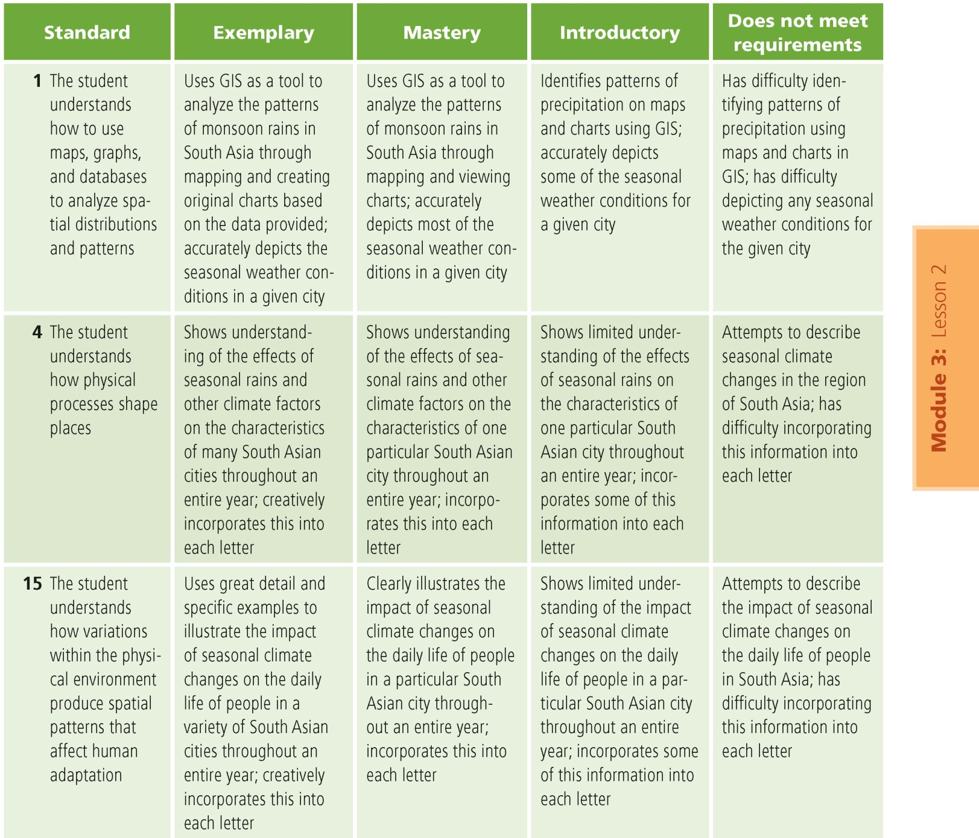

High school
This is a four-point rubric based on the National Standards for Geographic Education. The mastery level meets the target objective for grades 9–12.
