Module 5, Lesson 2
A line in the sand

The ever-changing map of the world reflects the forces of conflict and cooperation among nations and peoples of the world. In this activity, you will explore one of the first boundary changes of the twenty-first century—the creation of a new border between Yemen and Saudi Arabia. After more than 60 years of conflict, the two nations signed the historic boundary agreement in June 2000. Using data from the Treaty of Jeddah, you will create a map reflecting the treaty’s territory and analyze underlying physiographic and cultural considerations that influenced the location of the boundary.

Task 1: Open the map

- Launch an internet browser.
- Go to this link:
- http://www.arcgis.com/home/webmap/viewer.html?webmap=b7c1fc2db1a840d3bffe01ebb0ef8b63

The map document opens, and you see a physical map with the Saudi Arabian Peninsula outlined in red.

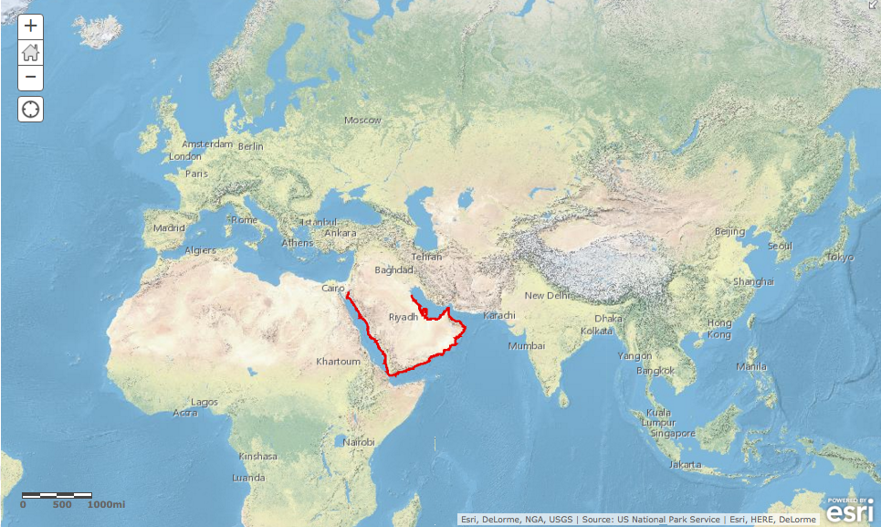

- Click on the Modify Map button on the top right corner above your map.
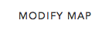

- If you would like to complete this lesson and save your work, click on the Save As button, provide your login and password and provide a new name for your Map. If you do not want to save your work, proceed to Step 4 without clicking on the Save As button.

Note: if you have issues saving your document, go to this link and follow further instructions.
http://education.maps.arcgis.com/home/item.html?id=431f6bc3b0474f5e8933f8ba81bdc925

- Click on the Show Contents of Map at the top of the Contents area on the left of the map.
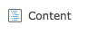
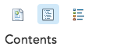
OR

You are now able to see all the map layers available to view with a check mark next to the layer name that tells you the World Physical Map and Arabian Peninsula layers are turned on and visible on the map.

Task 2: Identify countries that border the Arabian Peninsula

- Click the Bookmarks button and choose Arabian Peninsula. Now the Arabian Peninsula fills the view.

- Look in the Contents for a layer called “Neighbors - outline.” Click the box to the left of the layer name to turn it on.

- Click on any neighbor country on the map to display the country names in the popup box.
Answers to questions in this activity should be recorded on the answer sheet.

- Q1: What countries border the Arabian Peninsula to the north?

Task 3: Investigate the physical characteristics of the Arabian Peninsula

The map on your screen is a shaded relief map. It depicts landforms such as mountain ranges, valleys, plateaus, and plains.
- Q2: Is any part of the Arabian Peninsula mountainous?

- Q3: If so, where are the mountains located?

- Turn on the Water Bodies and Streams layers by clicking on the box to the left of those two layers.

- If necessary, zoom in one or two levels to see the streams and bodies of water display on the map.

- Pan around the map to look at where the streams are located on the Arabian Peninsula.

Most of the streams you see on your map are intermittent, which means that they are dry during some parts of the year.

- Q4: Are there any parts of the Arabian Peninsula that do not have any water at all? If so, where are these regions?

- Q5: Do you see any relationship between landforms and the availability of water?

- Turn off the Streams layer and observe the distribution of permanent bodies of water on the Arabian Peninsula.

- Zoom in one more level. Now you can see the bodies of water more closely. If you zoom in too far, your World Physical Map will disappear. Just zoom back out one level at a time until your map reappears.

- Q6: Describe the bodies of water in terms of their connectedness or disconnectedness.

- Click on the Bookmarks button to return to your view of the entire peninsula.
Your map display should look like this one.
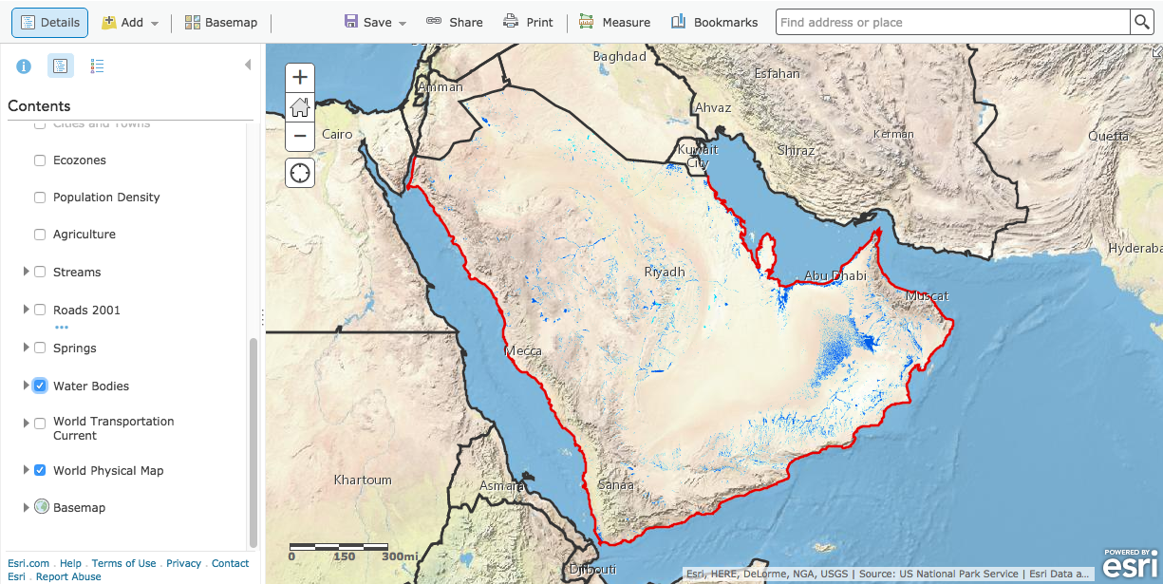

- Turn off the Water Bodies layer.
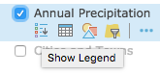
- Turn on the Annual Precipitation layer. Click on the Annual Precipitation layers name and click on the Show Legend icon to view the legend.

Amounts of rainfall are given in millimeters in the map document. The following table shows what some measurements in millimeters would be equivalent to in inches (25.4 mm = 1 in.).

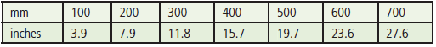

- Q7: A desert is defined as a place that gets less than 10 inches of rain per year. How many millimeters equal 10 inches?

- Q8: Based on the amounts of rainfall displayed on the map, do you think there is much farming on the Arabian Peninsula? Explain.

- Q9: Approximately what percentage of the Arabian Peninsula is desert?

- Turn off Annual Precipitation. Turn on the Temp: Sept. – Nov. layer and click on the Show Legend icon to see its legend.

Temperatures are given in degrees Celsius in the map document. The following table shows what some measurements in degrees Celsius would be equivalent to in degrees Fahrenheit.

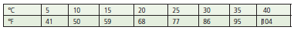

- Q10: What is the approximate range of temperatures across the Arabian Peninsula during September through November?

The three Temp layers below “Temp: Sept. - Nov.” display temperature information for the periods December–February, March–May, and June–August.

- Turn the temperature layers on and off one at a time to see the change of temperatures on the Arabian Peninsula through the four seasons. Remember, you can click on each layer name and the Show Legend icons to display the legends for each layer.

- Q11: Which season is the hottest?

- Q12: What is the approximate range of temperatures across the Arabian Peninsula during the hottest season?

- Turn off the Temperature layers. Turn on the Ecozones layer and expand its legend by clicking the name of the layer and the Show Legend icon in the Contents.

- Q13: What relationship do you see between the Arabian Peninsula’s ecozones and its patterns of landforms, precipitation, and temperature?

- Q14: Use your answers from previous questions and turn different layers on and off to come up with three observations for each physical characteristic in the table on the answer sheet.

- Q15: In your opinion, which of the region’s physical characteristics would be considered “valuable” in a boundary decision? Explain.

Task 4: Investigate the population characteristics of the Arabian Peninsula

The population of the Arabian Peninsula is approximately 77 million. The majority of this population lives in Saudi Arabia (27.5 million) and Yemen (22 million). The remaining 17 million live in Oman, Kuwait, Bahrain, the United Arab Emirates, and Qatar.

- Turn off Ecozones.

- Turn on the Agriculture layer. Click on the Agriculture layer name and Show Legend icon to expand the legend to see the types of agricultural activity on the Arabian Peninsula.

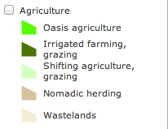

- Q16: What is the principal agricultural activity on the peninsula?

- Q17: Based on what you now know about the physical characteristics of the region, why do you think the agricultural activity is so limited?

- Turn off the Agriculture layer and turn on and expand the Population Density layer.

- Q18: How does Yemen compare to the rest of the Arabian Peninsula in population density?

- Q19: Describe the overall population density of the Arabian Peninsula.

- Turn off Population Density and turn on the Agriculture layer.

- Turn on the Springs layer and make sure the Water Bodies layer is turned off.

- Q20: Speculate about the ways water is most commonly used at these springs and water holes.

- Q21: Use your answers from Q16–Q20 and analysis of the maps to list two observations for each population characteristic in the table on the answer sheet.

- Q22: If an international boundary were to be drawn across some part of the Arabian Peninsula, how would these population characteristics influence the perception of certain regions as being more valuable than others?

Task 5: Investigate the Empty Quarter

- Turn off the Springs layer and turn on Roads 2001. Expand the Roads legend.

Take note of the large area with practically no roads in the south-central part of the peninsula. This region is called the Rub´ al-Khali and is also known as the Empty Quarter. Saudi Arabian borders with its southern neighbors cross this region.

- Turn the following layers on and off so you can observe the characteristics of the Empty Quarter: Streams, Population Density, Agriculture, Ecozones, Temperature, and Annual Precipitation.

- Q23: List two observations on the physical characteristics of the Empty Quarter and two observations on its population characteristics.

- Q24: What difficulties would an area like this present if an international boundary must cross it?

- Turn all layers off except the Basemap, the World Physical Map and Arabian Peninsula - outline.

Task 6: Explore Saudi Arabia’s southern boundaries

Boundaries define a country’s size and shape, or territorial morphology, which may be related to the cohesiveness of that country. Small compact nations or ones that are circular or hexagonal, for example, are likely to be more united than ones that are elongated or fragmented.

- Turn on the 20th Century Boundary layer. This layer reflects the boundary agreements Saudi Arabia made with most of its southern neighbors at the end of the twentieth century (not including Yemen).

- Q25: Are the boundaries what you expected them to be?

- Q26: Which boundary remained unsettled?

According to international boundary expert Richard Schofield, this boundary was “the last missing fence in the desert.” The only part of the boundary that was mutually agreed upon was the western area adjacent to the Red Sea. Over the years, the boundary has shifted. You will now add layers that reflect some of the major boundary changes.

- Turn on the Yemen1 layer and look at the red line of Yemen1.

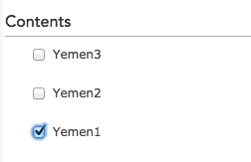

- This line represents the boundary between Yemen and Saudi Arabia established by the Treaty of Ta’if in 1934. It is the only part of the boundary that both countries recognized at the turn of the twenty-first century.

- Turn on Yemen2.

The green line of Yemen2 represents the Saudi–Yemeni border recognized by Yemen at the end of the twentieth century. It is based on lines established when a portion of Yemen called the Aden Protectorate was under British control in the early twentieth century. Most maps used these lines to delineate the extent of Yemen prior to 2000. This boundary was not recognized by Saudi Arabia.

- Turn on Yemen3.

This purple line represents the Saudi–Yemeni border claimed by Saudi Arabia at the end of the twentieth century. It is based on lines established by the Saudis in the mid-1930s. This line was still being used on Saudi Arabian maps to represent the boundary in the 1990s.

- Click on the Bookmarks button and then click on the Yemen bookmark to zoom into the country of Yemen. Now the map is centered on the country of Yemen.

- Q27: What does the area between the green and purple lines represent?

- Turn on Agriculture and expand its legend.

- Q28: What is the principal economic activity of the regions in dispute?

- Turn off Agriculture and turn on and expand Population Density.

- Q29: Describe the population distribution in the disputed territory.

If you were asked to settle the boundary dispute between Saudi Arabia and Yemen, where would you draw the line? You will now draw a proposed boundary between Saudi Arabia and Yemen.

- Turn off Population Density.

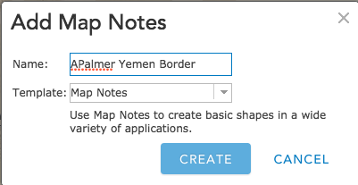
- Click on Add then click on Add Map Notes.

- Name the file with your Name and “Yemen Border”. Click on the Create button.

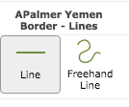

- Click on Line in the Add Features box.

- On your map, click the eastern end point of the brown boundary line (this is the boundary that both countries agree on). Proceed eastward (to your right) and click your proposed boundary line. Double-click when you get to the end of your boundary.

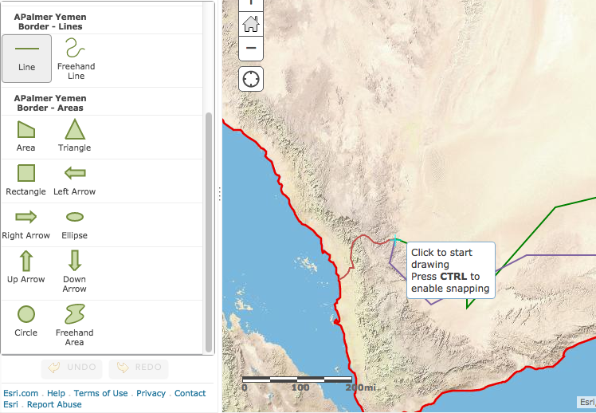
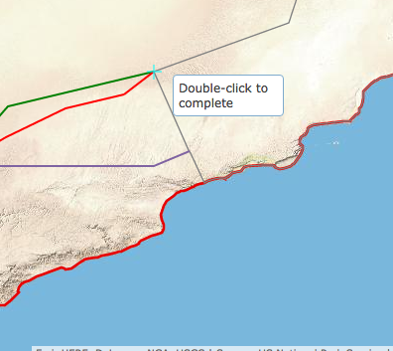

When you are finished drawing your line, you should have a green line that extends from the short brown line on the western border east to Oman. (When you are drawing the line it will be red but will turn to green when you double-click to complete the line.)

- Click Close on the Lines drawing box and click on the Edit button to close the Map Notes.

Task 7: Draw the Saudi-Yemeni boundary

In June of 2000, Saudi Arabia and Yemen signed the Treaty of Jeddah, which settled their 65-year-long boundary dispute. The boundary agreement had three parts. The first part of the treaty reaffirmed agreement on the 1934 Ta’if line (the Yemen1 line). The agreement did say, however, that the line would be amended in any place where it cuts through villages.

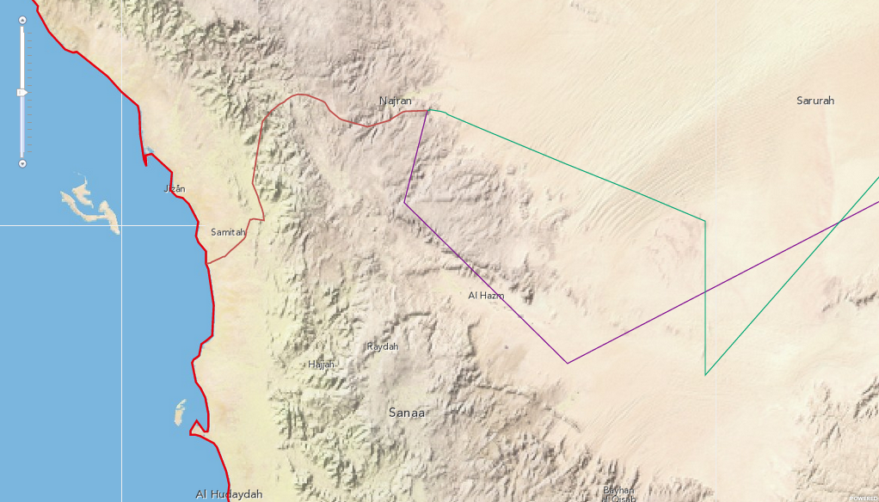
- Zoom to the Ta’if line (brown line) by choosing the Ta’if line Bookmark. Zoom in one more level. The World Physical Map will disappear.
- Turn on the Cities and Towns Layer. The small towns and villages will appear at this zoom level. (Make sure the Population layer is turned off so you can see the names of cities and towns.)

- Q30: Does the brown Ta’if line go through any cities or towns? (You may need to zoom in again.) If yes, approximately how many does the boundary pass through?

- Q31: How would you decide on which side of the town to put the boundary? Remember, this decision would determine whether the residents of that village would be citizens of Saudi Arabia or Yemen.

The second part of the Treaty of Jeddah determined the new boundary from the end of the brown Ta’if line to the border with Oman, 500 miles to the east. The treaty did not actually draw the line but gave its starting and ending points and points in between as latitude/longitude grid coordinates. These points have been entered into a CSV (comma separated values) file for you to view on the map and locate the new boundary line.

- Click on the Add button and Search for Layers. Type in YemenSaudiBorderPoints in the Find box. Make sure the “Within map area” box is not checked.

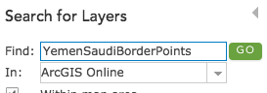

- Click Go and Add to add the CSV file to the map. Click Done Adding Layers.

- Repeating what you learned in steps 36 – 40, draw a line connecting the GPS coordinates you just added to the map. In this step add the coordinates on LAND only and you may zoom in a level to see the points more clearly. Name your new layer “yourname Saudi Yemen Boundary Land”.

- Click on the Edit button to the close the Add Features pane.

- Q32: Does the new line seem to favor Yemen or Saudi Arabia? Explain.

Task 8: Add the maritime portion of the boundary

The third and final part of the Treaty of Jeddah clarified the maritime boundary between Saudi Arabia and Yemen. A maritime boundary defines the offshore limits of a country. It too was defined by a series of latitude/longitude grid coordinates.

- Click on the Add button and Search for Layers. Type in YemenSaudiMaritimePoints in the Find box.

- Follow the procedure you just used above to draw the land border to now map the maritime boundary between Saudi Arabia and Yemen.

- Click the zoom out bar once or until you can see the Maritime boundary you just drew.

- Q33: What body of water does the maritime boundary traverse?

- Q34: How does the actual boundary established by the Treaty of Jeddah compare with the boundary you drew earlier (black line)?

- Q35: Write three observations about the boundary line created by the Treaty of Jeddah (turn on Agriculture and Population Density as needed).

Task 9: Define the pastoral area

The Treaty of Jeddah included additional provisions about the new Saudi–Yemeni boundary. One of these was the creation of a “pastoral area” on either side of the boundary. Shepherds from either Yemen or Saudi Arabia are allowed to use the pastoral area and water sources on both sides of the border according to tribal traditions. The treaty declared that the pastoral area extends 20 kilometers on either side of the border. Think about how much land the 20-kilometer pastoral area would cover. (The 20-kilometer area on both sides of the border you drew is called a buffer in GIS.) You may want to measure that distance with the measure tool to get an idea of how much space that is on each side of the border.

- Q36: How many miles is 20 kilometers? (1 kilometer = 0.6214 miles)

- Q37: In which portion of the Saudi–Yemeni border will the pastoral area be most significant? Explain.

- Q38: Why do you think the Treaty of Jeddah created a pastoral area?

In this lesson, you explored physical and population characteristics of the Arabian Peninsula. After analyzing this data, you explored boundary issues in this region and plotted the new Yemeni–Saudi boundary established by the 2000 Treaty of Jeddah.

