Module 6, Lesson 2
Share and share alike

On January 1, 1994, the North American Free Trade Agreement (NAFTA) was enacted to enhance trade and increase access to the total trade market available to businesses in North America. Tariffs and quotas were eliminated to increase the competitiveness of goods produced by all North Americans. Now, more than a decade after NAFTA’s inception, your task is to evaluate whether these objectives have been accomplished for all three countries involved. In this activity you will analyze graphs of exports and trade balances for the NAFTA trading partners. Ask yourself the following questions as you are working through the activity:
- Have export levels or trade balances changed since the inception of NAFTA?
- Is the market available for business in North America larger than before?
- Is there greater competition forcing businesses to provide the best products and best prices for their goods?
- Has NAFTA been equally beneficial for all countries involved?
- Does the trade balance of a country tell the whole story of how effective NAFTA is?
- Can you tell a difference between trade in the years directly before NAFTA (1991–1993) and trade after the inception of NAFTA (1994)?

Ultimately, you will have to decide if you think NAFTA is effective!

Task 1: Open the map

- Launch an internet browser.

- Go to this link: http://www.arcgis.com/home/webmap/viewer.html?webmap=13d9ee57190e455da4bcb3f0f4ac886a

When the map document opens, you see the map of North America that shows the three countries participating in NAFTA.

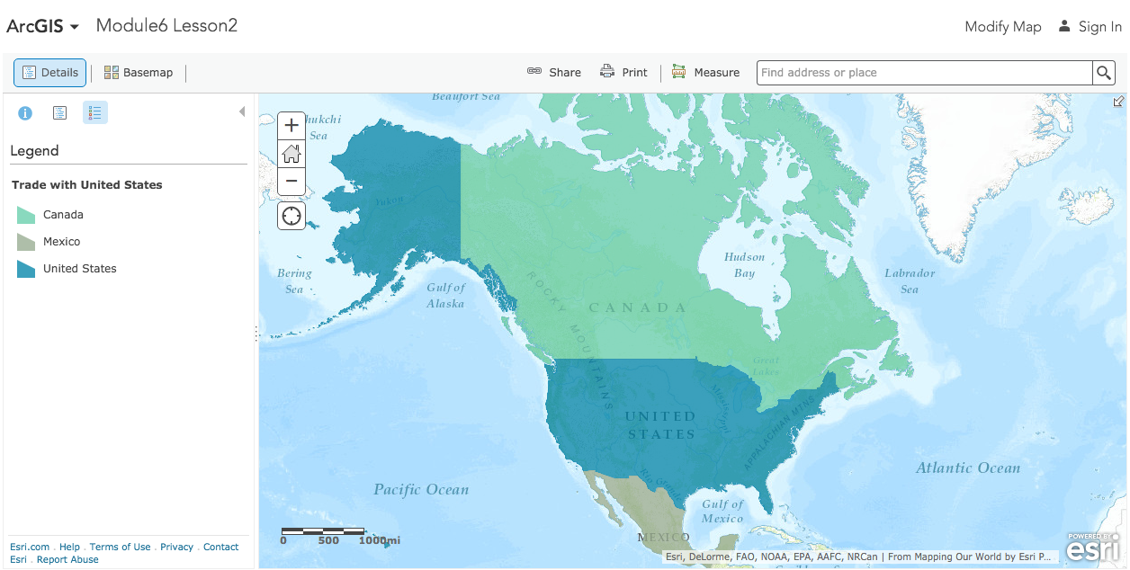

Task 2: Examine the map and attribute table

- Click Canada on the map.

You see a popup window showing Canada’s Exports to the US.

- Look at the attribute names in the popup window.

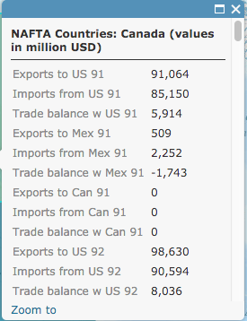

- Scroll down the list and answer the following questions.

Answers to questions in this activity should be recorded on the answer sheet.

- Q1: For which years does the layer contain data?

- Q2: How many attributes are there for each year?

Field names with the word “to” in them represent the value of goods and services exported from one country to another. For example, the attribute Exports to US 91 represents the value of goods and services that a country exported to the United States in the year 1991.

Field names with the words Trade balance represent the difference between how much a country exports to a trading partner and how much it imports from that partner.

The values are expressed in millions of U.S. dollars. That means you have to multiply the number you see by 1,000,000 to get the actual dollar value.

- Q3: What was the value of goods and services exported from Canada to the United States in 1991?

Task 3: Examine export graphs

- Scroll down the popup until you see a graph displaying Canada’s Exports to the US.

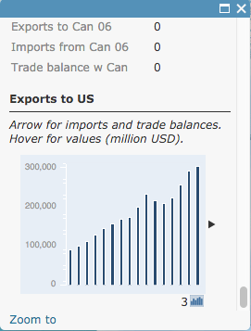

- Slowly hover over each column in the column graph.

- Q4: What does each column in the graph represent?

- Scroll back up to the data at the top of the popup.

- Q5: Which country exported more goods and services to Canada: Mexico or the United States?

- Q6: Why does the data display zeros in some of the fields?

- Hover over and click on the Show Contents of map icon.

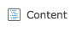
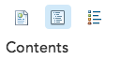
O
OR

- Turn off the Trade with United States layer.

- Turn on the Trade with Canada layer.

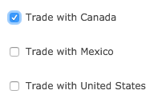

- Click Mexico on the map. Mexico is now outlined in blue.

- Q7: What happened to the popup?

The graph in the popups is created from the data in a database attached to the map. When you select a country on the map, only the data for that associated database is displayed in the popup and the graph.

- Q8: How many years of data are represented on the graph at the bottom of the popup?

- Q9: What year does the first bar on the left represent?

- Q10: Look at the numbers on the y-axis. Are the numbers on the graph in thousands, millions, or billions of dollars? (Remember that the attributes of the NAFTA Countries values are in millions of dollars.)

- Q11: Looking at the graph, how would you describe the trend of Mexican exports to Canada over the 16-year period?

- Q12: What was the approximate value of Mexican exports to Canada in 1991? In 2006?

- Q13: Approximately how many times greater is the 2006 amount of Mexican exports to Canada than the 1991 amount?

- Turn off the Trade with Canada layer.

- Turn on the Trade with United States layer and click on Mexico on the map.

- Q14: How would you describe the trend of Mexican exports to the United States over the 16-year period?

- Q15: Approximately how many times greater is the 2006 amount of Mexican exports to the United States than the 1991 amount?

Note that the same column height on two different graphs may represent different dollar values.

Task 4: Examine a trade balance graph

- Turn on the Detailed Trade Balance Graphs layer.

- Click on the pushpin that shows up in the Caribbean Sea. (You may need to close a popup.)

This popup displays the trade balance graphs for Mexico with each of the other NAFTA countries. Remember, trade balance is the difference between how much a country exports to a trading partner and how much it imports from the same partner. (You can click on the graph to enlarge it.)

- Q16: Did Mexico have a trade surplus or deficit with the United States for 1992?

- Q17: What was the approximate value of the trade balance for 1992? (Remember, the y-axis is in millions of dollars.)

- Q18: What was the first year that Mexico exported more to the United States than it imported from the United States?

- Q19: Describe the trend of Mexico’s trade balance with the United States over the 16-year period.

- Close the popup and click on the pushpin that is in the Atlantic Ocean off the eastern coast of the United States.

This popup displays the trade balance graphs for the United States with each of the other NAFTA countries.
- Q20: Did Canada have a trade deficit with the United States anytime during the 16-year period?

- Q21: In 1998, was Canada’s trade balance with the United States greater, smaller, or about the same as Mexico’s trade balance with the United States?

- Q22: In 2006, was Canada’s trade balance with the United States greater, smaller, or about the same as Mexico’s trade balance with the United States?

- Make sure the Trade with United States layer is on and click on Canada on the map.

- Q23: Referring to the attributes of NAFTA Countries: Canada, what was the exact value of Canada’s trade balance with the United States in 2006?

- Ask your teacher if you should stop here and save this map document. Follow your teacher’s instructions on how to rename the document and where to save it in your school ArcGIS Online Organization account. (If you don’t need to save the document, skip Q24.)

- Q24: Write the map document’s new name and location.

Task 5: Evaluate the effectiveness of NAFTA

In this lesson, you are looking at the level of trade among the NAFTA trading partners: Canada, Mexico, and the United States. You are also looking at changes in the level of trade among the three countries over time.

Remember, it is nearly impossible for any country to produce everything it needs to support its people. Countries must import (purchase) goods from other countries. One country’s imports are its trade partner’s exports. In this map document, you have no graphs for imports because you can figure out that information by looking at the export graphs.

For example, to find the United States’ imports from Canada, you switch the question in your mind and look for Canada’s exports to the United States. You would find this information on the graph entitled Exports to United States. To decide whether or not NAFTA is meeting its goals, you will need to further explore the data in the graphs and tables in the map document. You will gather the information that you need to decide if you think NAFTA is effective. You may want to refer to the NAFTA Objectives handout or the list of NAFTA goals you developed with your teacher at the beginning of the lesson. Remember these formulas as you examine the graphs and answer the questions that follow:

Trade Balance = Exports – Imports
Trade Surplus = Exports > Imports
Trade Deficit = Imports > Exports

- If you are starting a new ArcGIS Online session, in a new browser window or tab, go to the following link. If you did not close ArcGIS Online, continue using the Module6 Lesson 2 map you have open.

http://www.arcgis.com/home/webmap/viewer.html?webmap=13d9ee57190e455da4bcb3f0f4ac886a

- Q25: Determine from the graphs the approximate value of exports in 2006 for each pair of countries in the table on the answer sheet. Record the values in the middle column.
You can use both the tables in the popups on the map as well as the comparative tables in the pushpin popups. They represent the same data.

- Q26: Add the export values together for each pair of countries (for example, exports from the United States to Mexico plus exports from Mexico to the United States). Record the totals in the last column in the table in Q25.

- Q27: Rank the trading partners by total volume of trade. Use 1 for the partners trading the most and 3 for the partners trading the least.

- Q28: Did NAFTA have a positive (+), negative (–), or neutral (N) effect on trade volume between partner countries?

- Q29: Do you think that any one of these three countries benefited more than the other two from NAFTA? If so, which country? Explain your answer.

Most countries prefer to export a higher volume and dollar value of goods than they import, but either a large trade surplus or a large trade deficit may negatively affect a country’s overall economic health.

- Using the pushpin popups look at the comparative trade balances with Canada graph.

- Q30: What country has a healthier trade balance with Canada: Mexico or the United States?

- Q31: On what graph do you find a set of bars that looks like a mirror image of those for the U.S. trade balance with Canada?

- Compare the trade balance graphs.

- Q32: What country had the most dramatic change for the better in trade after NAFTA came into being in 1994?

- Q33: Estimate U.S. trade deficits with Canada and Mexico for 2004 and 2006 and record them (in billion dollars) in the table on the answer sheet.

- Q34: Did the U.S. combined trade balance get better or worse between 2004 and 2006? By how much?

- If you would like to complete this lesson and save your work, click on the Save As button, provide your login and password and provide a new name for your Map. If you do not want to save your work, close the map tab in your browser.

Note: if you have issues saving your document, go to this link and follow further instructions.
http://education.maps.arcgis.com/home/item.html?id=431f6bc3b0474f5e8933f8ba81bdc925

In this activity, you used ArcMap tables, graphs, and a map to explore and analyze trade data for the three North American countries.

