Module 2, Lesson 1
The earth moves

In this activity, you will observe worldwide patterns of seismic activity (earthquakes) and volcanic activity (volcanoes). You will analyze the relationships of those patterns to tectonic plate boundaries and major physical features of the earth’s surface. Then you will identify cities at risk.

Task 1: Open the map

- Launch an internet browser.
- Go to this link:
http://www.arcgis.com/home/webmap/viewer.html?webmap=47bbca89d7b8451ebbcf952bd18172f6

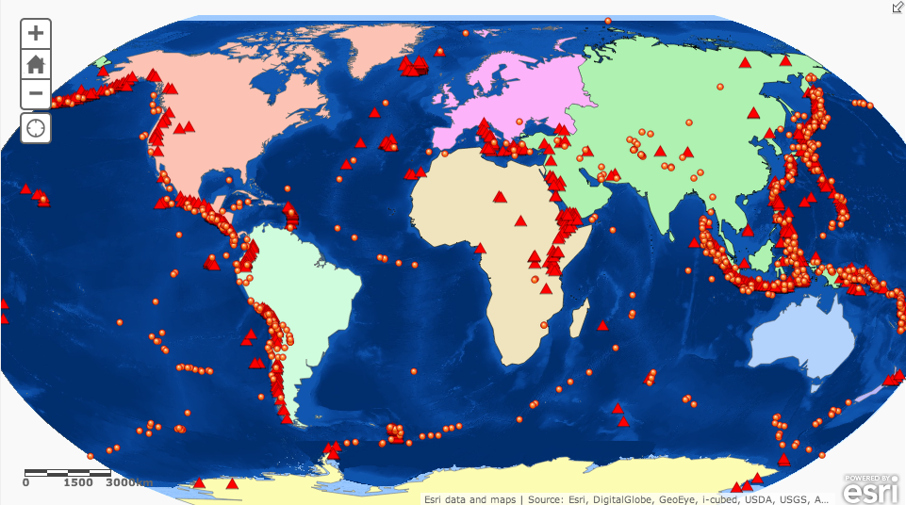

- Click on the Modify Map button on the top right corner above your map.
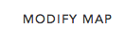

- If you would like to complete this lesson and save your work, click on the Save As button, provide your login and password and provide a new name for your Map. If you do not want to save your work, proceed to Step 4 without clicking on the Save As button.
Note: if you have issues saving your document, go to this link and follow further instructions.
https://www.dropbox.com/s/25g07fiof7ceq9q/Opening%20the%20right%20map.pdf

- Click on the Show Contents of Map at the top of the Contents area on the left of the map.
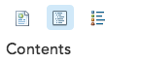
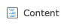
OR

When the map document opens, you see a map with four layers turned on: Earthquakes Magnitude 5.7+ (2004-2007), Volcanoes, Continents and World Imagery. The check mark next to the layer name tells you the layer is turned on and visible on the map.

Task 2: Analyze earthquake locations

You will now compare the predictions you made in the Supplement about earthquake and volcano locations to actual data using GIS.
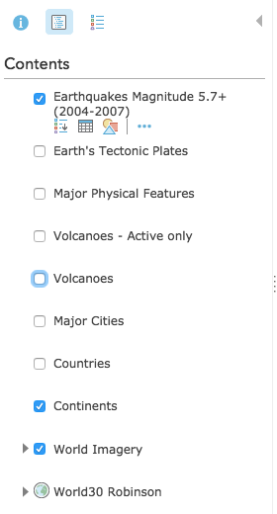
- Turn off Volcanoes so that only Earthquakes Magnitude 5.7+ are showing on the map.

The points show the locations of earthquakes that occurred in 2004 through 2007 and were a magnitude of 5.7 or over.

Answers to questions in this activity should be recorded on the answer sheet.

- Q1: Do earthquakes occur in the places you predicted? List the regions you predicted correctly for earthquake locations.

- Q2: What patterns do you see on the map?

Task 3: Sort and analyze earthquake magnitudes

You can take a closer look at the data behind the dots by looking at the attribute table of the Earthquakes layer. An attribute table contains specific information about the features in a layer. In the Earthquakes layer, each point represents an earthquake with a magnitude of 5.7 or greater on the Richter scale. You will focus on the 20 strongest earthquakes.
- In the table of contents, hover over the Earthquakes magnitude 5.7+ (2004-2007) layer, click on the Show Table button.
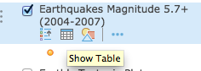

You see below the attribute data associated with the orange earthquake points on the map.
- Scroll down to review the records. Remember, each record in this table represents one point on the map.
Now you will put the magnitudes in order from largest to smallest.
- Click the field (column heading) labeled MAGNITUDE. This field represents the magnitude of the earthquakes and a Sort Ascending/Sort Descending box will appear. Click on Sort Descending.
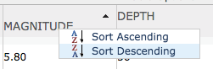

The records are now arranged from largest to smallest and you will select the 20 largest earthquakes from the list.

- Click on the record that is the first in the list. While depressing the shift key, click on each row until you get to the twentieth record. You may need to hit the down arrow of your keyboard to see more rows to click. Note that there are now earthquakes highlighted in blue on your map.

To make sure you have highlighted 20 earthquakes, look at the status bar at the top of the table. It should look like the following graphic:

If you select too few records, depress the Shift key again and click on the rows that you are missing. If you have too many records, depress the Shift key and click on the rows that you wish to stop highlighting.

- Q3: How do the 20 selected locations compare to your Supplement map? List three ways. (You may need to pan your map to see all highlighted earthquakes.)

- At the top right of the attribute table window, click the Table Options down arrow and click Clear Selection.

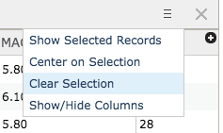

- Close the attribute table by clicking the “X” in the top right corner of the table.

Task 4: Analyze volcano data

- Turn off the Earthquakes Magnitude 5.7+ layer and turn on the Volcanoes layer.

- Q4: How do the volcano locations compare with your original predictions? List the regions of volcanic activity you predicted correctly.

- Q5: What patterns do you see in the volcano locations, and how do they compare with the earthquake patterns? (Turn the Earthquakes layer on and off as needed.) The data includes volcanoes that are not active. You will focus on the active volcanoes.

- Q6: Formulate a hypothesis as to why volcano eruptions and earthquakes happen where they do.

The data includes volcanoes that are not active. Next you will focus on the active volcanoes.

Task 5: Identify active volcanoes on different continents

- In the Contents, hover over and click on the Volcanoes layer and click the Show Table button.
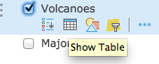

- Click on the field heading Type and click on Sort Ascending. Scroll down the table to look at the different types of volcanoes. As you see, the Type field tells you if a volcano is active, potentially active, or solfatara (emits gases but is otherwise inactive).

You will view just the Active volcanoes that have been filtered out in a different layer.

- Close the table for the Volcanoes layer and turn on the Volcanoes – Active only layer.

- Click an active volcano on the map. The popup window shows you the name of the volcano, its elevation, type, and country. For example
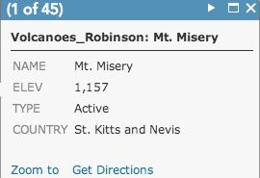

- Close the Identify window so you can see your map.

- Turn on the Countries layer and turn off the continents layer.

- Using the scroll button on your mouse, zoom in to the continent of your choice.
Remember, you can zoom in and out by scrolling your mouse scroll button, and you can pan your map by holding down the scroll or left click buttons and moving your mouse.

- Q7: Click on active volcanoes in green to find the names, elevations, and countries of three active volcanoes.

- Zoom back out until you can see your entire map on the screen.

Task 6: Plate boundaries and Physical Features

The earth is always changing. The crust of the earth is composed of several tectonic plates that are always on the move. The effects of movement are most noticeable at the boundaries between the plates.

- Q8: Based on the locations of earthquakes and volcanoes, where do you think the plate boundaries are? Draw them on the Supplement map.

You will now investigate the locations of plate boundaries and their effects on adjacent physical features. The four basic types of plate boundaries are:

- Divergent boundary. One or two plates are splitting apart. New crust is being formed from the center of the earth, causing the plate to spread. Rift valleys are one example of this type of plate movement.
- Convergent boundary. Two plates are colliding, forcing one plate to dip down underneath another one. The plate that is folding under has old crust that is being destroyed, while the plate on top has mountains and volcanoes being formed. In the ocean, these appear as trenches.
- Transform boundary. Plates are sliding against each other, causing large fault lines and mountains to form. Here, the crust is neither created nor destroyed.
- Plate boundary zones (zigzagged). Plate boundaries appear erratic (zigzagged). Scientists believe there are microplates in these areas, but it is unclear what effect they have on the physical environment.

- Turn off the Volcanoes and the Volcanoes – Active only layers.

- Turn on the Earth’s Tectonic Plates layer.

- Q9: Compare the actual plate boundaries to the ones you drew on the Supplement map. Record all similarities and differences.

- In order to get a closer look at physical features and plate boundaries, turn on Major Physical Features.

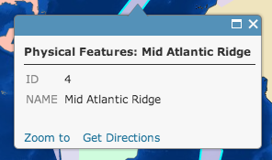
- Click on the map to identify a physical feature or other map layers you have turned on. (You may need to zoom in to be able to easily click on a physical feature on the map)

- Q10: Are there any areas where physical features, plate boundaries, and seismic and volcanic activities overlap?

- Q11: Write the names of physical features in the first column of the table on the answer sheet and label them on the Supplement map. The first entry in the table is already completed for you as an example.

- Q12: In the second column of the table on the answer sheet, write how you think each physical feature was created. Refer to the descriptions of the types of plate boundaries on pages 7 and 8.

Task 8: Identify major cities at high or low risk for seismic or volcanic activity

- Turn off the Earth’s Tectonic Plates and Major Physical Features layers.

- Turn on the Major Cities, Continents and Volcanoes layers in the table of contents.

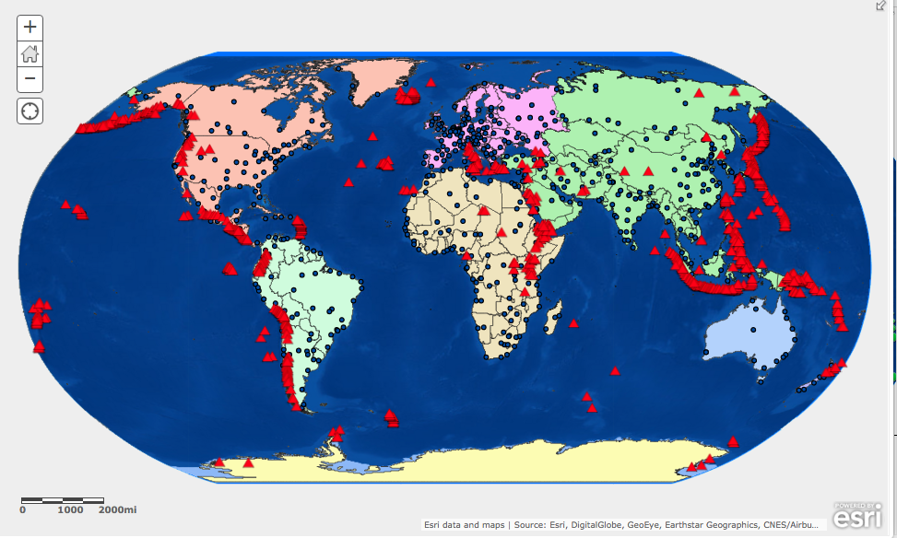

- Use the Zoom and Pan tools and click on the map to identify cities that have a high risk or low risk for an earthquake or a volcanic eruption.

- You may like to use the Measure tool to learn the distance from volcanic and seismic activity to major cities by clicking once on a volcano and then once on its closest major city.

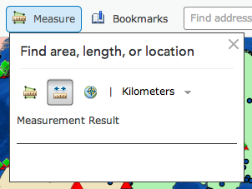

- Q13: List five high-risk cities and five low-risk cities. Remember to turn layers on and off and move them around as needed.

In this lesson, you used different layers to find the locations of earthquakes and volcanoes around the world. You were then able to identify cities at high or low risk for seismic or volcanic events.

